

Sales & Distribution

Guided By – Sivakumar Nivarthi

**INDEX**

|  |  |  |
| --- | --- | --- |
| **Sr. No.** | **Title** | **Page No** |
| 1 | Introduction  Company Code  Sales Organisation  Distribution Channel  Division  Plant | 4 |
| 2 | Customer Master  Customer with Reference  Three views in Customer  Partner Functions | 9 |
| 3 | Material Master  View in Material Master  Moving Average  Adding Stock | 15 |
| 4 | OTC/O2C Cycle  Inquiry  Quotation  Order  Delivery  Billing | 22 |
| 5 | CMIR | 33 |
| 6 | Sales Document Type | 35 |
| 7 | Pricing Procedure  Condition Technique  Pricing Condition  Access Sequence | 38 |
| 8 | Free Goods  Exclusive  Inclusive | 44 |
| 9 | Credit Management  Simple Credit Management  Automatic Credit Management | 46 |
| 10 | Account | 49 |
| 11 | TPO  MIGO  MIRO  Statistical Group | 50 |
| 12 | Availability Check  CP & CN Determination  Forward Scheduling  Backward Scheduling | 57 |
| 13 | MTO & MTS  Material Type  Select View  Strategy Group | 59 |
| 14 | Output Control | 63 |
| 15 | Text Control | 70 |

INTRODUCTION

**SAP** – It is System Applications Products and Data Processing.

**SD** (Sales and Distribution) - It is an important module in SAP which deals with order replacement, delivery, shipping and invoicing.

SAP SD is integrated with four important things as follows

* Customer
* Material
* Price
* Tax

We are currently using EHP 6 ECC 8.0 Version of SAP

Supply Chain Management includes 3R (Continuously)

* Right time
* Right place
* Right Quantity

ERP (Enterprise Resource Planning) works in the following flow

* Organizational Structure
* Master Data
* Configuration
* Transaction
* Reports

Resources in SAP (3M)

* Money
* Material
* Manpower

Landscape Involves

1. Development
2. Quality
3. Production

Types of projects in SAP

• Green field – Fresh or new sap

• Brown field – Existing customer moving to S4/Hana (Migration to s4/Hana)

Steps of SAP implementation methodology

* Project Kick-Off
* AS IS- TO BE
* Realization
* Go-live
* Support

**OTC/O2C cycle -**

Inquiry -> Quotation -> Sales Order -> Delivery -> Billing

**Sales Hierarchy -**

* Sales Office-> Regional
* Sales Group-> State
* Sales District-> District

**SPRO - SAP Project Reference Object**

**Company Code- OX02**

It is organizational unit responsible for external financial transactions.

FI consultant is responsible for this unit.

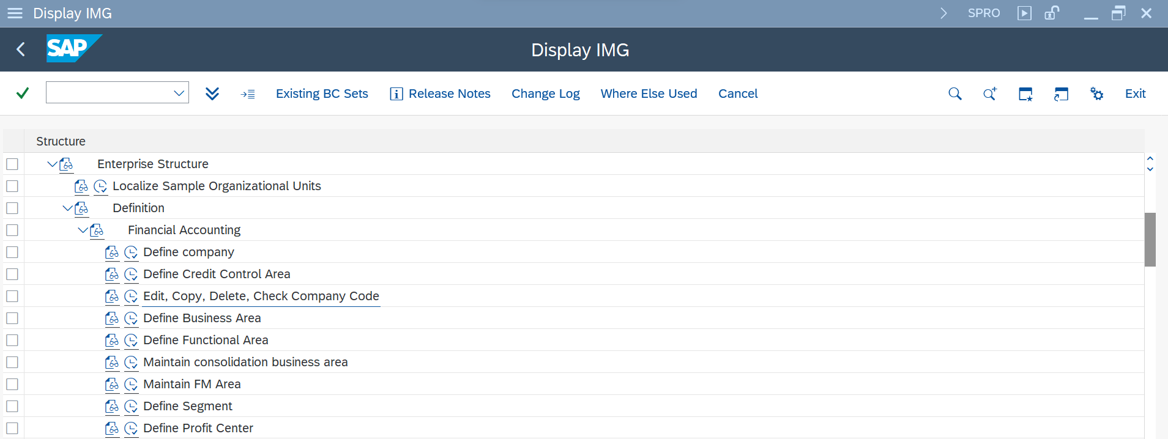

**Sales Organization- OVXS**

It is responsible for sales and services.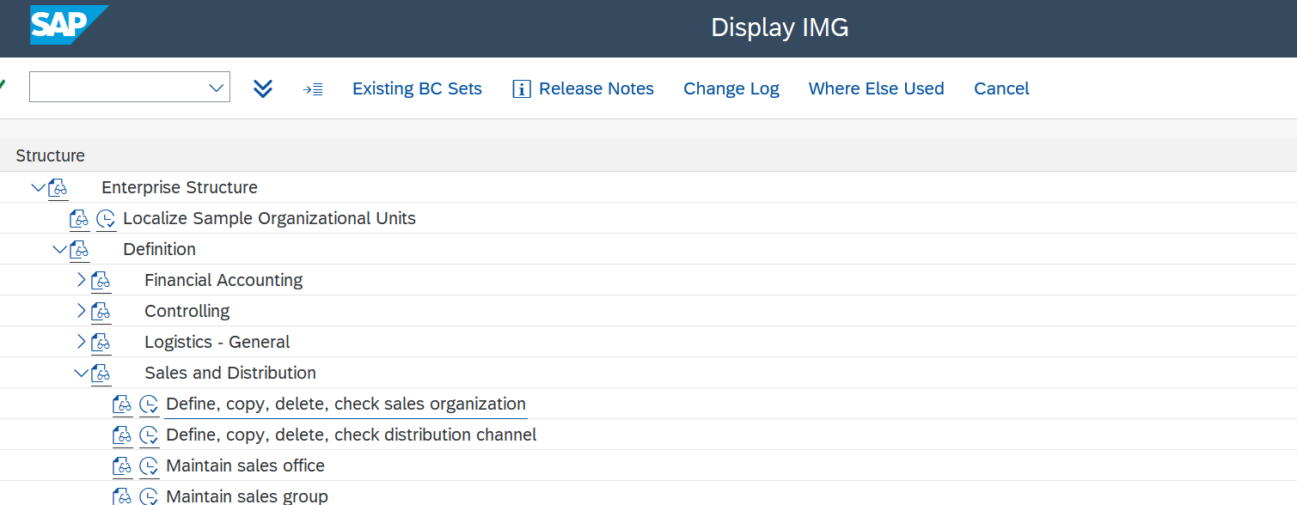

**Distibution Channel- OVX1**

Channel for selling goods to end customers/ way of distributing goods.

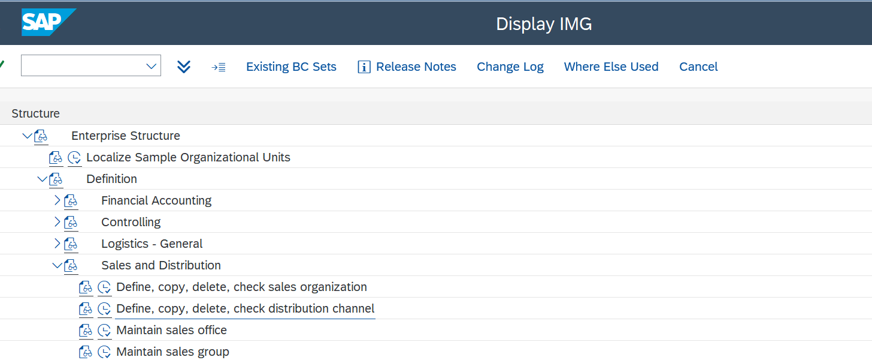

**Division- OVXB**

The sales unit where we can see profit and loss of organization

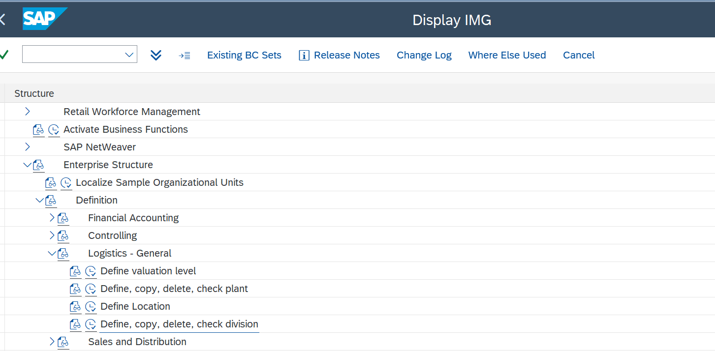

**Plant- OX10**

Physical location where manufacturing is done

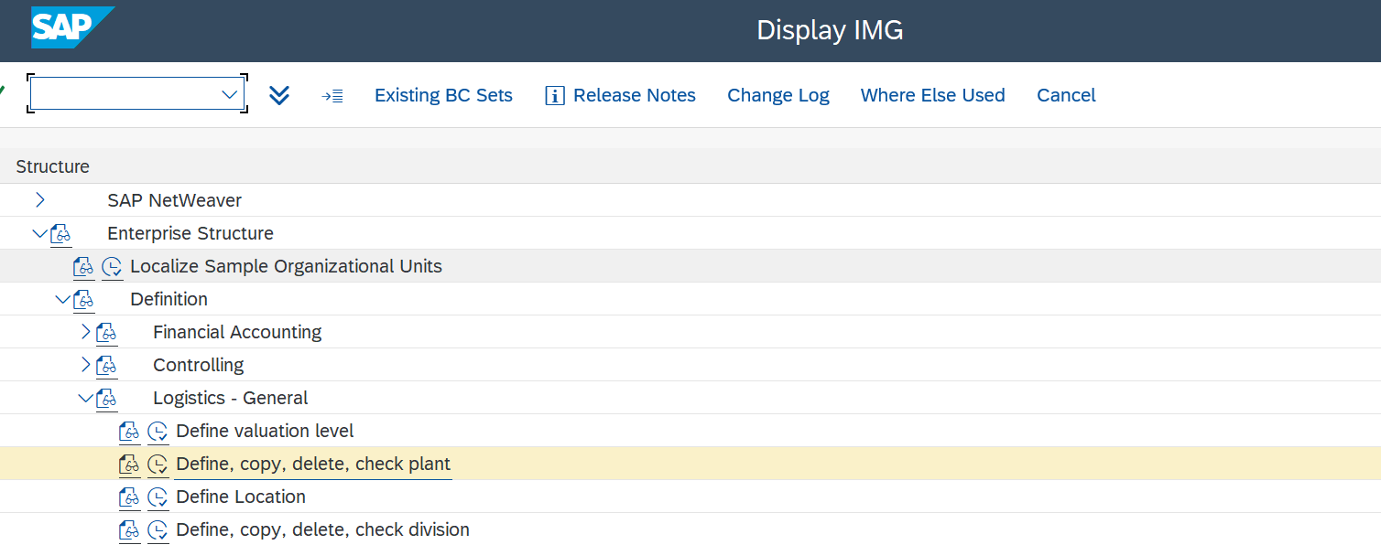

**Shipping point- OVXD**

Physical location where process of loading groups and dispatching is done.

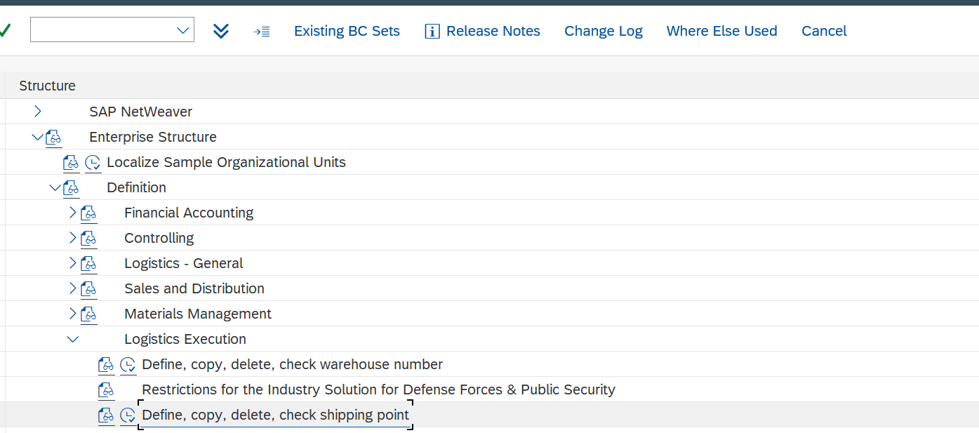

CUSTOMER MASTER

**T - Codes**

XD01- Create customer with three fields.

FD01- Create customer with general data and company code data.

VD01- Create customer with general data and sales area data.

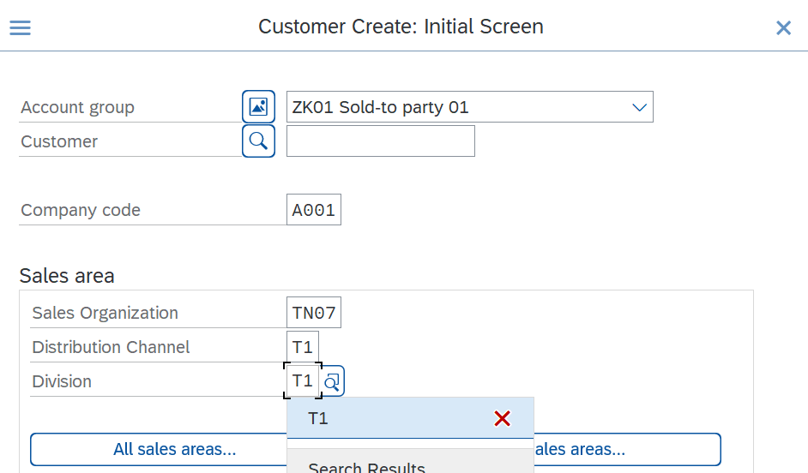

**Create customer with reference.**

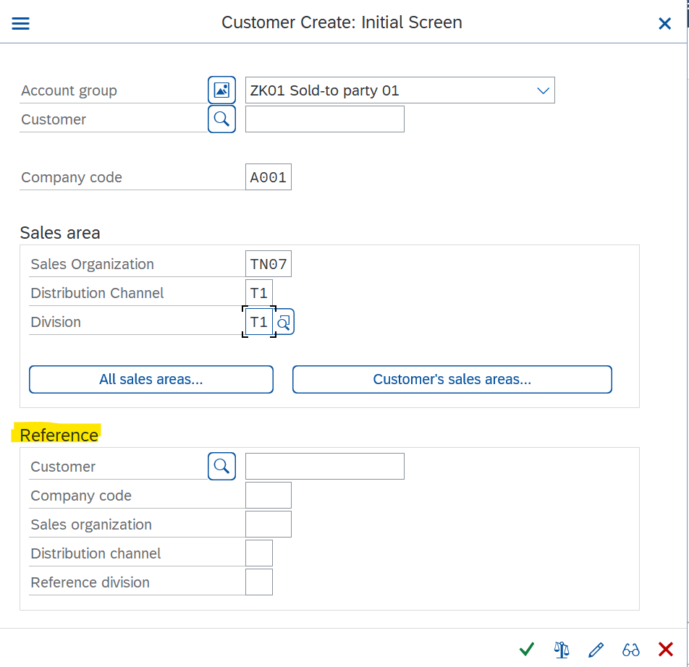

**Three views of customer master -**

* General Data
* Company Code Data
* Sales Area Data

**General Data**

Contains Data related to address, names of a customer etc which are common to entire organisation

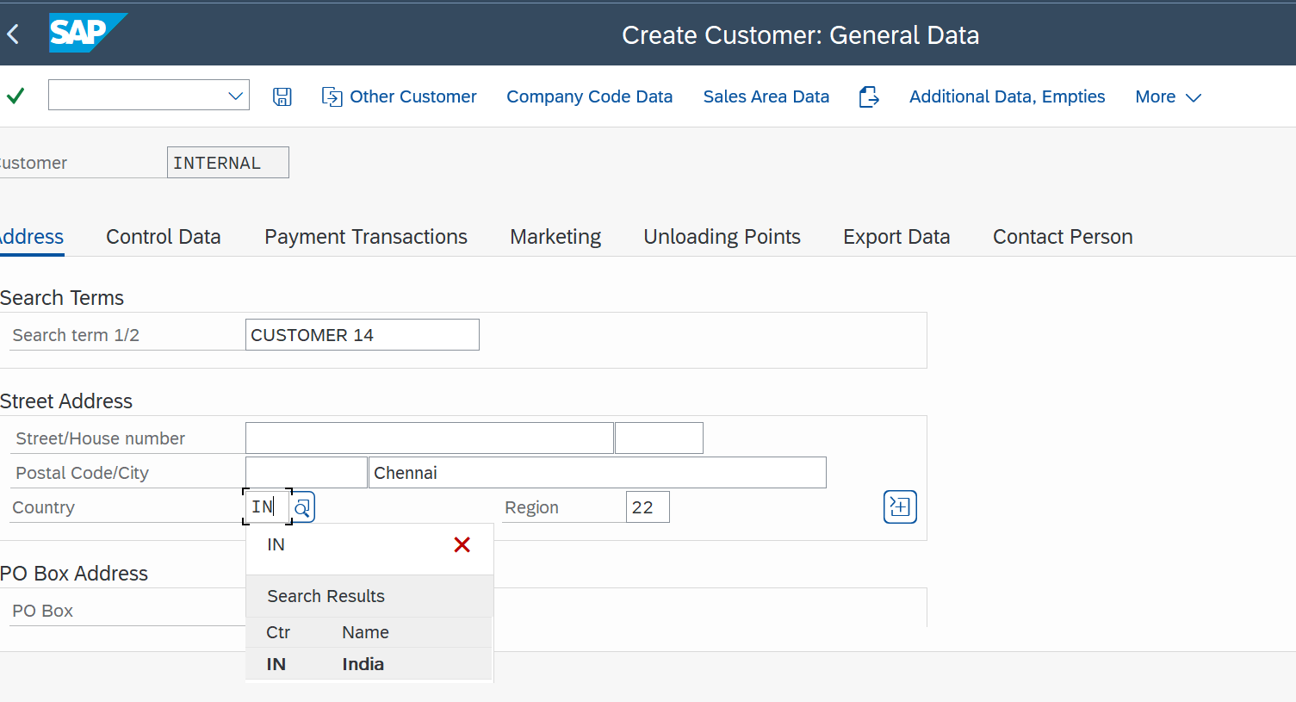

Region is imp for tax determination

**Company Code Data**

View is finance related, interest, payment method, insurance that are specific to company.

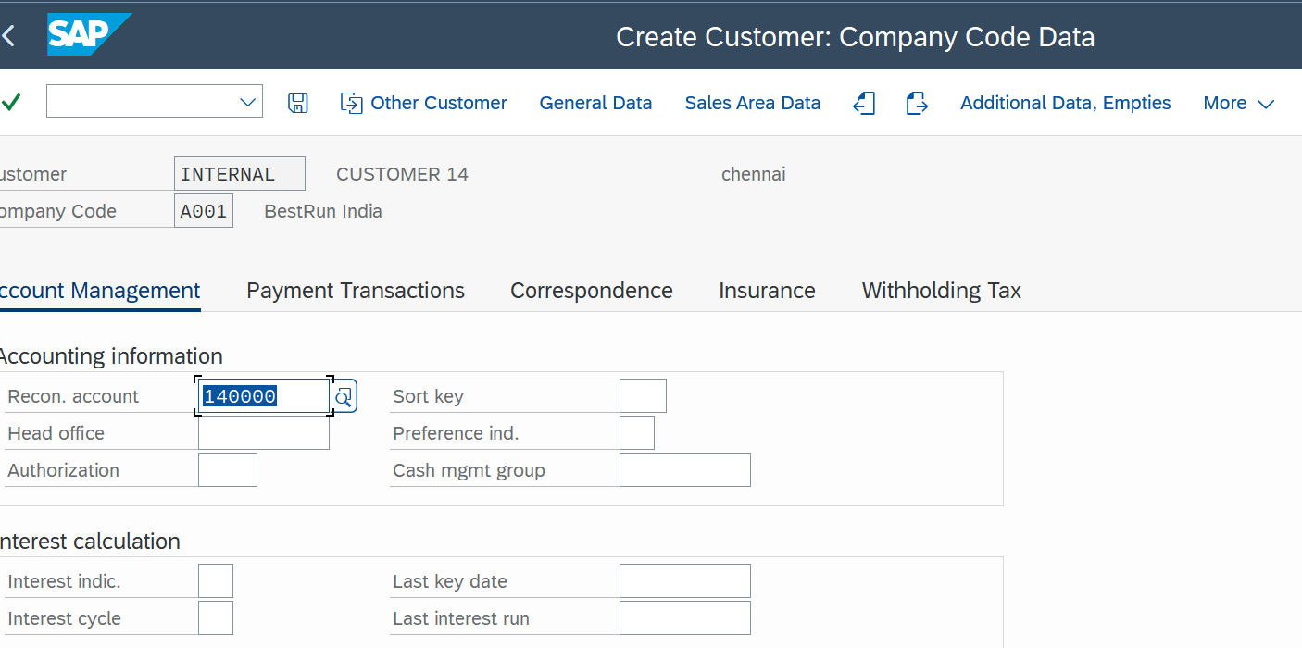

**Sales Area Data**

Sales related data containing sales-customer pricing procedure, price list, shipping condition, delivery plant, incoterms, payment terms, partner functions

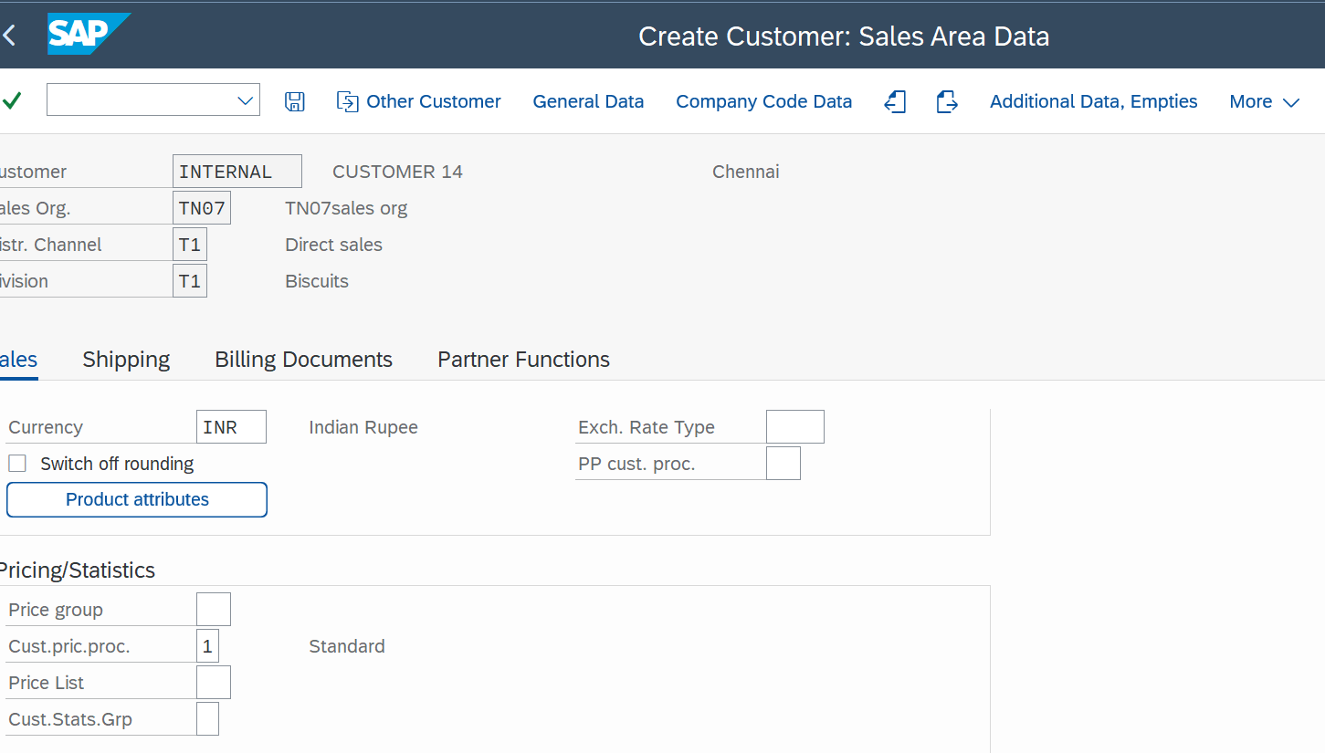

*Customer Pricing procedure is link between customer master and pricing procedure.*

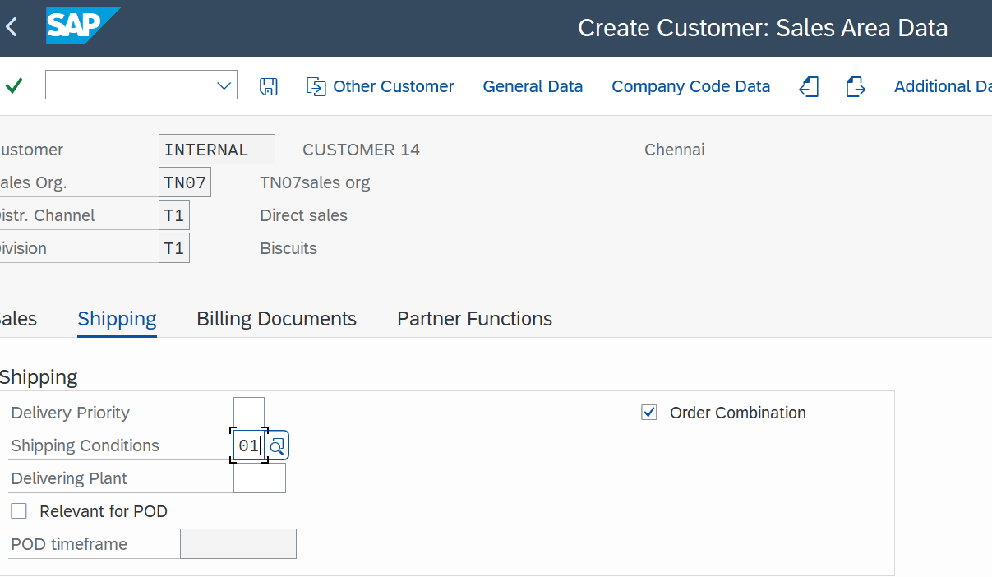

*Shipping condition is important for shipping partner determination.*

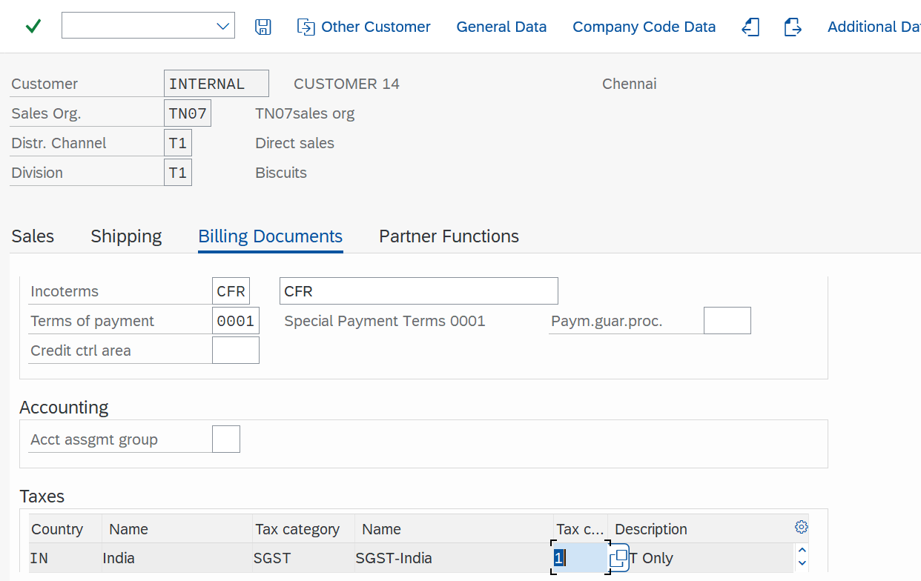

*Incoterms is how the product is delivered.*

*Terms of payment is mode of payment.*

*Here tax classification is done.*

**Partner Functions**

Sold To Party(AG)- Customer

Bill to Party(RE)- The one who will receive the bill

Payer(RG)- The one who will pay the bill

Ship to Party(WE)- The one who will receive the order

Note There can be multiple bill to, ship to and payer parties but ship to party cannot be changed and it is single in the number

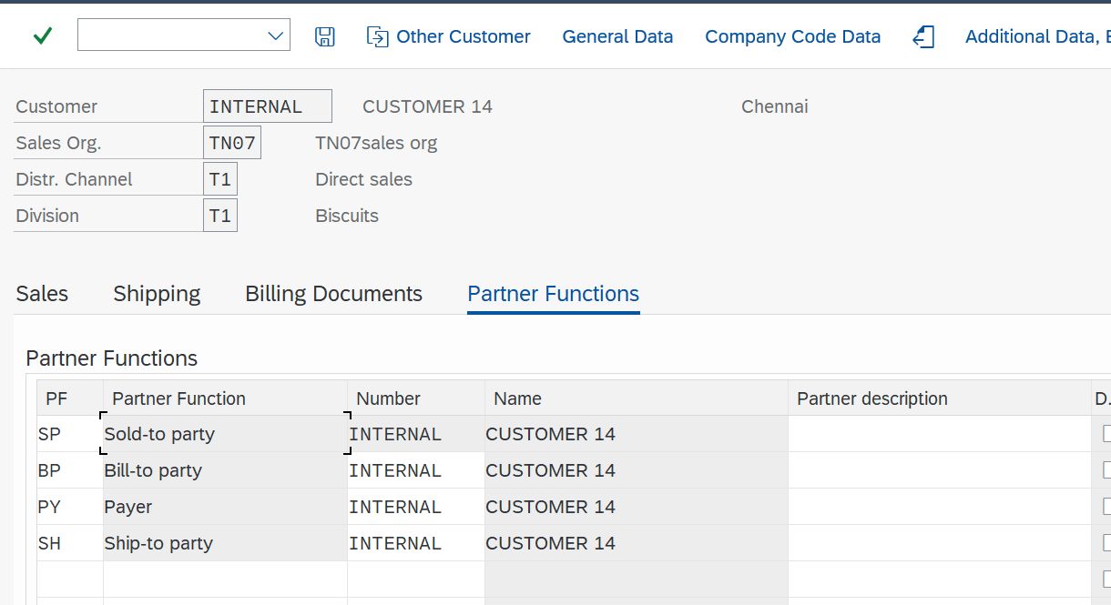

**Account Group** - The account group is a classifying feature within customer master records.

It determines

* in which number range the customer account number should be.
* whether the number is assigned by the user or by the system.
* which specifications are necessary or possible in the master record.

To make any field suppress/req.entry/opt.entry/display in the customer master:

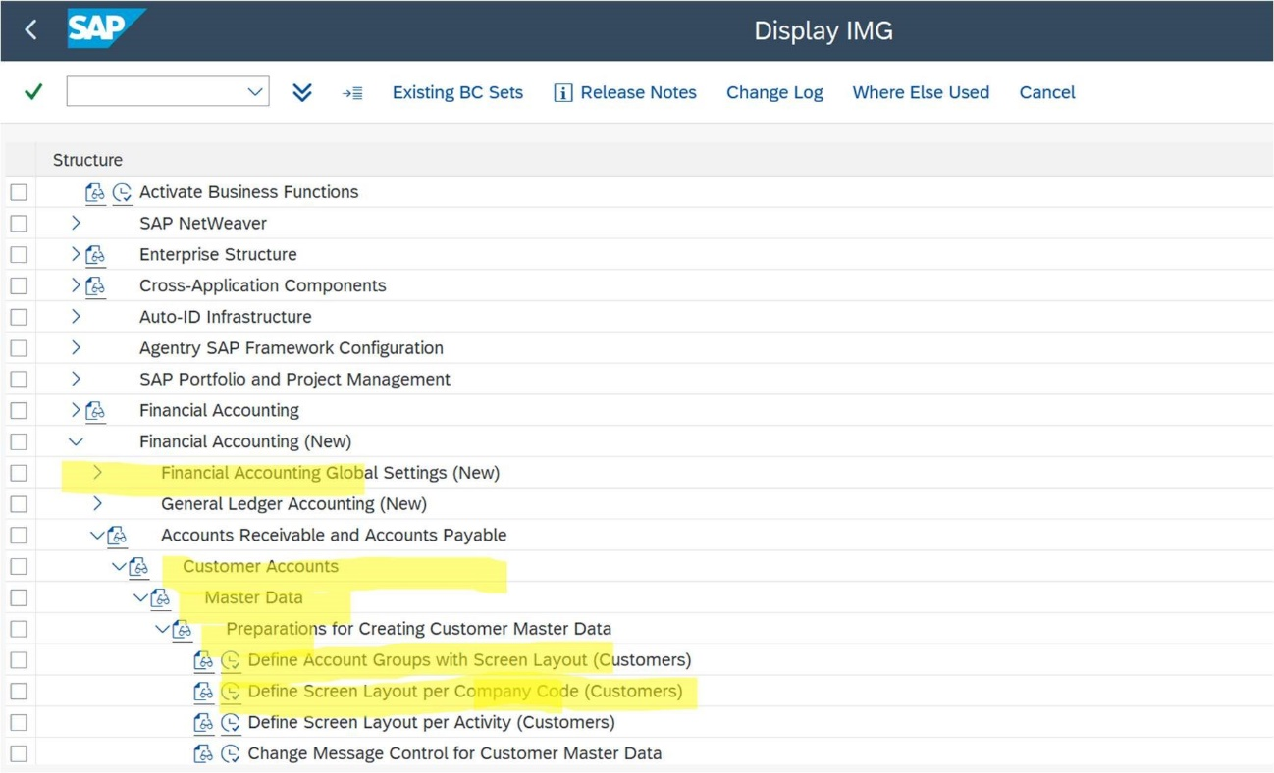

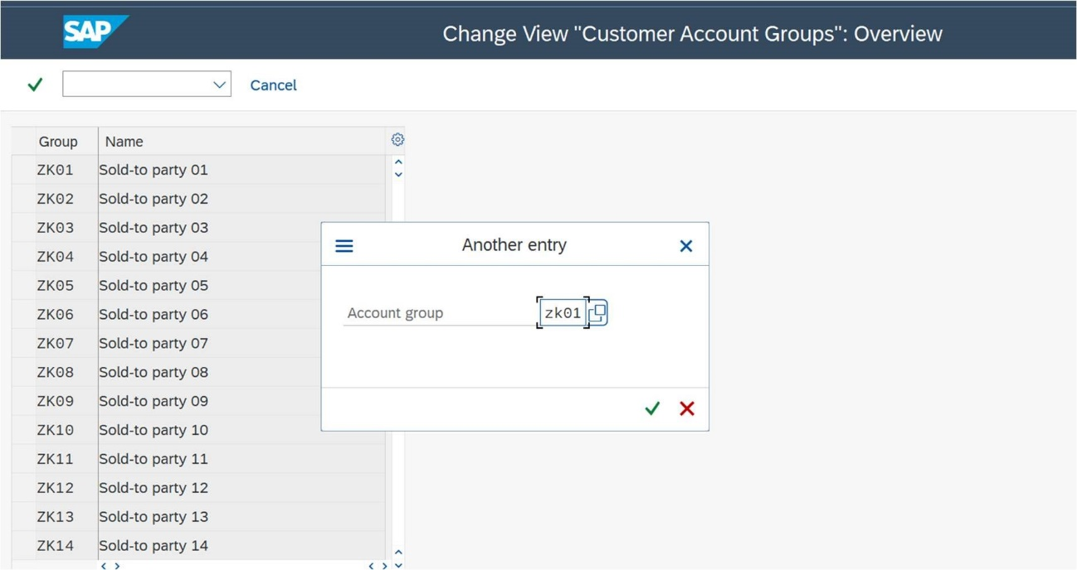

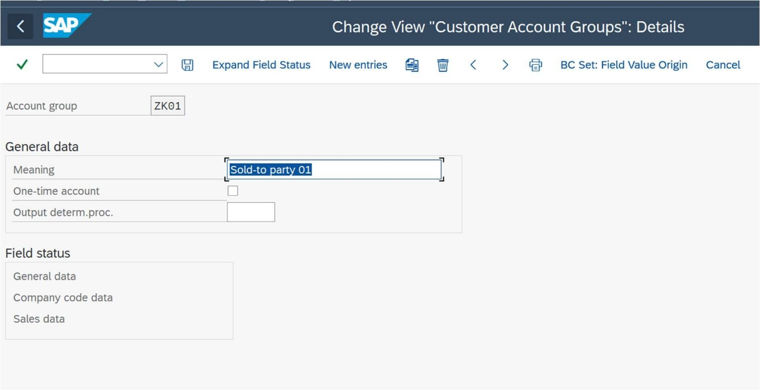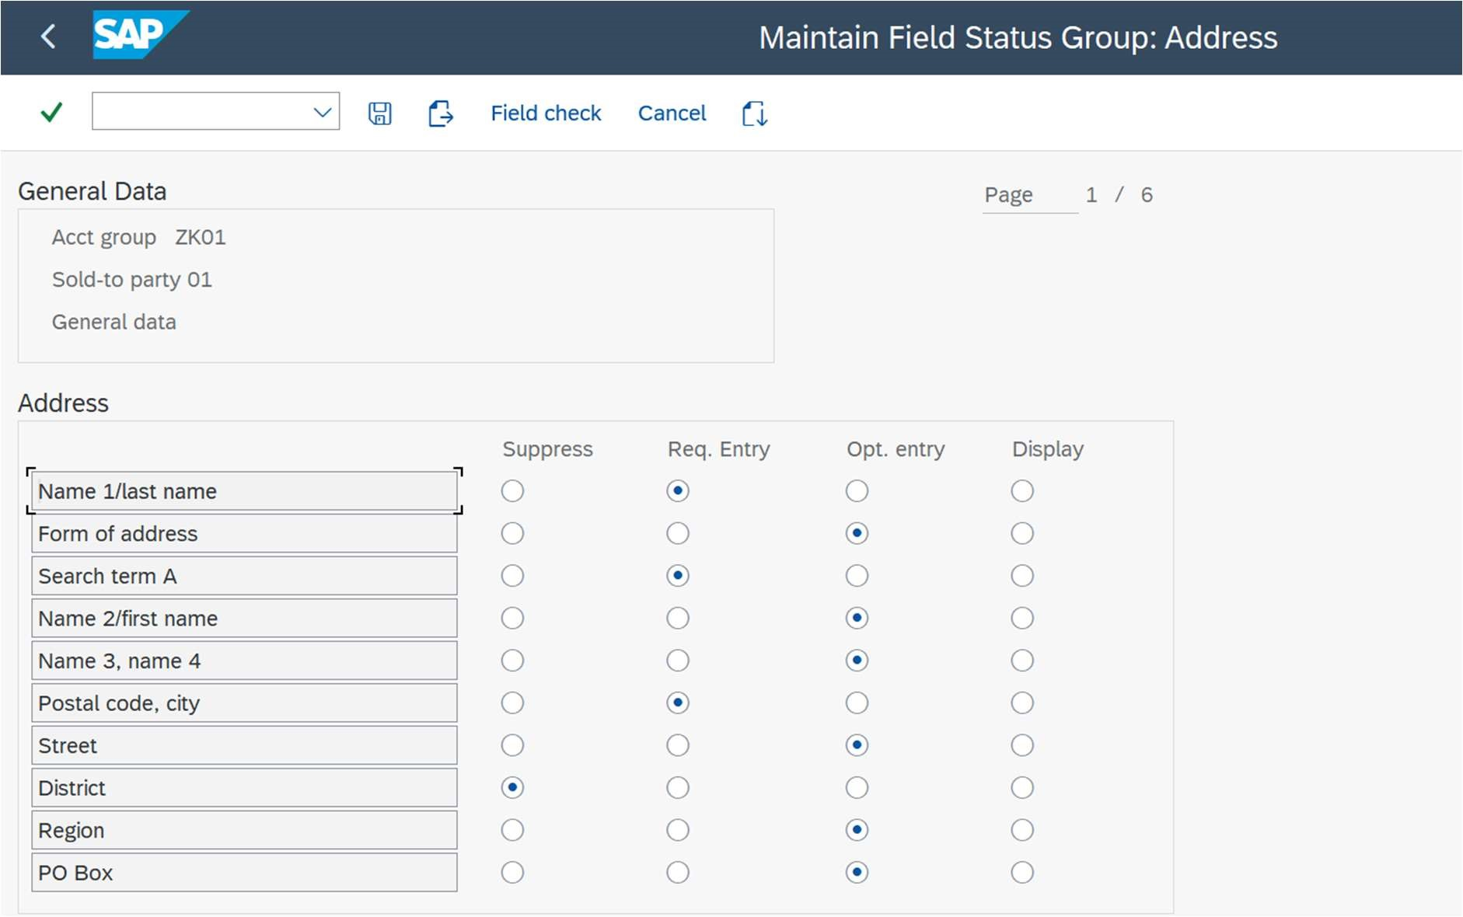

Select any and perform changes as per

the requirement.

MATERIAL MASTER

**T-codes**

MM01 – Create a material.

MM02 – Edit a material.

MM03 – Display a material.

MM60 – View the list of materials.

MMBE – To view a material and its stock.

MB1C – To setup inventory for the material.

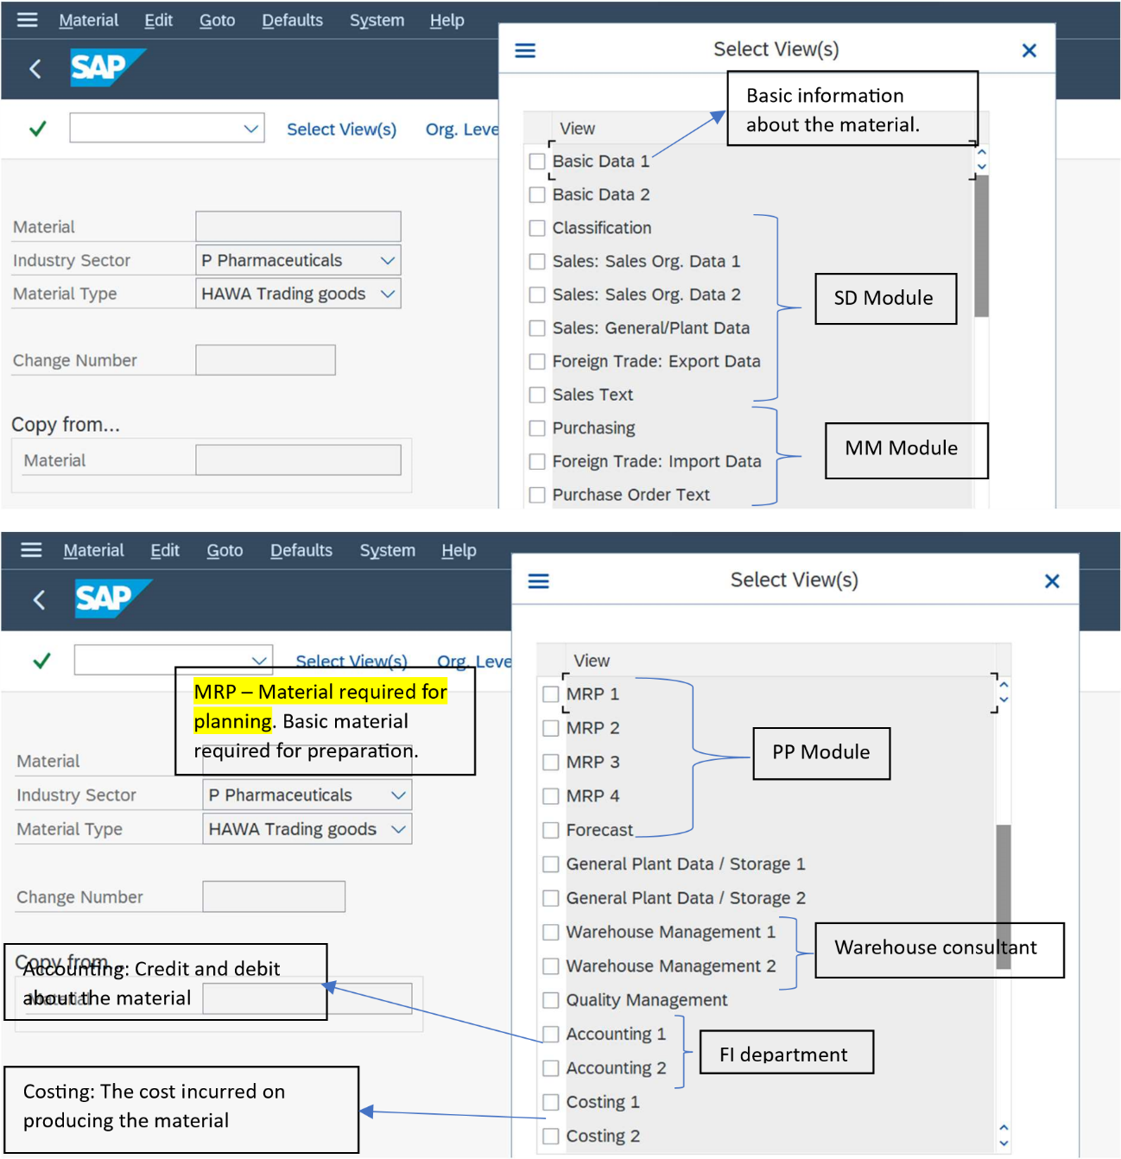

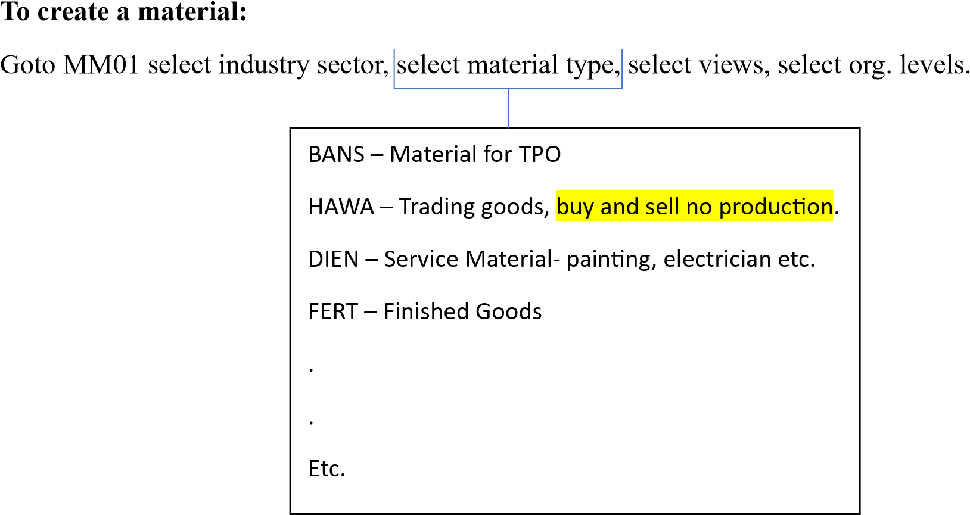

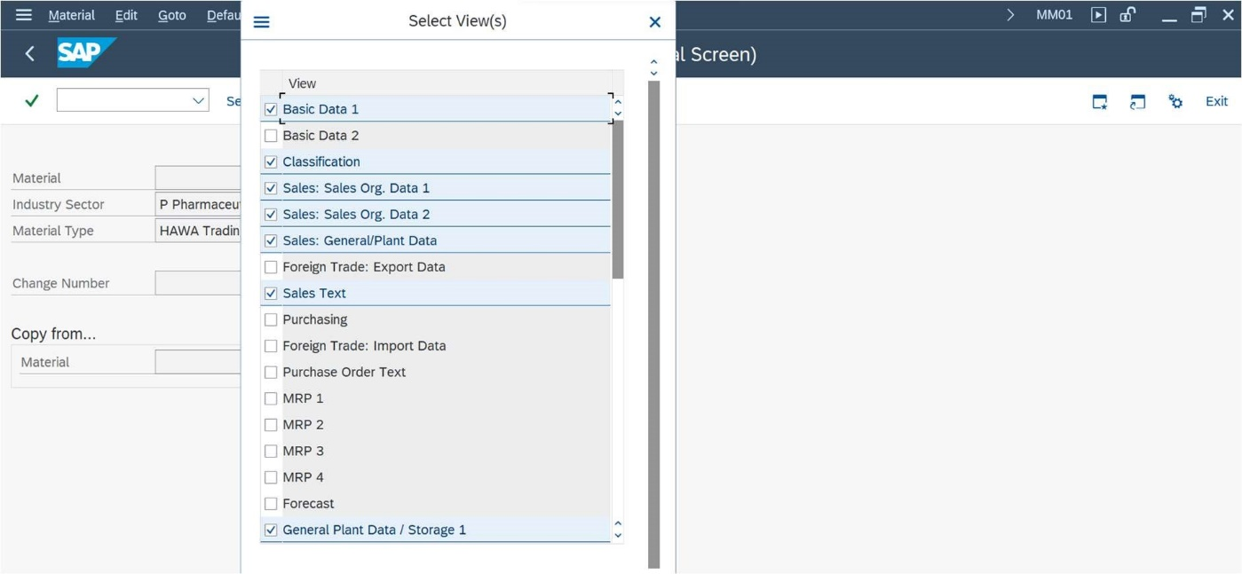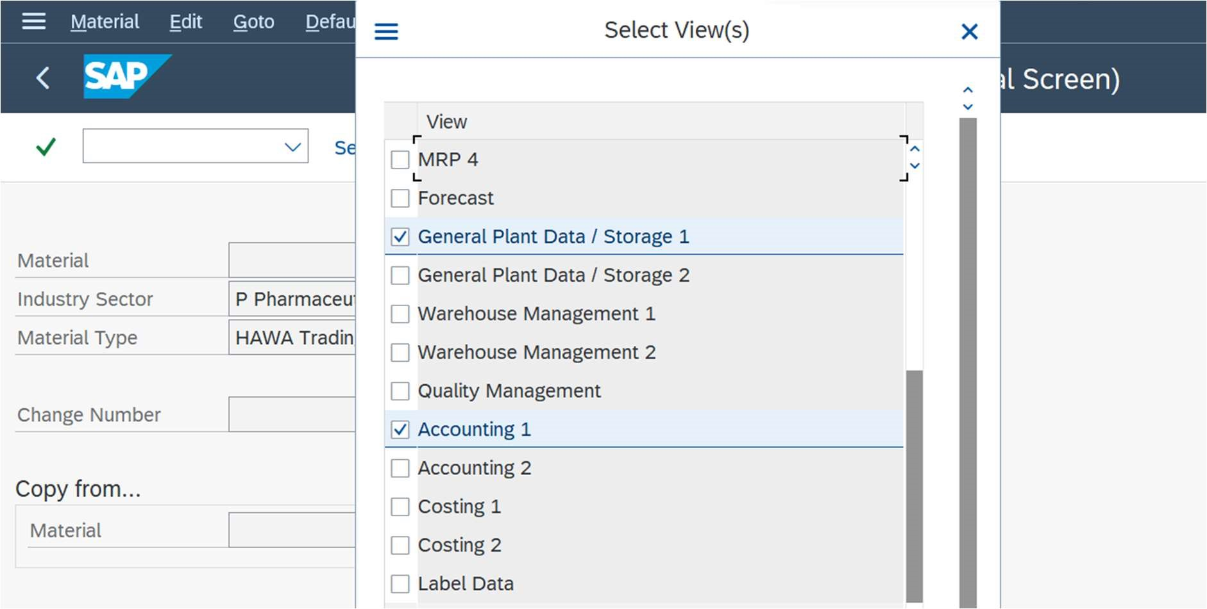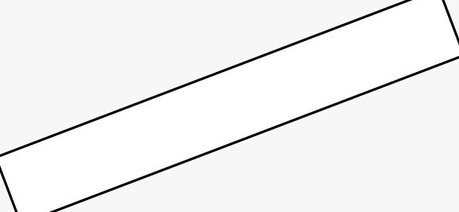

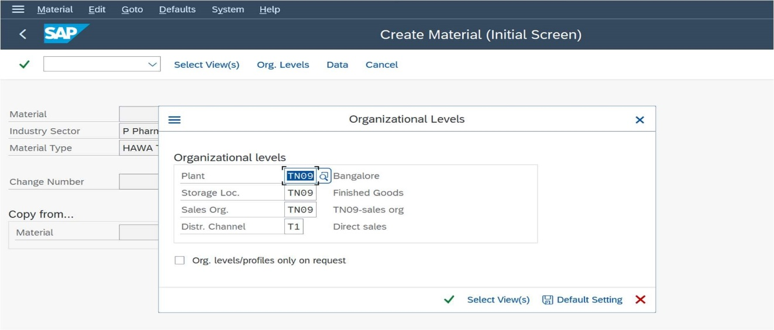

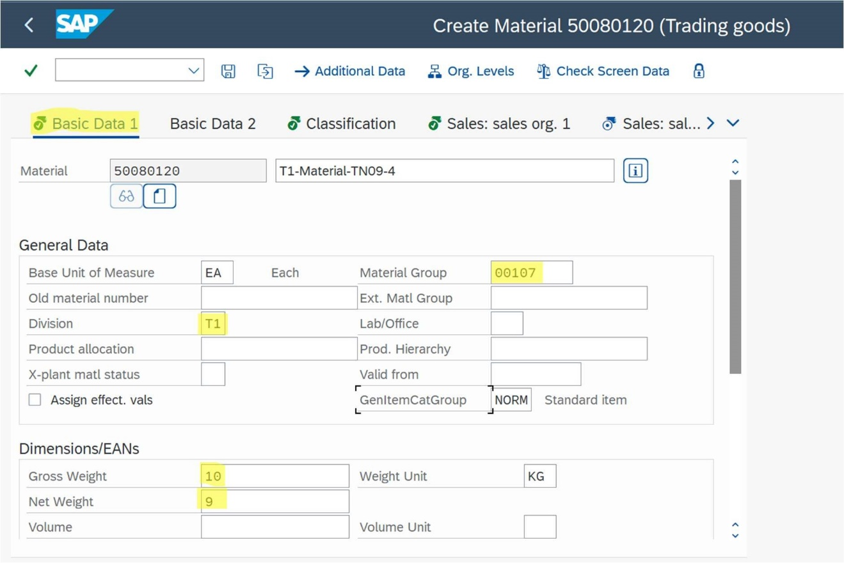

Sales unit - Unit in which sales is happened.

|  |  |
| --- | --- |
| E.g. If a company buys petrol in Gallons/Kilo liters, but it sells the petrol in liters to the | |
| customers. |  |

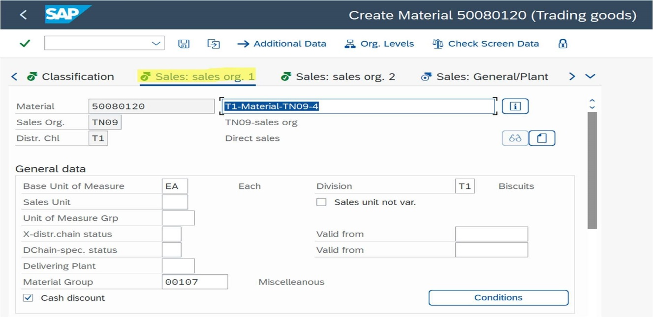

Usually, materials are identified using serial numbers. But some of the materials like medicines (any processing industry) are identified on batch number so, for that purpose we use batch management.

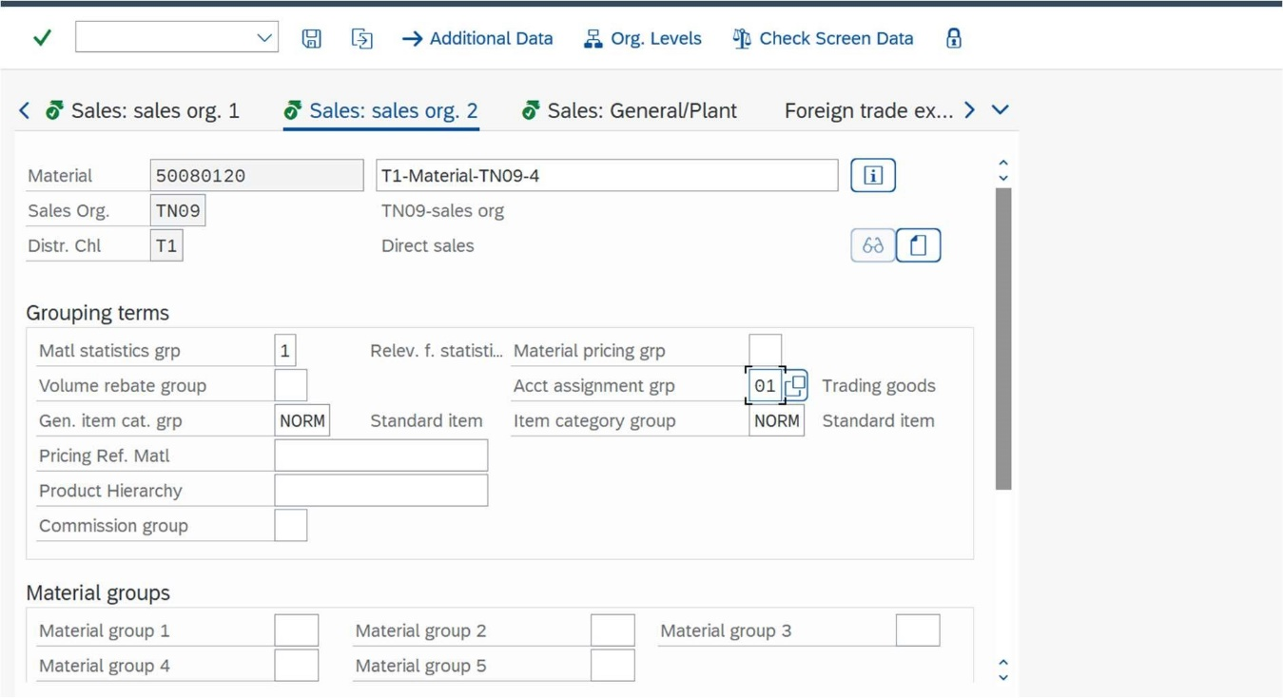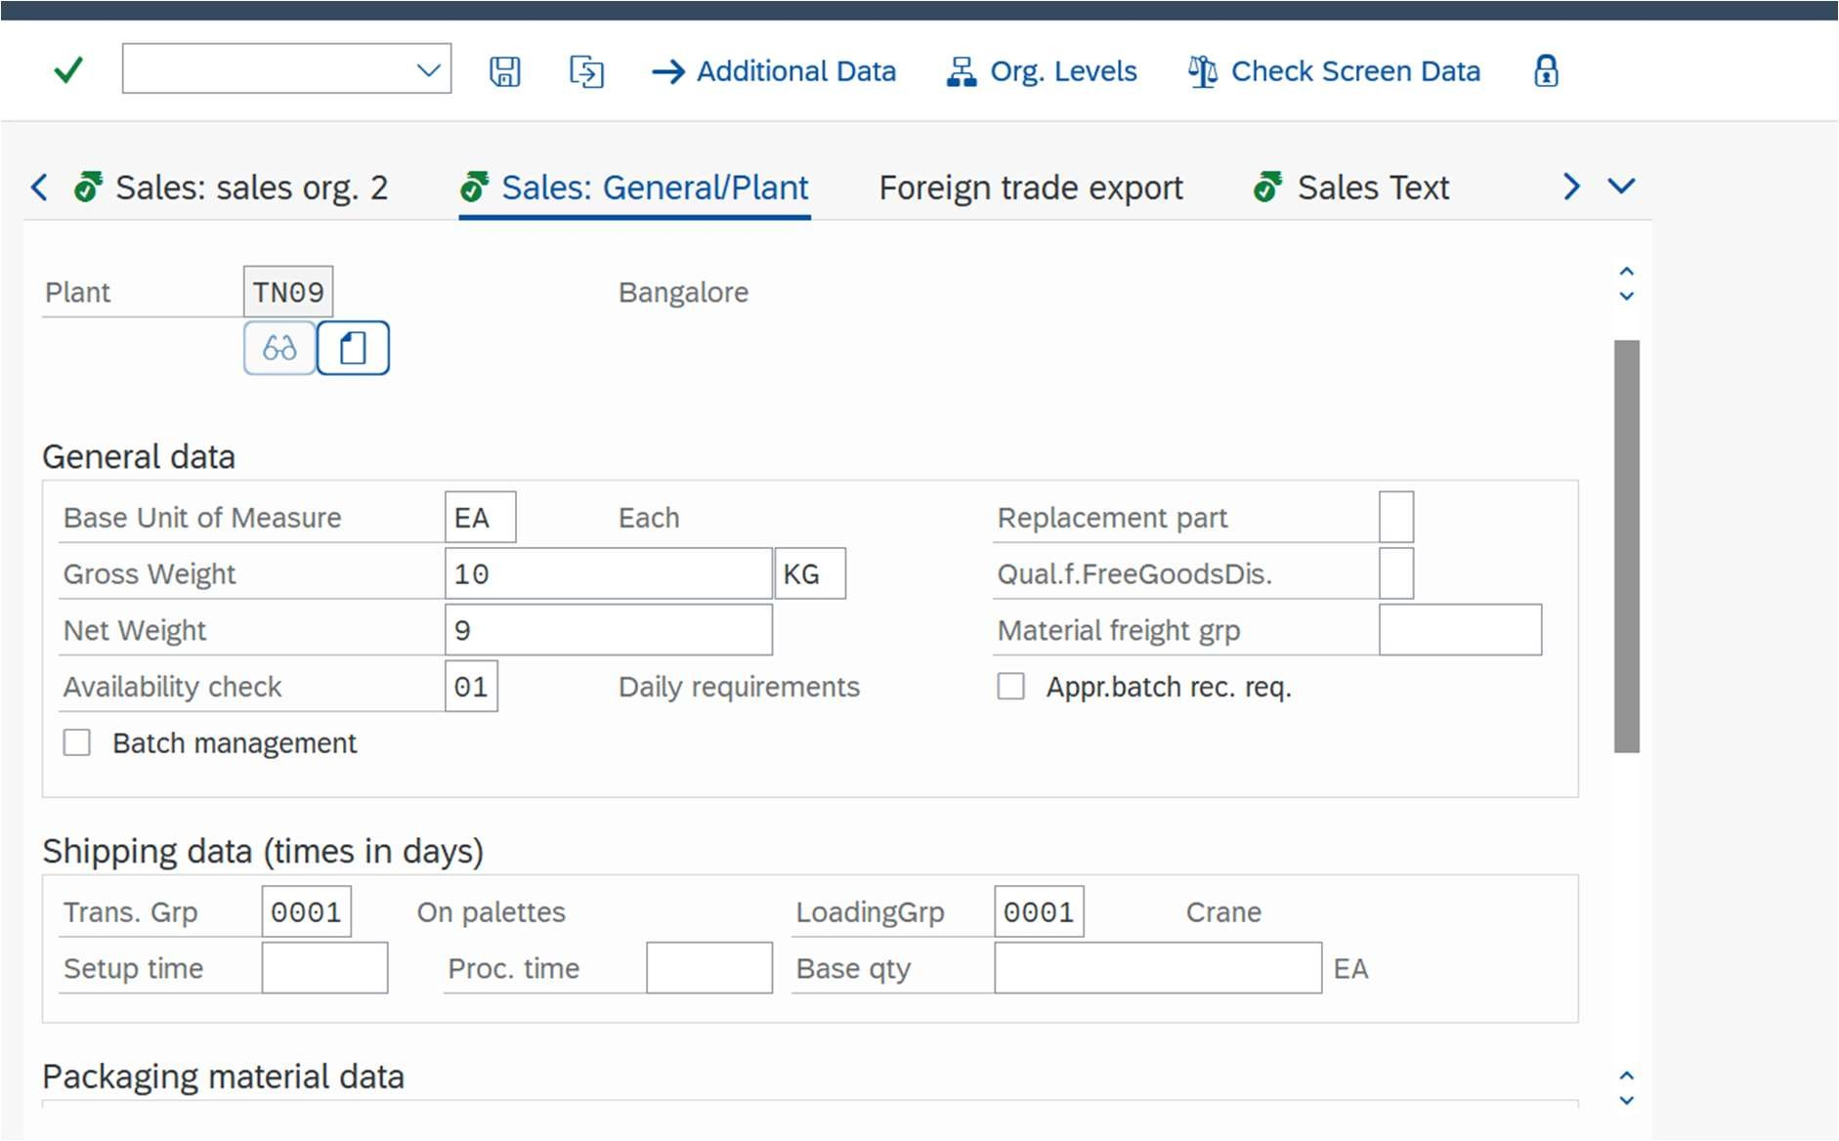

Group of materials with the same

accounting requirements.

To maintain SAP standard

reports.

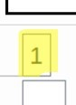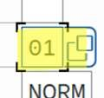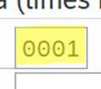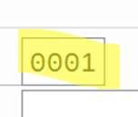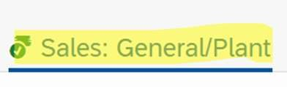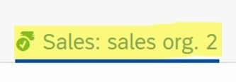

**Transportation Group:** A grouping of materials that share the same route and transportation requirements.

**Loading Group:** A grouping of materials that share the same loading requirements.

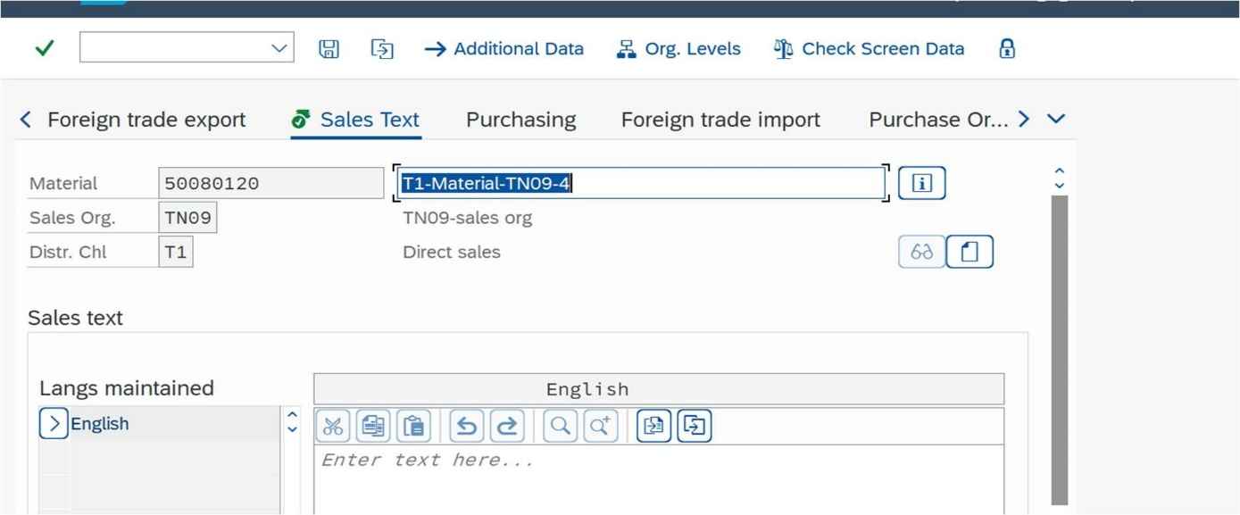

Material description takes only up to 40 characters. If we want to describe beyond that we can specify the details in this sales text and can be pull out for printing.

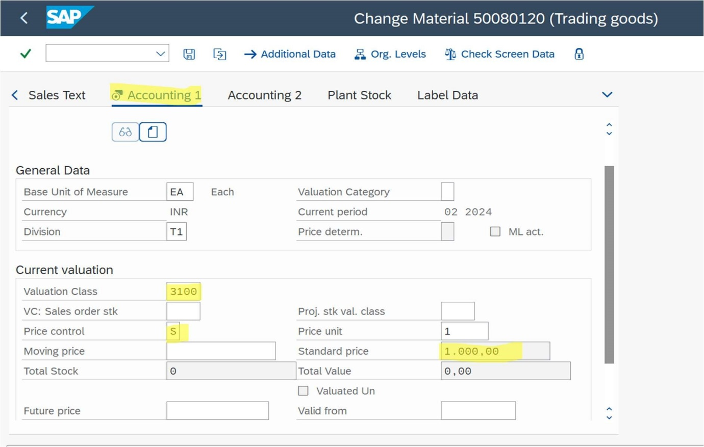

# **Moving average price: Total price/Total Quantity**

Note - To edit any existing view use MM02 and to add a new view in material we have to do it in MM01.

Now, after creating material we must add stock/inventory using MB1C check it in MMBE.

Before adding inventory:

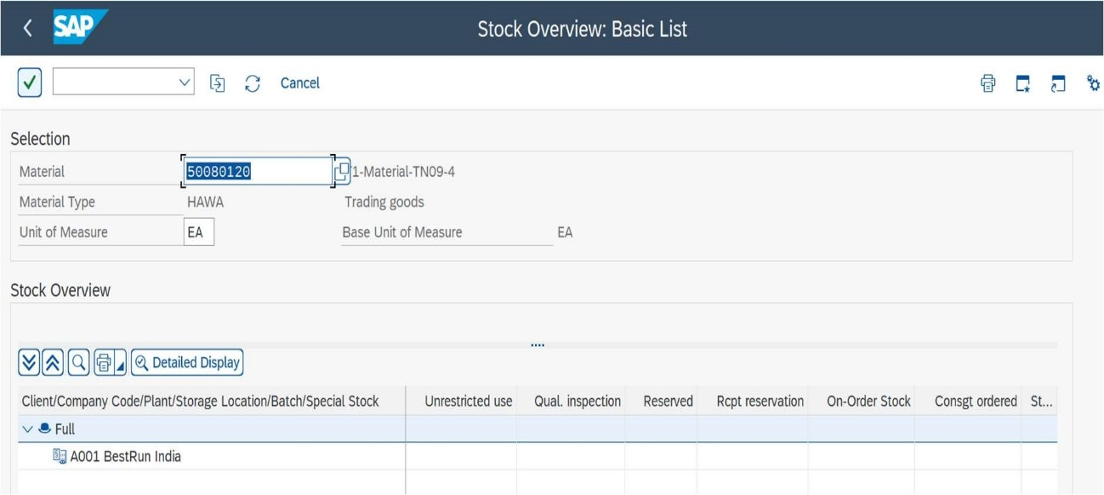

Add stock using MB1C:

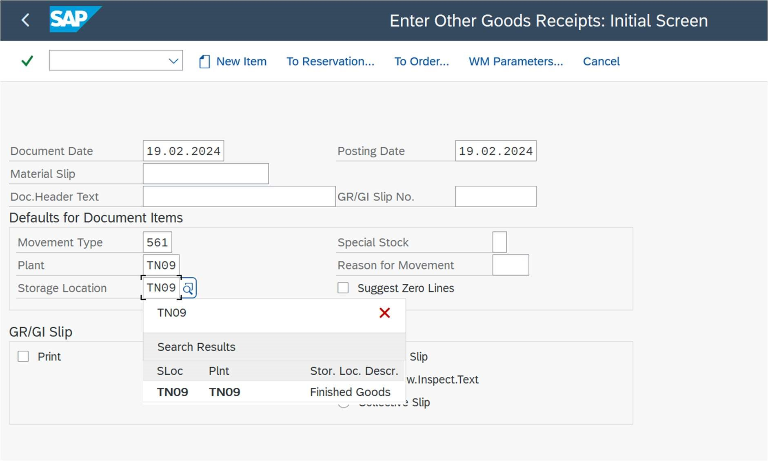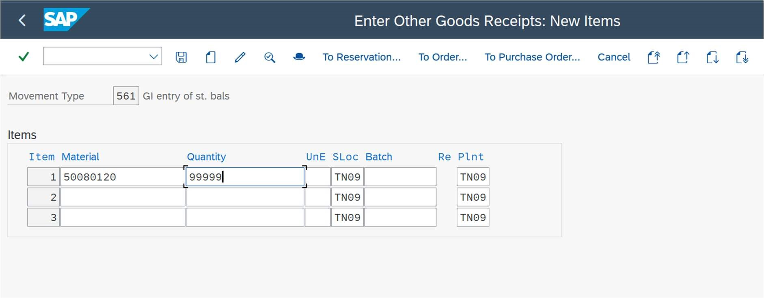

After adding stock:

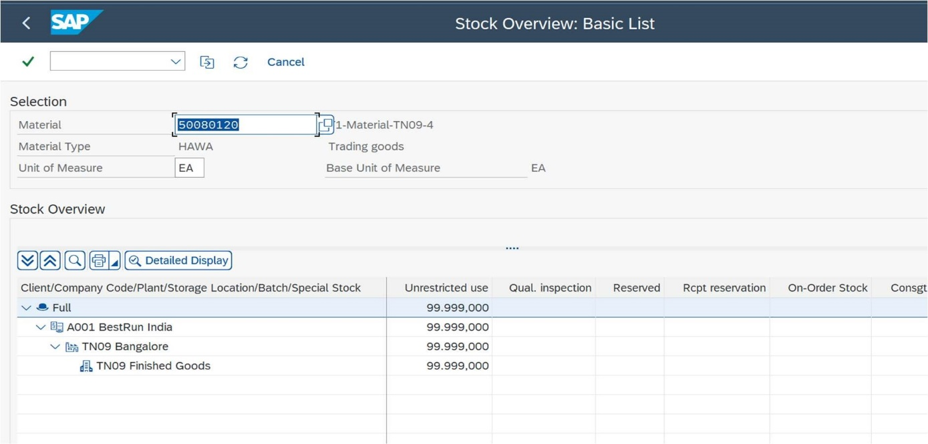

OTC/O2C CYCLE

INQUIRY 🡪 QUOTATION 🡪 ORDER 🡪 DELIVERY 🡪 BILLING

Checking the availability of sales document types like ZIN, ZOR

* SPRO🡪Sales🡪Sales Document🡪Sales Document Header🡪Define Sales Document🡪
* Here, define sales document types is like a library from where we have to pick a document type and then assign sales area
* Sales Document types are created here

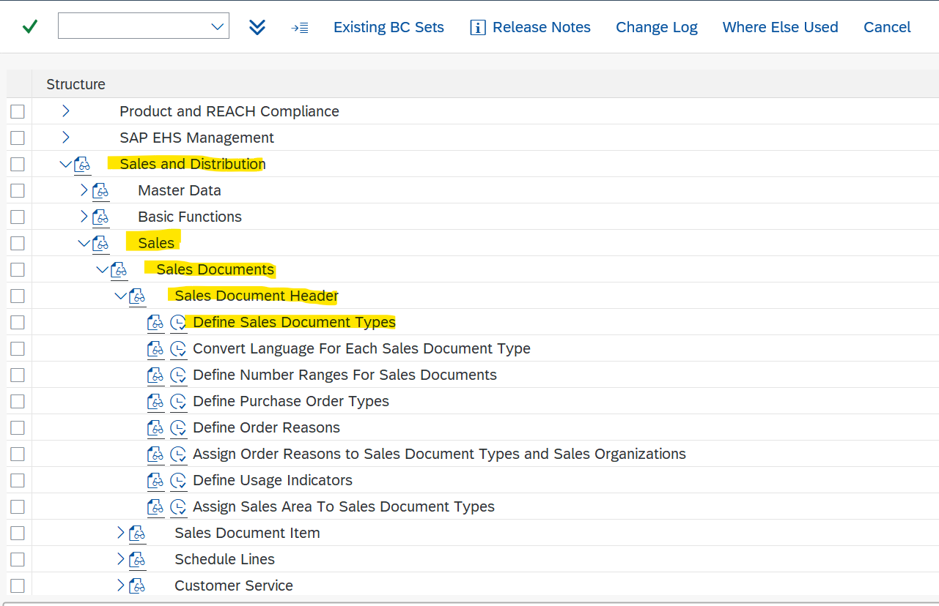

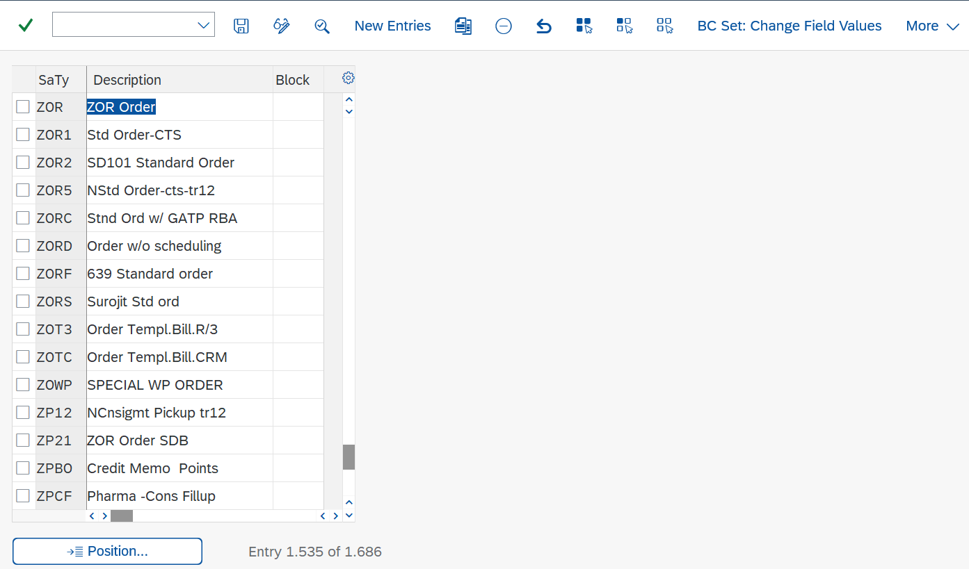

* Copying the sales document types to your sales area

SPRO🡪Sales🡪Sales Document🡪Sales Document Header🡪Assign Sales Area To Sales Document Types🡪Assign sales order types permitted for sales areas🡪go to position and copy the sales document types to your sales area

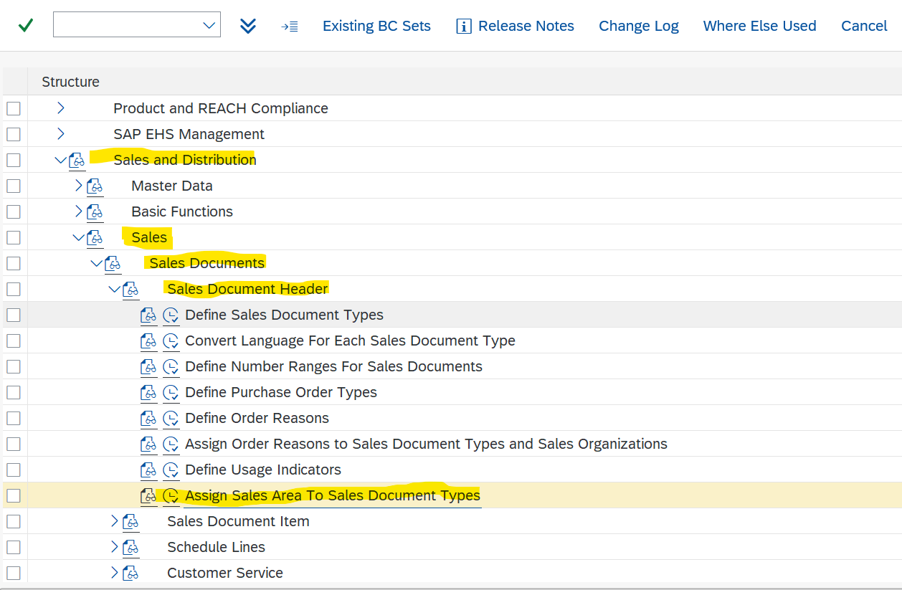

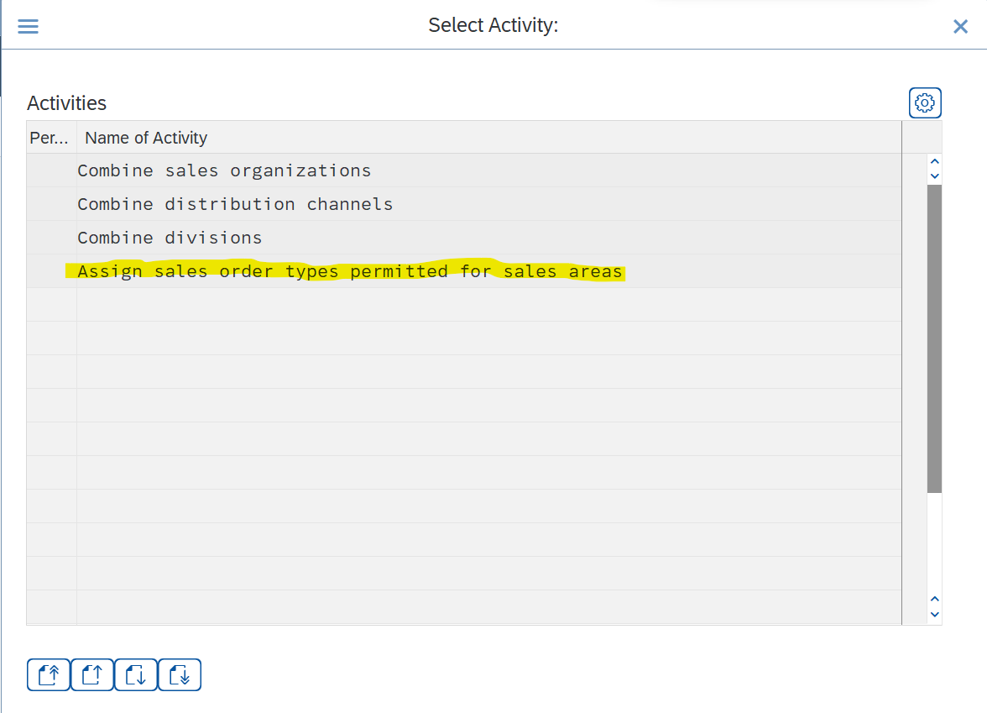

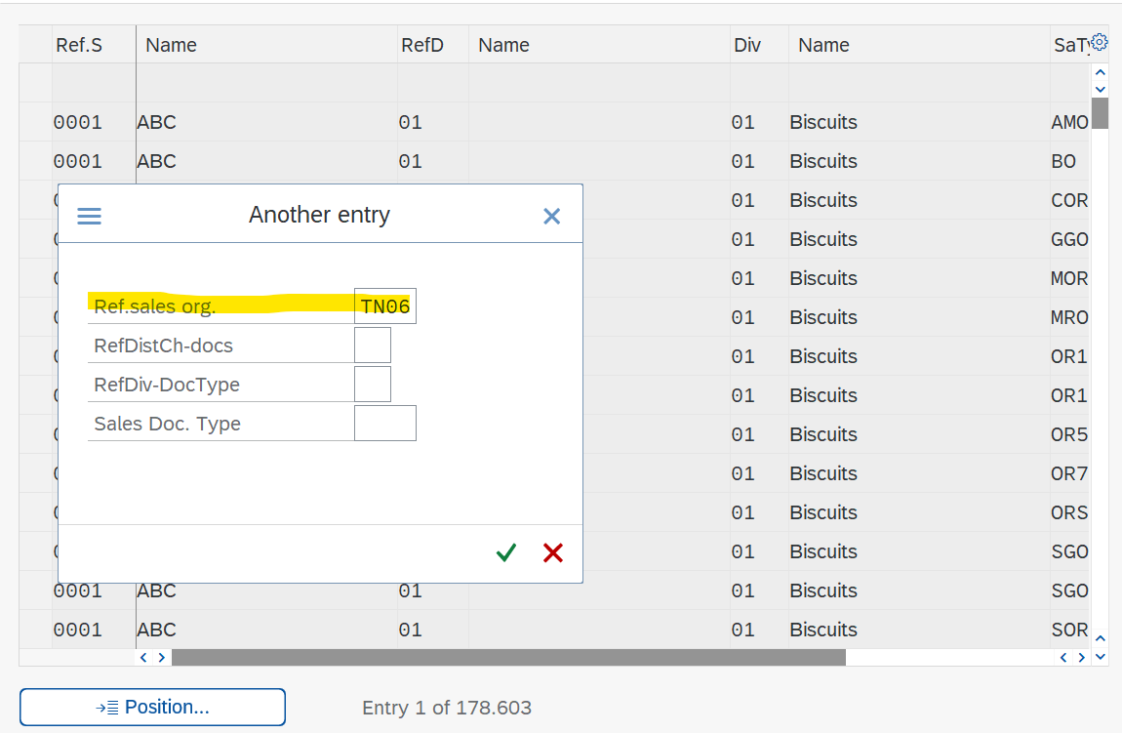

* **INQUIRY (IN)**

VA11🡪to create the inquiry

VA12🡪edit

VA13🡪display

VA15n🡪list of inquiry documents

* + - SPRO🡪Sales and Distribution🡪Basic Functions🡪Pricing🡪 Pricing Control🡪Define and Assign Pricing Procedures🡪Define Pricing Procedure Determination🡪copied ZSK001 to our sales area
    - Any sales is done against the purchase order no. (PO) only
    - Components of a sales document
      * Header
      * Item
      * Schedule Lines
    - Document Header : Configuration till PO Date is called Document Header

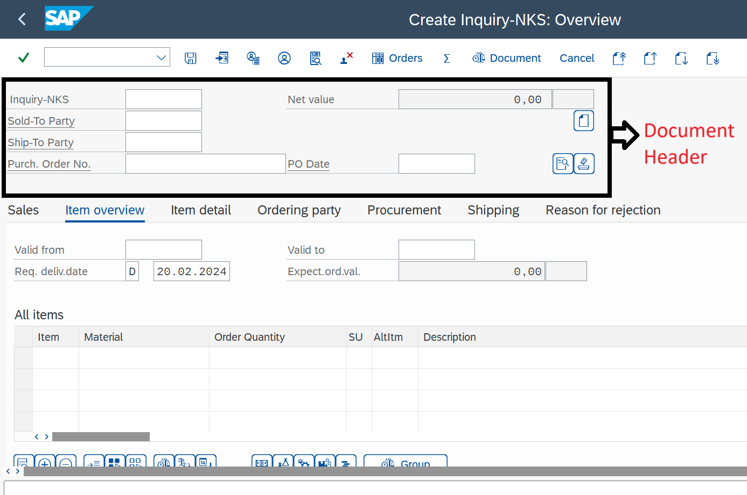

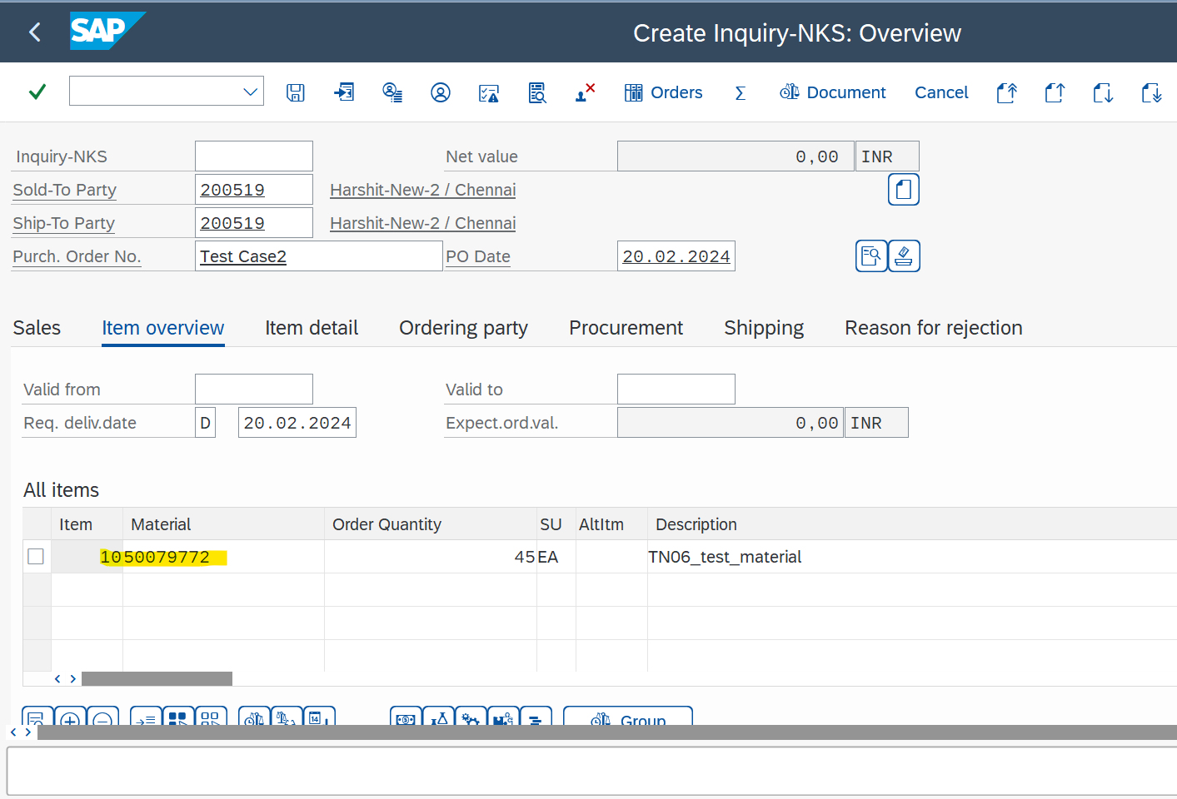

* Document Item: Clicking on material line we can get document item
* Incompletion log : After entering the details go to Edit🡪Incompletion log

It is used to check if anything is pending or not. After checking incompletion log only we should save it

* Schedule line : When it is going to be delivered

Second line comes in schedule lines when the delivery date is in future

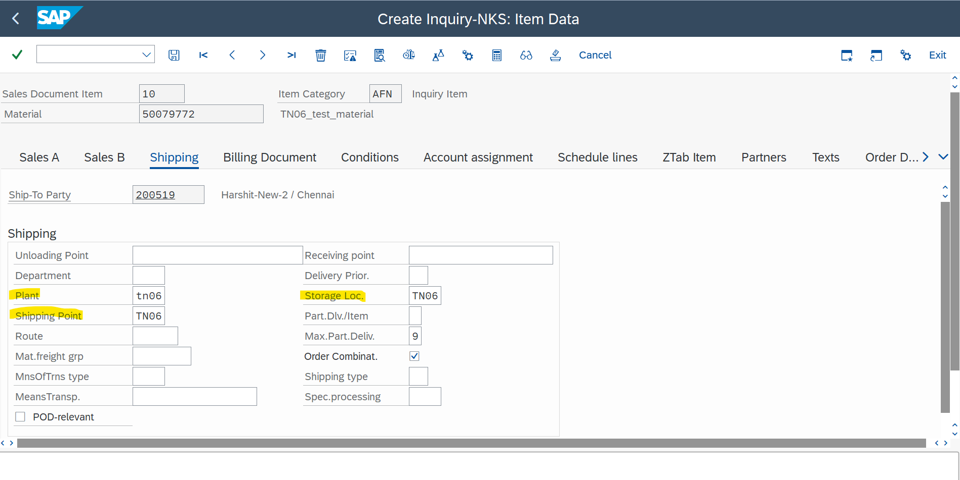

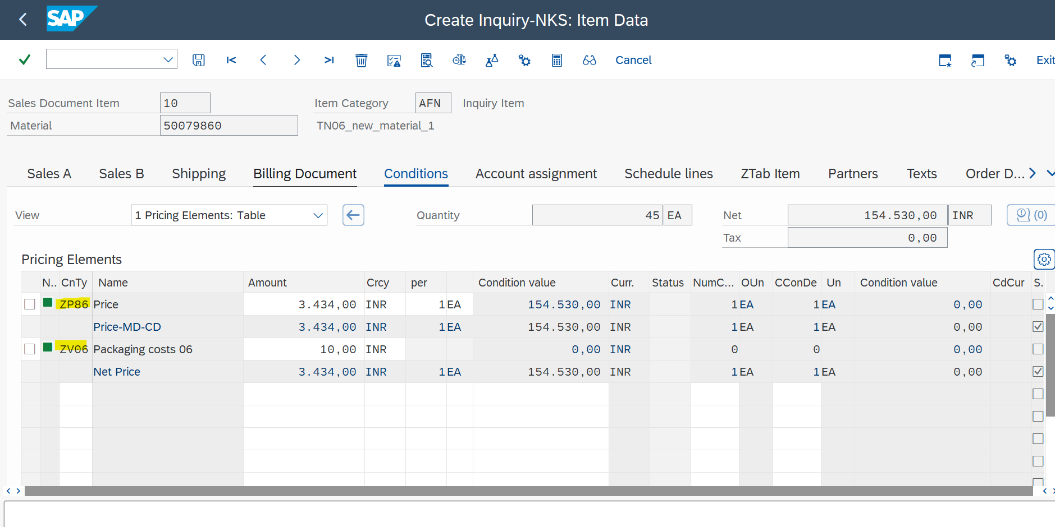

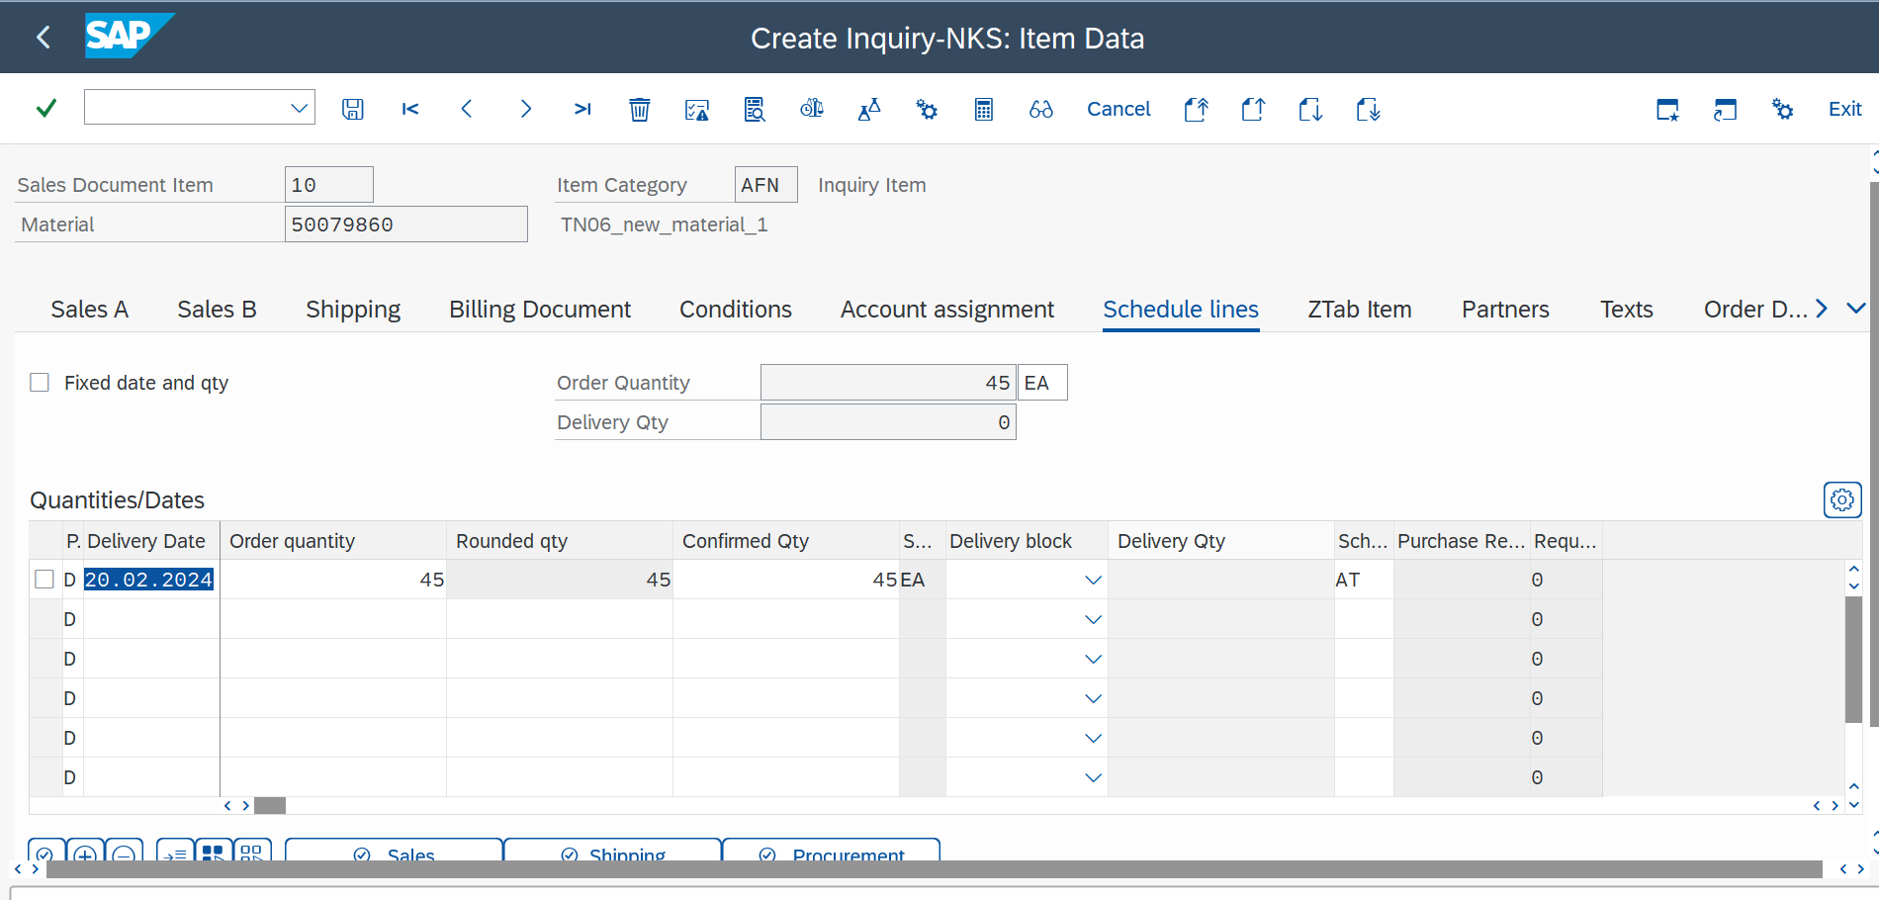

* **QUOTATION (QT)**

VA21 🡪to create

VA22 🡪to edit

VA23 🡪to display

VA25N 🡪to list

* **ORDER (OR)**

VA01🡪to create

VA02🡪to edit

VA03🡪to display

VA05N🡪to list

* **DELIVERY (LF)**

VL01N🡪to create

VL02N 🡪to edit

VL03N 🡪to display

VL06 🡪delivery monitor

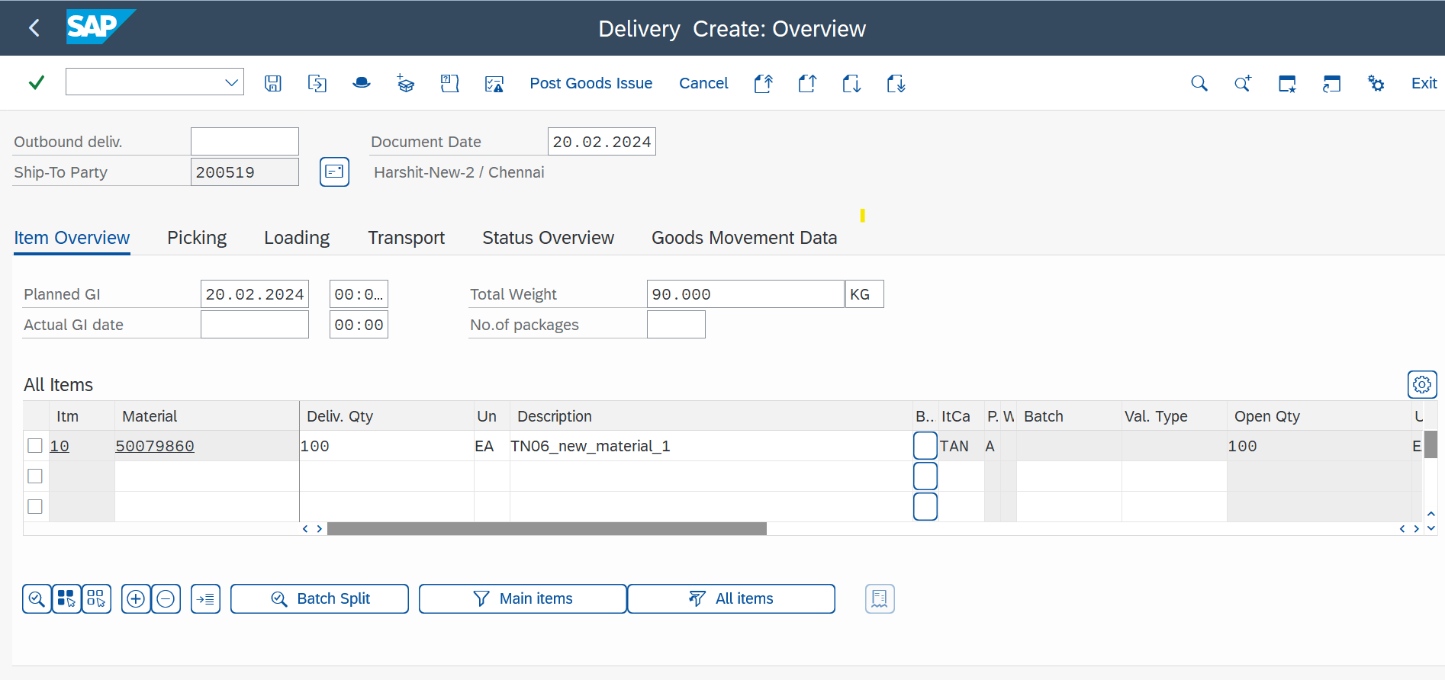

* + - Components in delivery

Picking the delivery – Delivery quantity and picked quantity should be same

Post Goods Issue – If the accounting entries is done the goods is posted

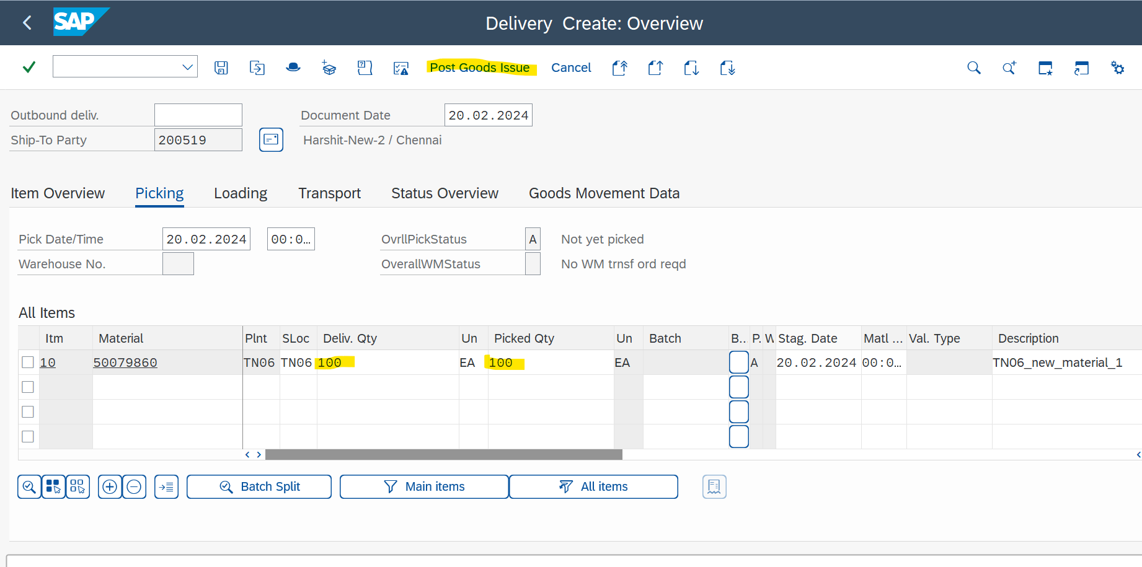

* + - Viewing Material Document from delivery document

Go to the document flow 🡪 Goods Issue + Display document 🡪Accounting Document

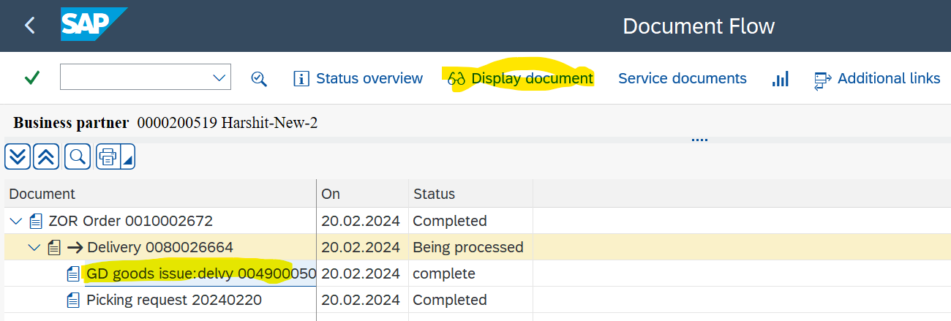

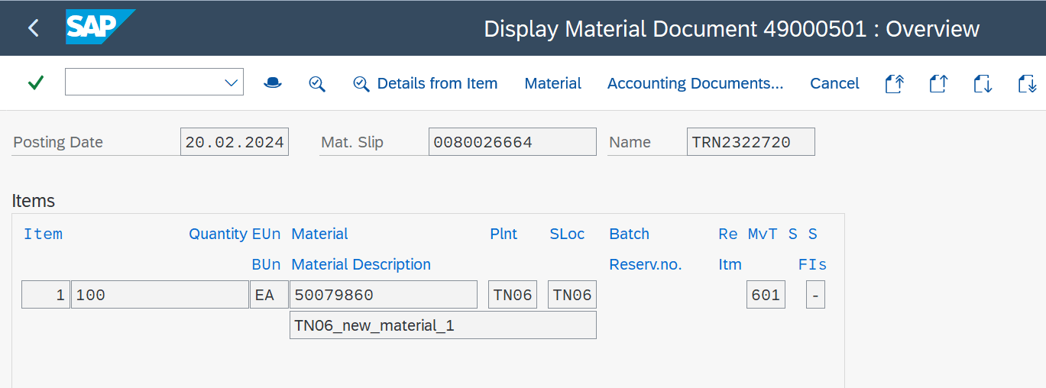

* + - Viewing Sales Order Document from delivery document

Document flow 🡪 Sales Document + Display document

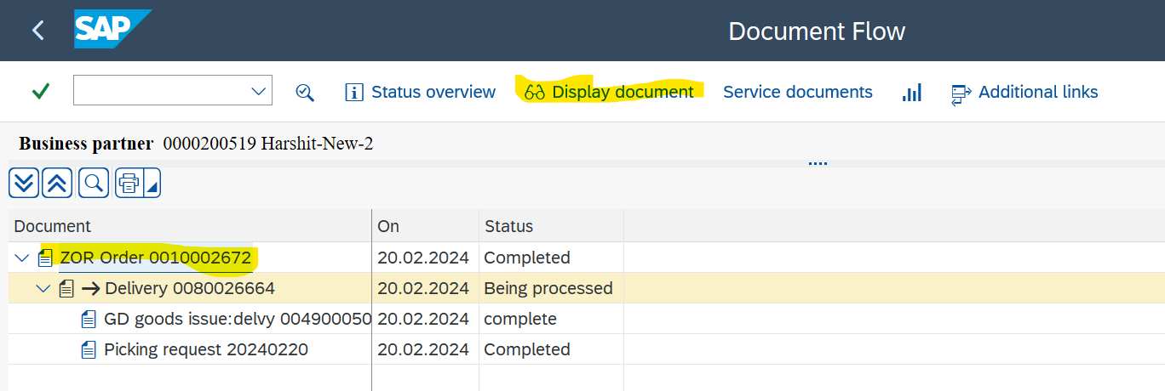

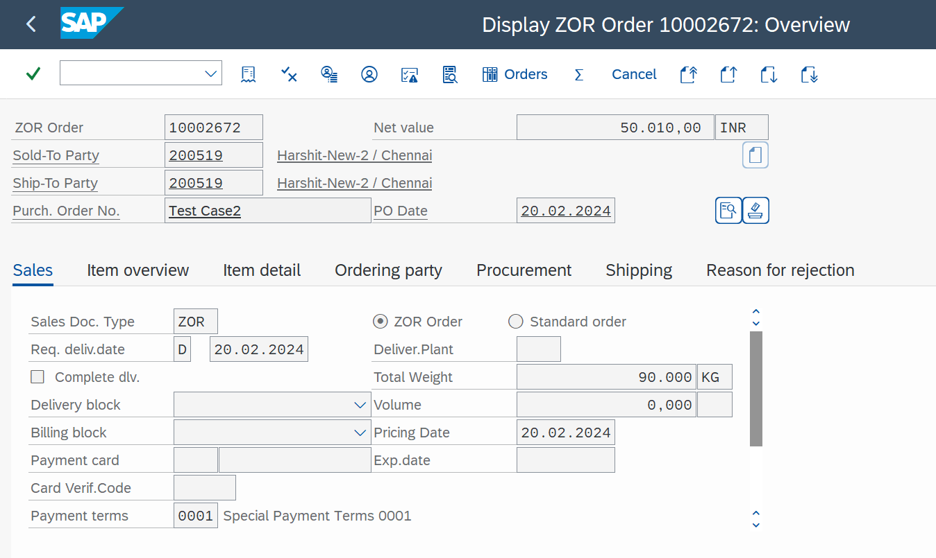

* **BILLING (F2)**

VF01🡪to create

VF02🡪to edit

VF03🡪to display

VF05N🡪to list

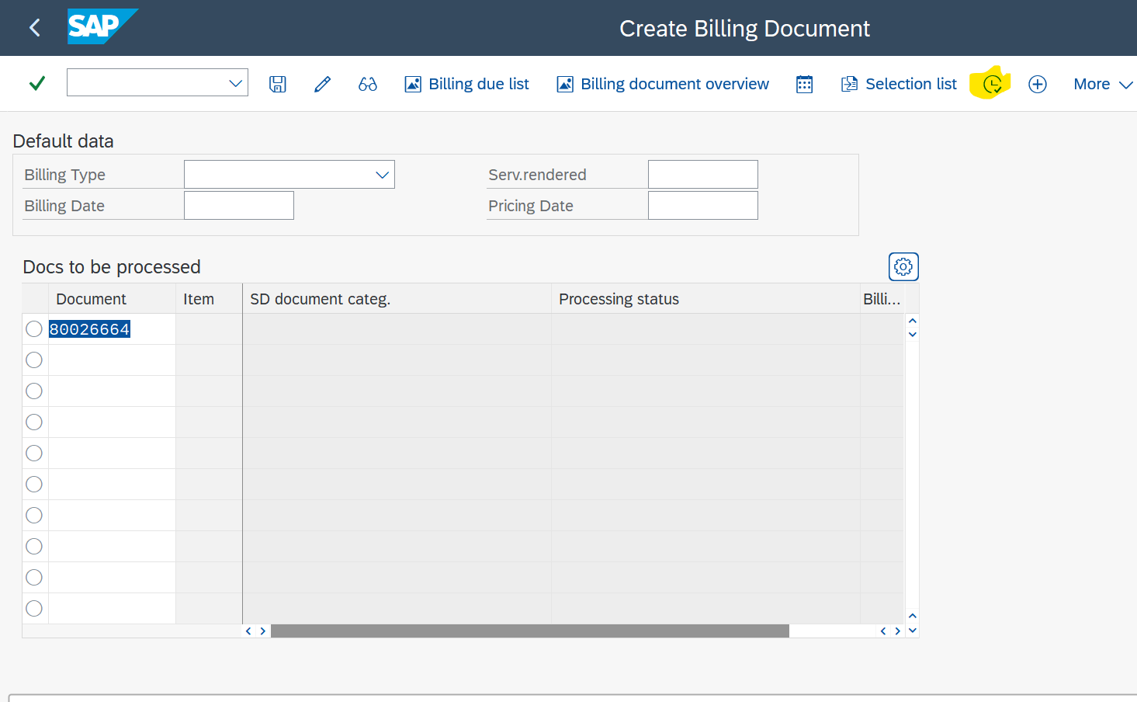

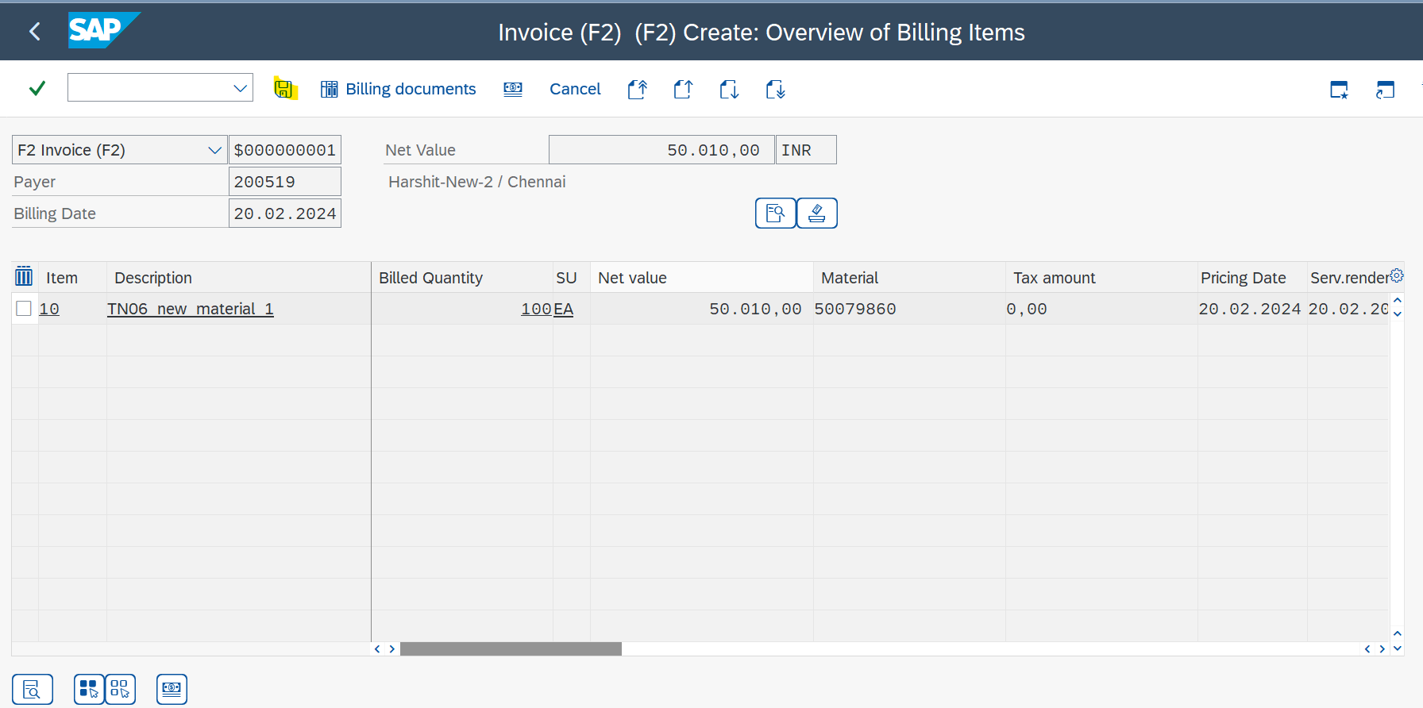

* **SHIPPING POINT DETERMINATION**

SPRO🡪Logistics Execution 🡪Shipping🡪Basic Shipping Functions🡪Shipping Point and Goods Receiving Point Determination🡪Assign Shipping Points🡪Position🡪Shipping condition-01, Loading Group-0001, Plant

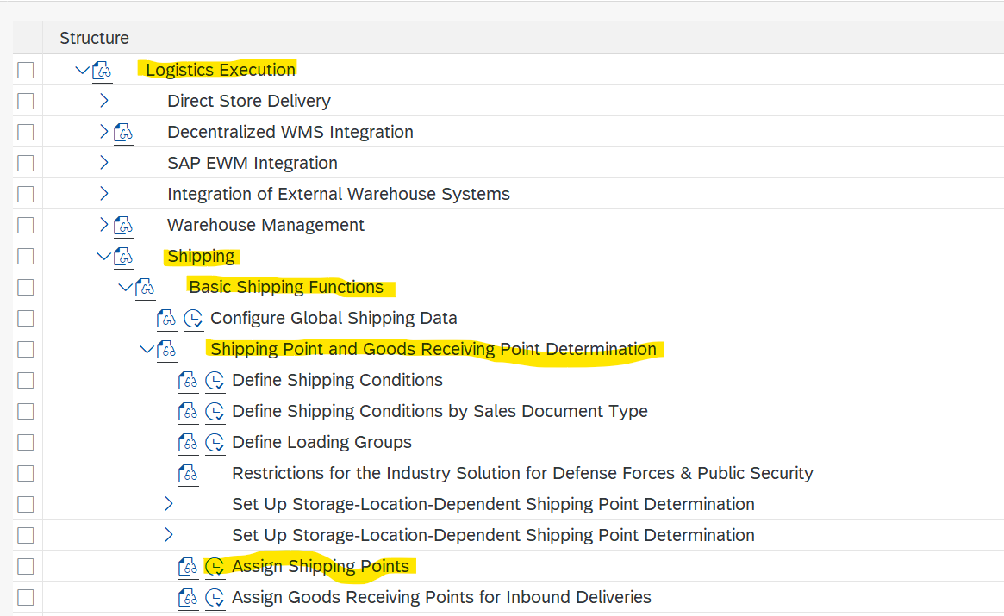

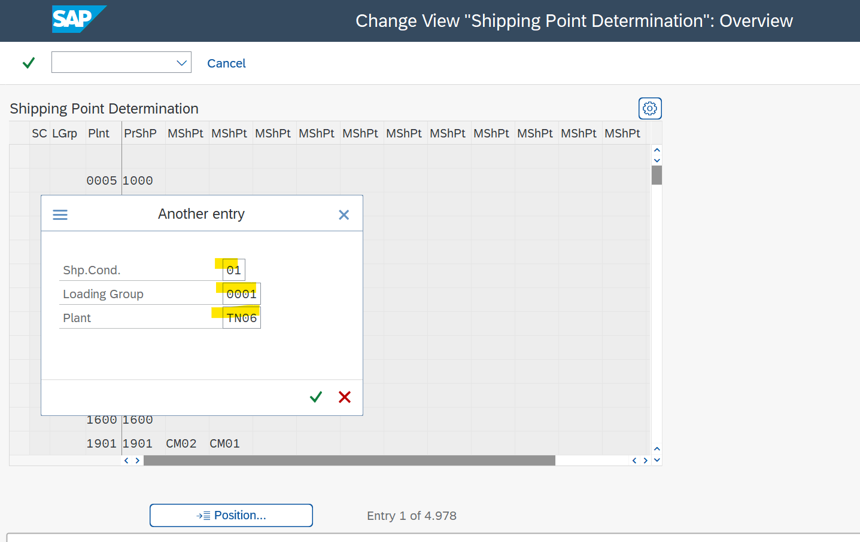

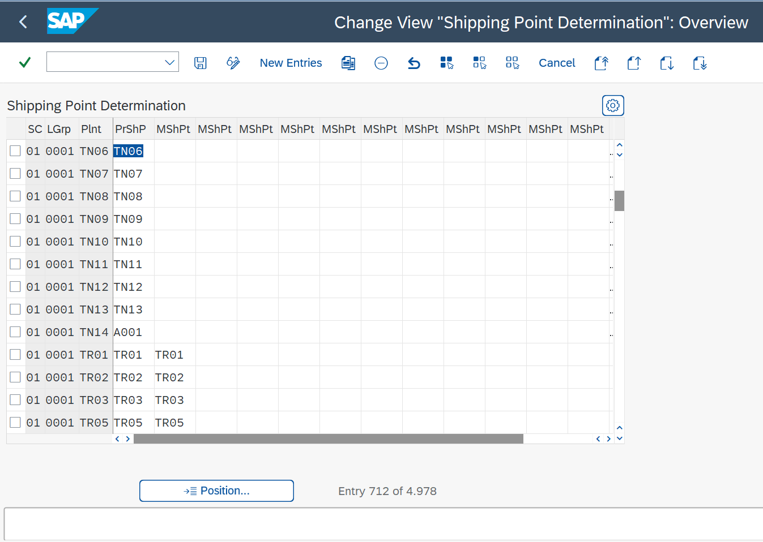

CMIR

**Customer Material Info Record (CMIR): -**

**T - Code**

Create - VD51

Edit - VD52

View - VD53

List - VD59

Note: - To copy anything in SAP use CTRL+Y

CMIR is used to connect legacy system to new system.  
  
While creating CMIR after entering material no. and Customer material click on detail button to add additional details.

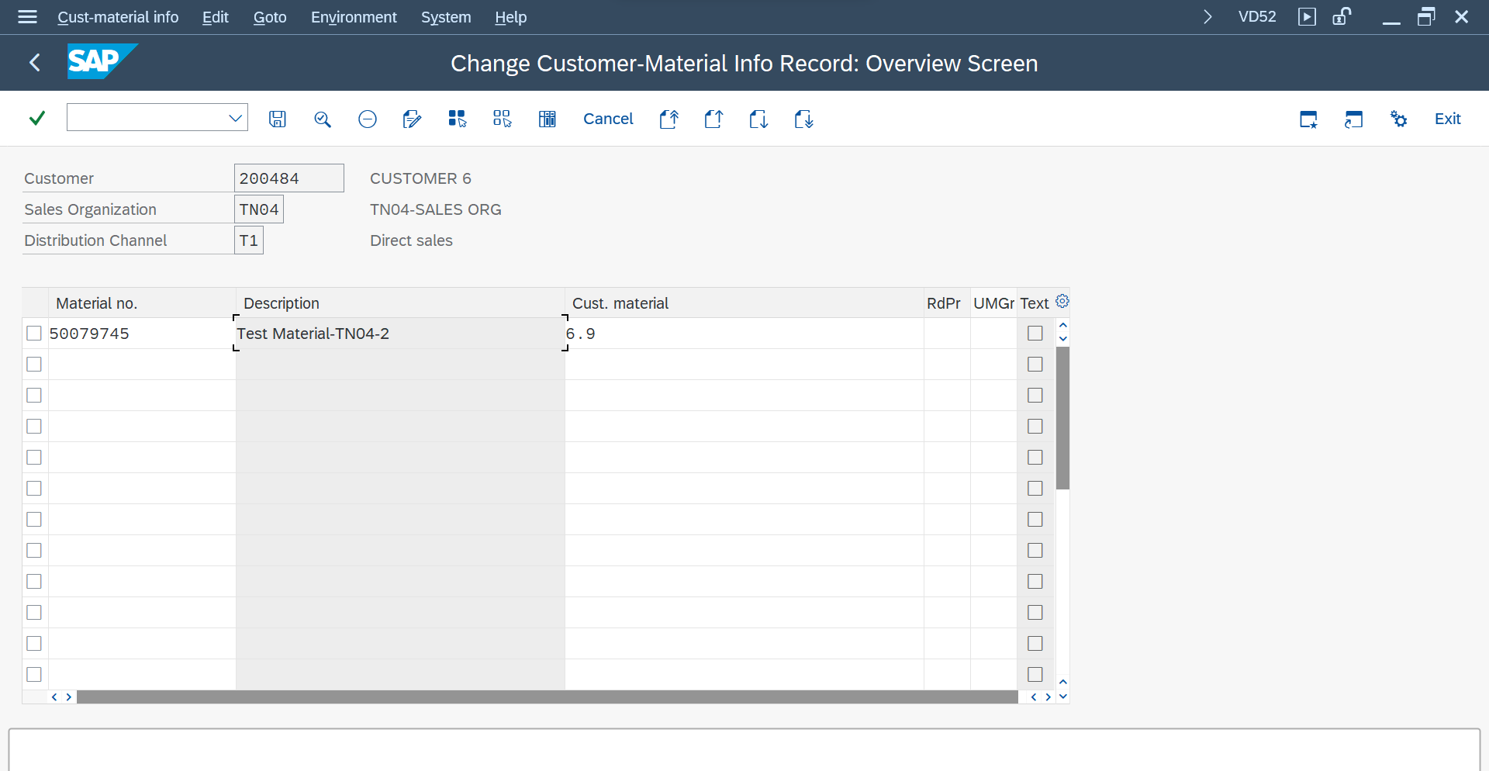

Following details can be added or edited in detail tab of CMIR  
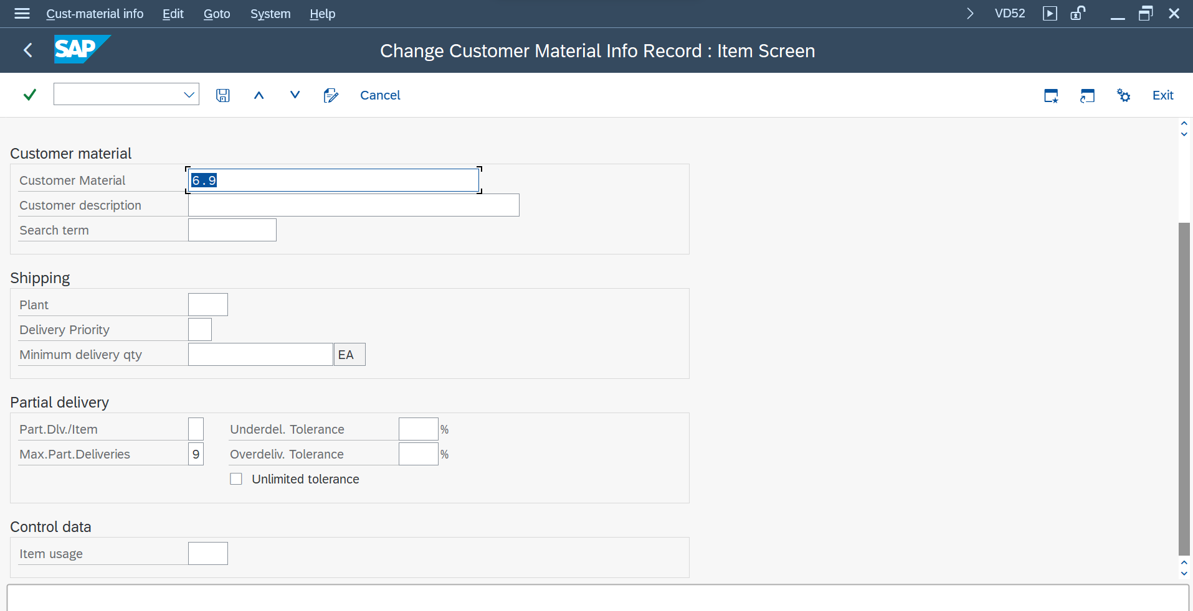

**Q) Where/How is the plant defaulted and what is the hierarchy?**  
A) It is defaulted in CMIR. Plant given in CMIR has precedence that any other place like customer master or material master.

SALES DOCUMENT TYPE

**Sales Document Type: -**

**Path -** SPRO->Sales and distribution->Sales->Sales Documents->Sales document header->Define sales document types

Checks and controls in sales document (ZOR): -

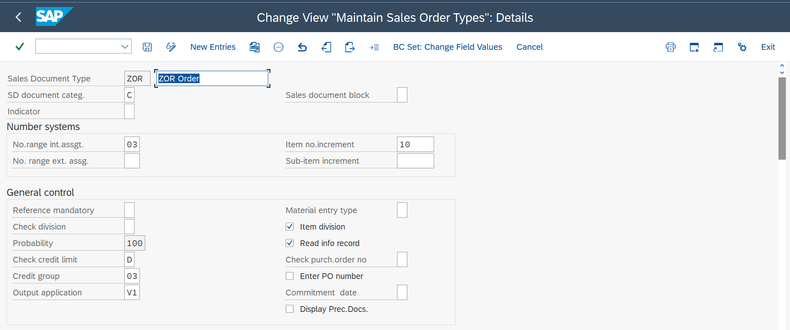

* Sales Document block - To block the order (key=X)
* Item No. increment - Increments the item with the given number.
* Reference mandatory - Without reference order cannot be created.
* Item division check box - order cannot be created from another division if this is selected.
* Order probability - for converting the % of order quantity to billing.
  + e.g. - if 100% order probability all the order quantity will be sent for delivery and billing.
* Read info record check box - It will read the info record (CMIR).
* Check purchase order no. - Will not allow to create duplicate purchase order number.

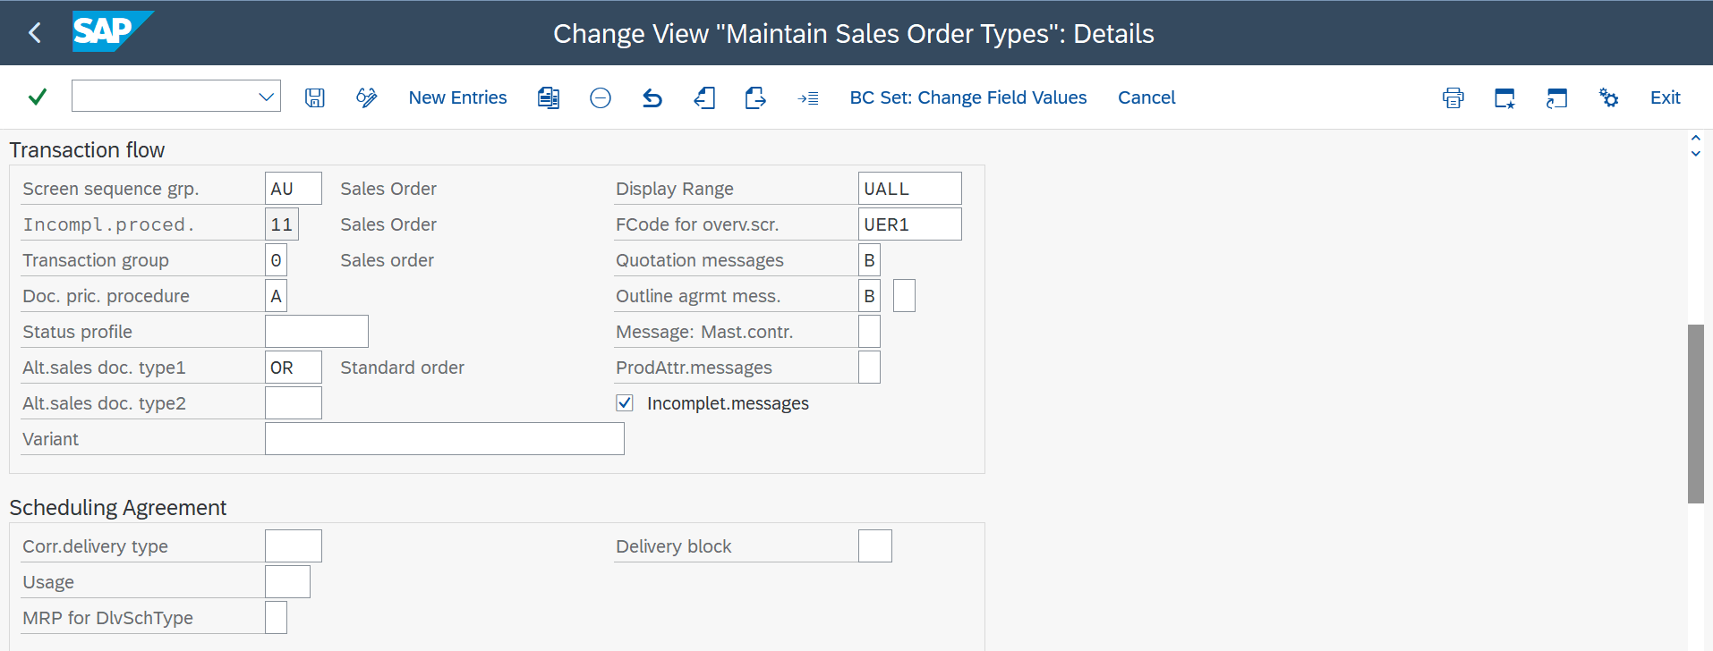

* Incompletion procedure - Follows the given incompletion procedure.
* Doc. Pricing Procedure: - Without this pricing won’t work (It is assigned in pricing procedure determination.)
* Status Profile: - Authorization at different levels
* Alternate sale document type1/type2 - within order to access another document type.

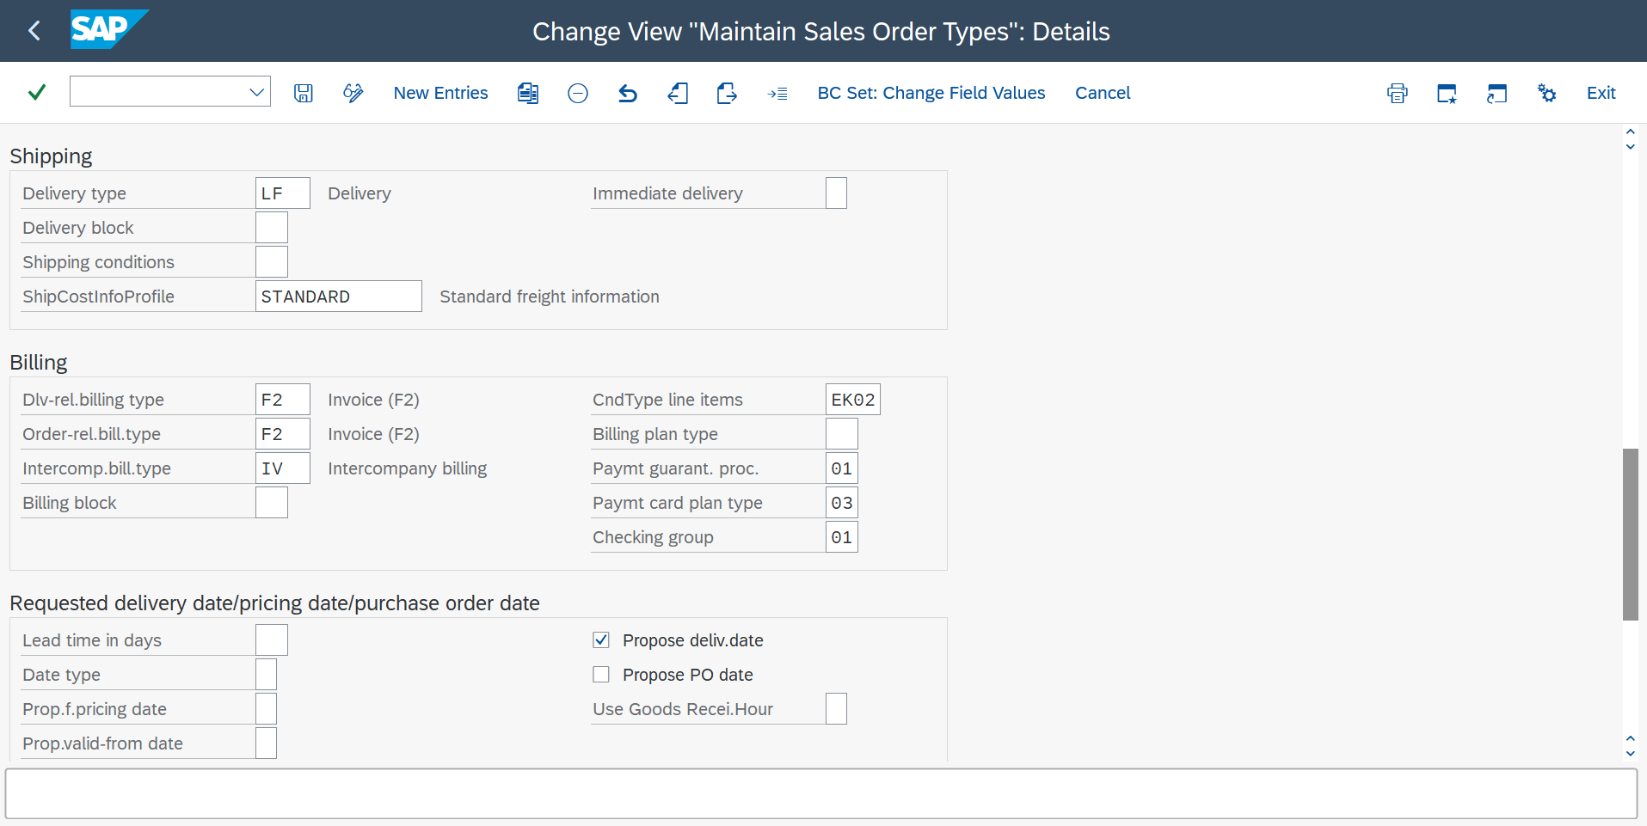

* Delivery type - determines the type of delivery (LF).
* Billing type - Determines the billing type (F2).
* Lead time in days - Effects the delivery date based on the given days.  
  e.g. - if 2 days is given as lead time delivery date is given as 2 days.
* Propose delivery date check box - Propose delivery date.

**Different document types -**1) Cash Sales (CS)

2) Rush Order (RO)

3) Credit Note (TR) (Order related billing (No delivery))

4) Debit Note (DR) (Order related billing (No delivery))

5) Consignment fill-up (CF)

6) Consignment Issue (CI)

7) Consignment Returns (CO)

8) Consignment pick-up (CP)

9) Return Order (RE)

10) Scheduling Agreement (DS) (T-code=VA31)

11) Quantity Contract (QC) (T-code=VA41)

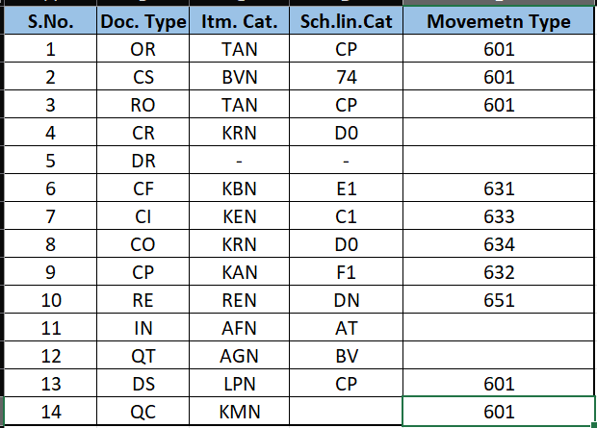

PRICING PROCEDURE

Pricing procedure works on condition technique.

Condition technique is nothing but specific to general.

**Specific** – For some person or party, same product with different prices.

E.g. –

Specific

General

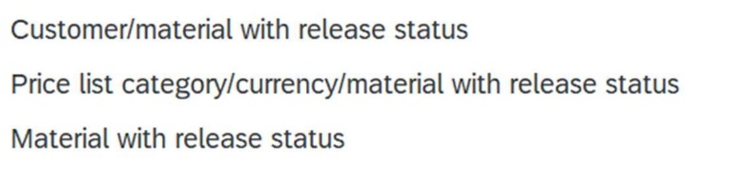

**General** – Normal price for everyone. Whoever comes same price.

An invoice consists of two conditions that are header conditions and price conditions.

Header of an invoice consists of header conditions and other header information that are applicable for the whole invoice irrespective of the product purchased. E.g. – Company details, Insurance details…etc.

Price conditions contains pricing components or condition types.

E.g. – Price, discount, taxes etc

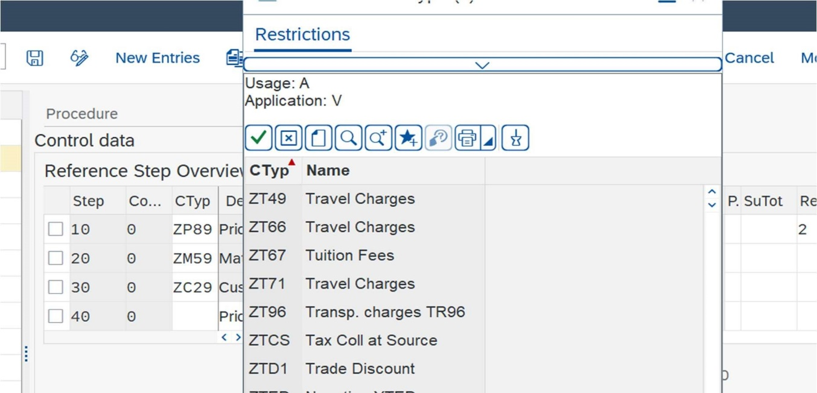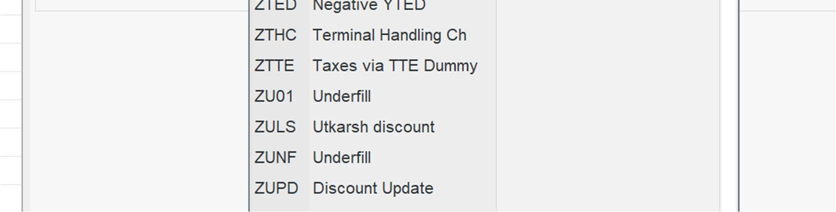

|  |  |  |
| --- | --- | --- |
|  | |  | | --- | | Header area, consists of header condii ons | |
| |  | | --- | | Price components or condi on types | |

**Access Sequence**

It contains of condition techniques/Key combinations. Access sequence is a search criterion for assigning price to a automatic condition type.

|  |  |
| --- | --- |
| For manual conditions there is no need of Access Sequence, but for automatic pricing | |
| conditions access sequence is a must. |  |

We must maintain the manual or automatic condition in two places, i.e., 1. Condition type and 2. Maintain pricing procedure.

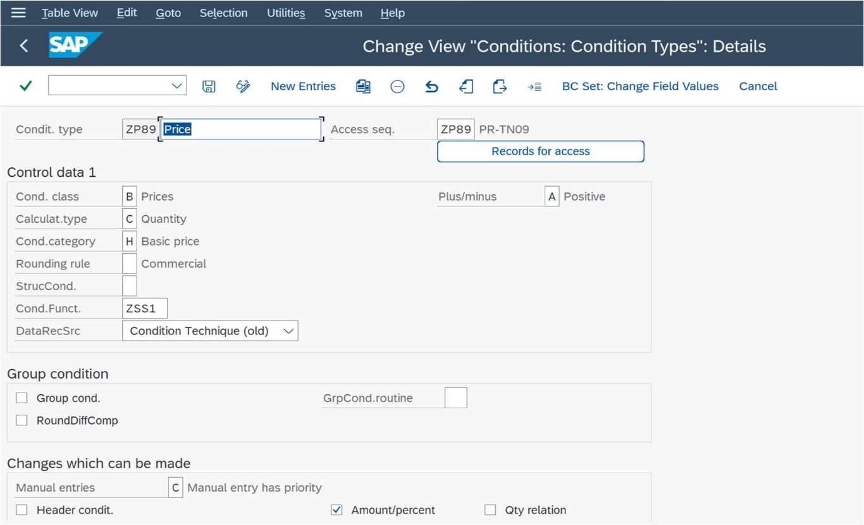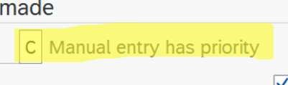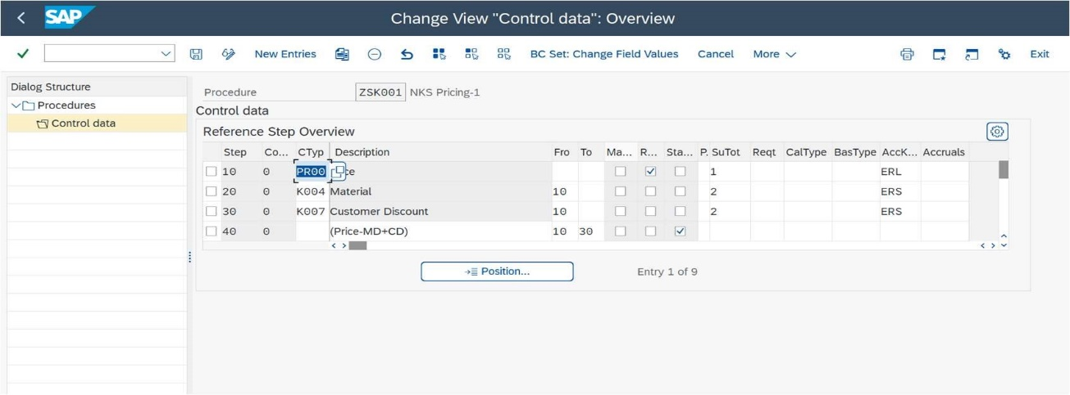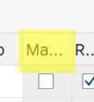

Steps to create our own pricing procedure

SPRO -> SD -> Basic Functions -> Pricing -> Pricing control

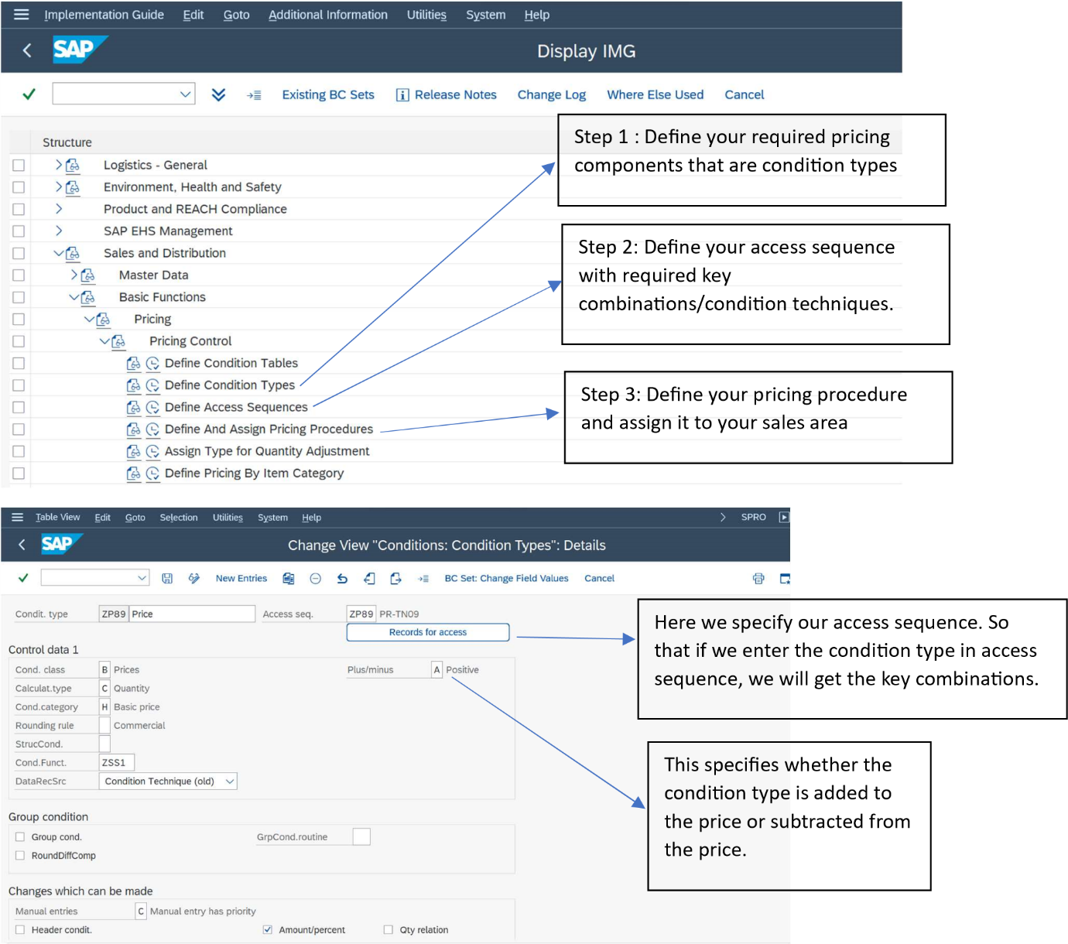

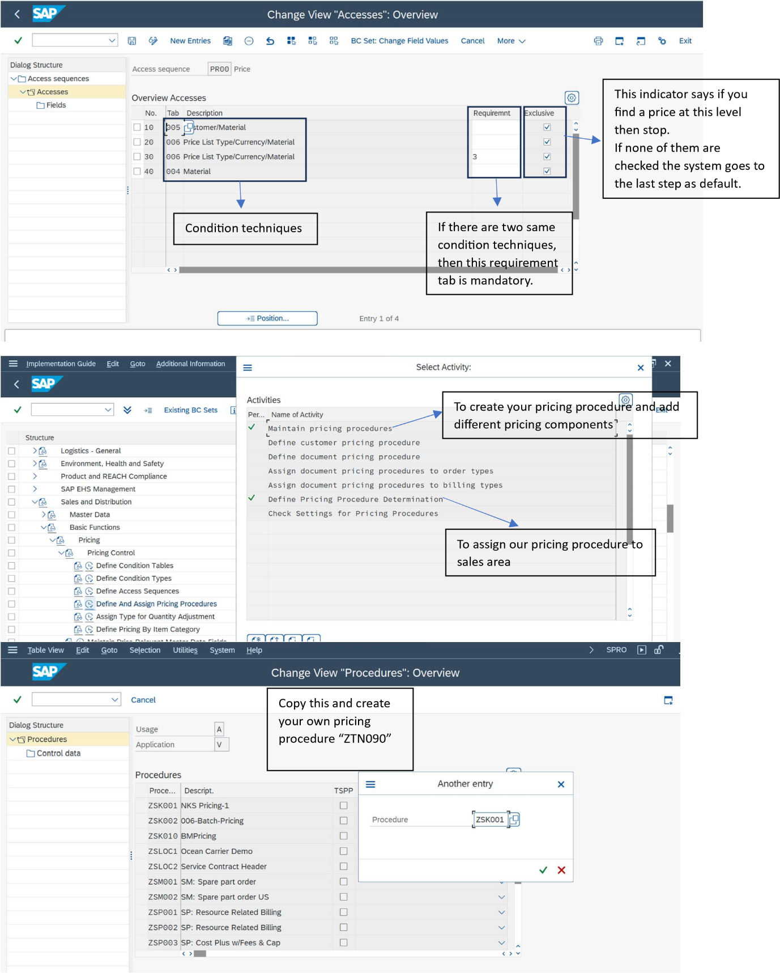

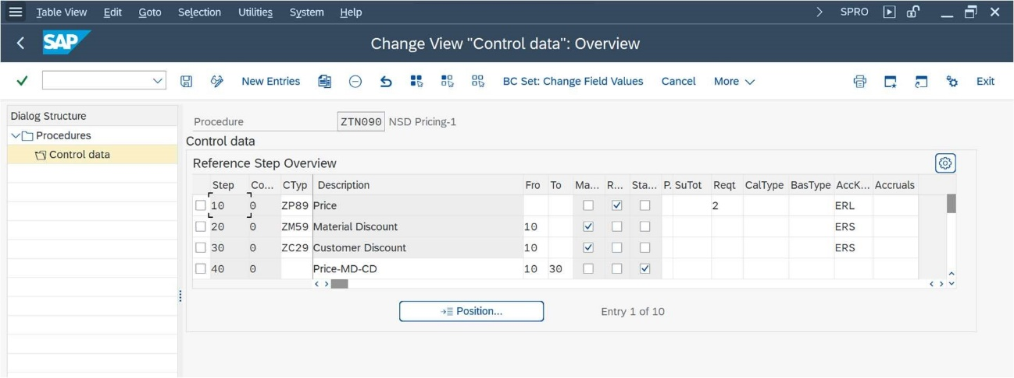

After completing the above process give price to automatic pricing components using “VK11”

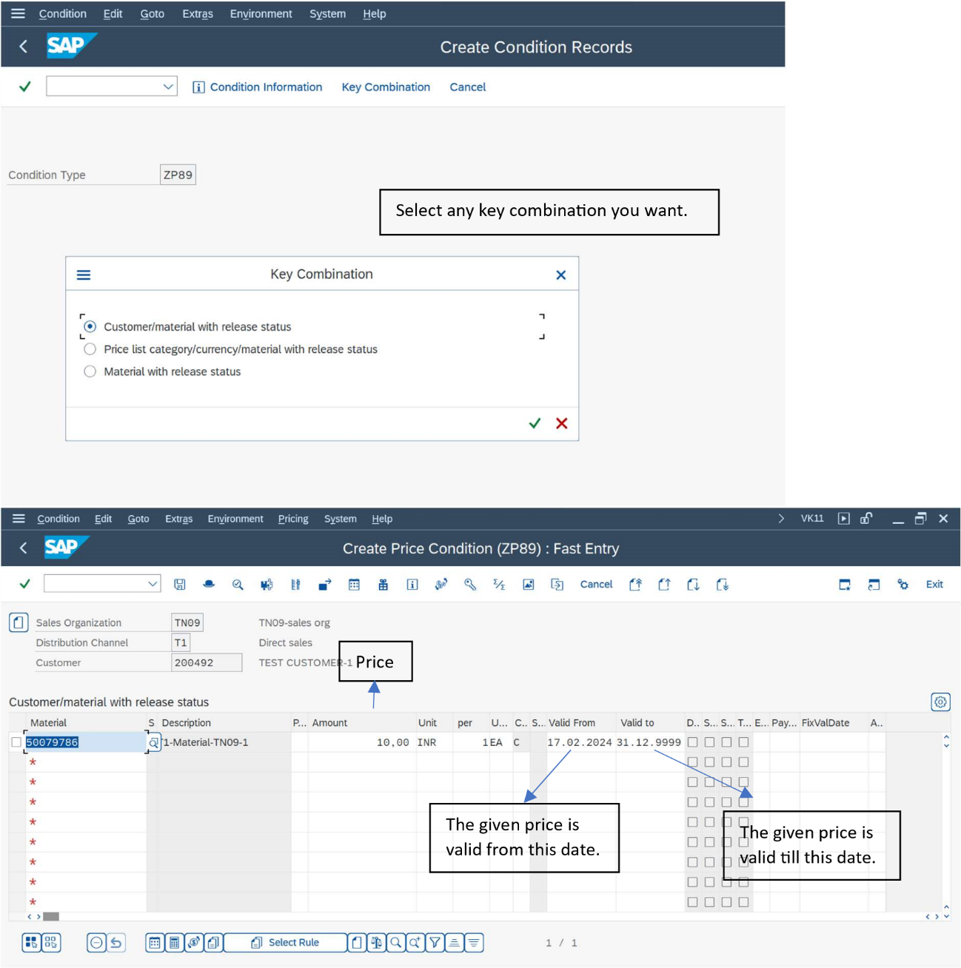

|  |  |
| --- | --- |
| Pricing can never be deleted from the records. We can just give a new price and deactivate the | |
| old one using new dates. |  |

To check if the pricing is working properly or not, we can go through the analysis option in the sales order.

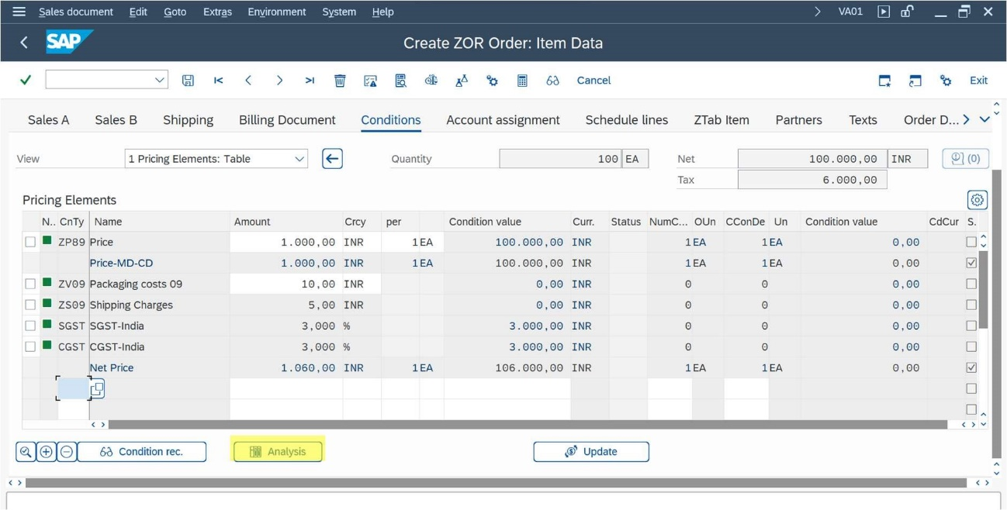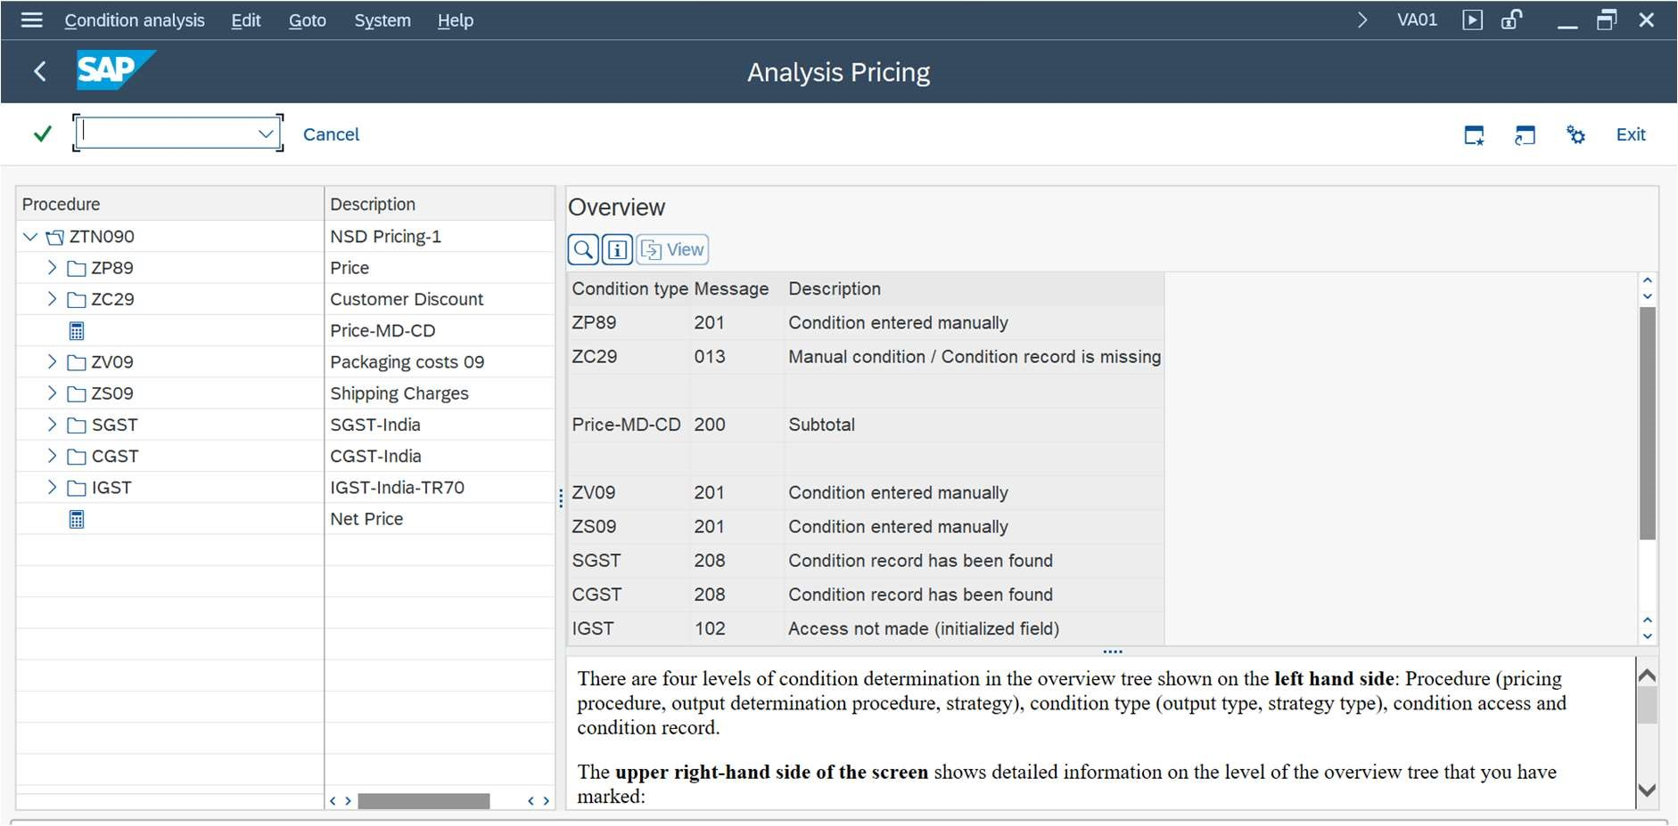

FREE GOODS

**T - Codes -** VBN1(Creating Free Goods)

**Path -** Spro -> sales and distribution -> basic function -> free goods ->

condition technique for free goods -> Activate free goods determination

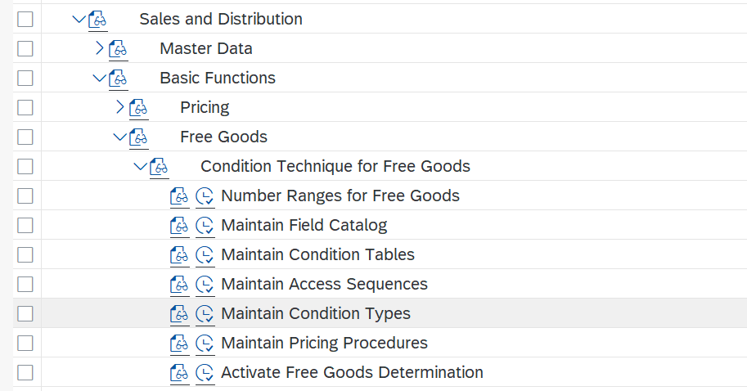

Two types of free goods

Inclusive -> if the free quantity lies within the order quantity.

Exclusive -> if the free quantity lies outside the order quantity.

Calculation Rules in free goods -

**Pro rata -** Interprets the free goods quantities as a proportional agreement.

**Unit Reference -** Interprets the free goods quantities as being related to number of units.

**Whole Unit** **-** Grants to free goods only if whole units are ordered.

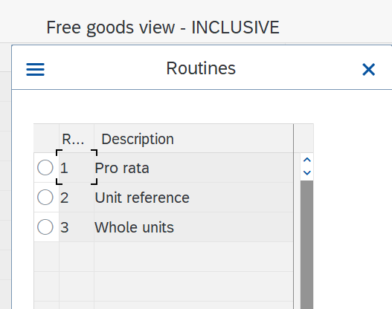

**Free Goods Determination -** Sales area + Document pricing procedure + customer pricing procedure

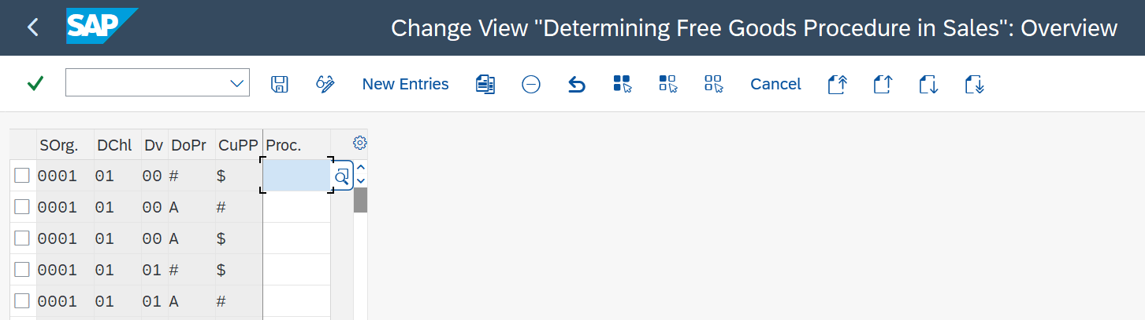

CREDIT MANAGEMENT

Credit management have two types

• Simple

• Automatic credit check

**Simple credit check**

We can block only at order level.

There is no risk management.

System only consider receivable.

**Automatic credit check**

Here we can block at order level, delivery level, PGI level also.

Risk management is there.

• Low risk – can block this at pgi level.

• Medium Risk – can block at delivery level.

• High risk – block at order level.

system consider:

• Open order

• Open delivery

• Open billing

• Open item

**Credit process**

* Centralized credit process – different company code have only one credit control area.
* Decentralized credit process- different company code have different credit control area.

T Code

FD32 = Where we give credit limit of a customer.

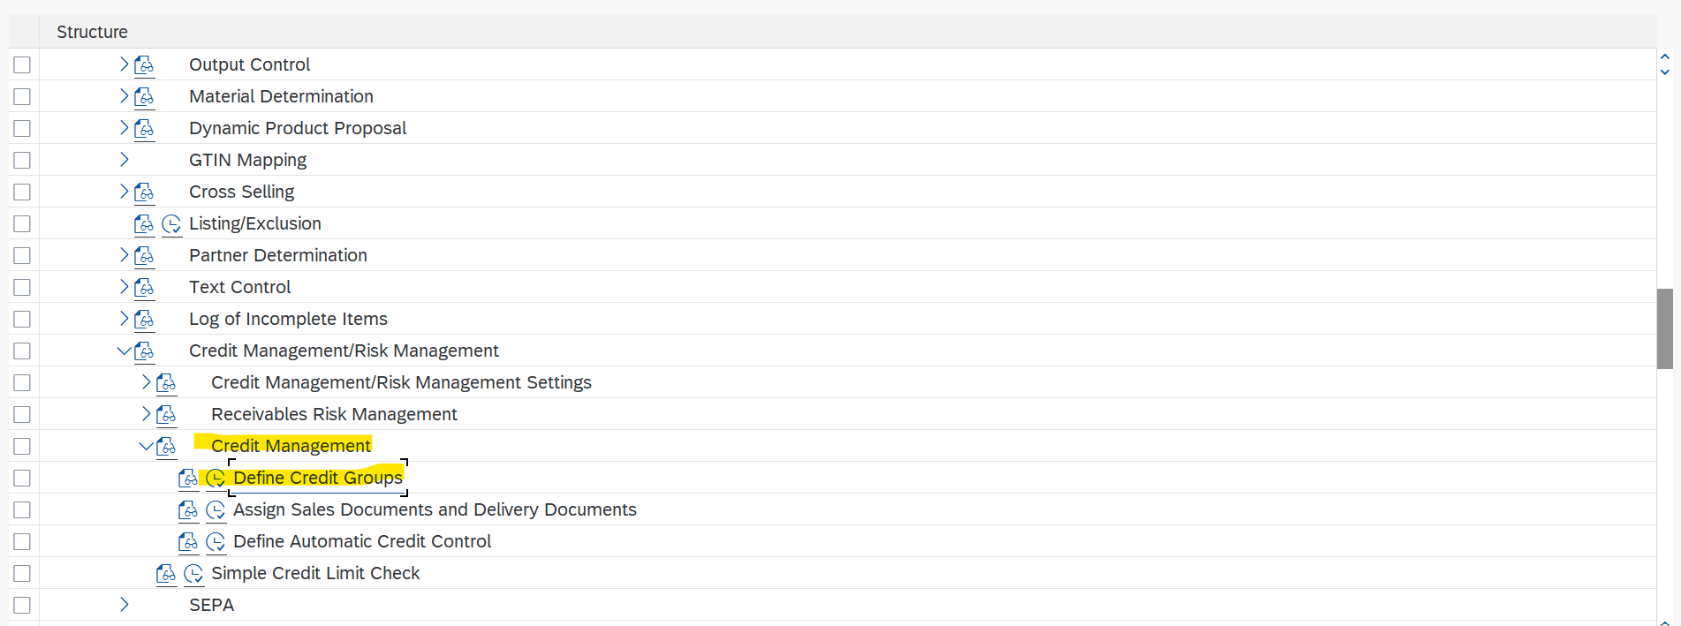

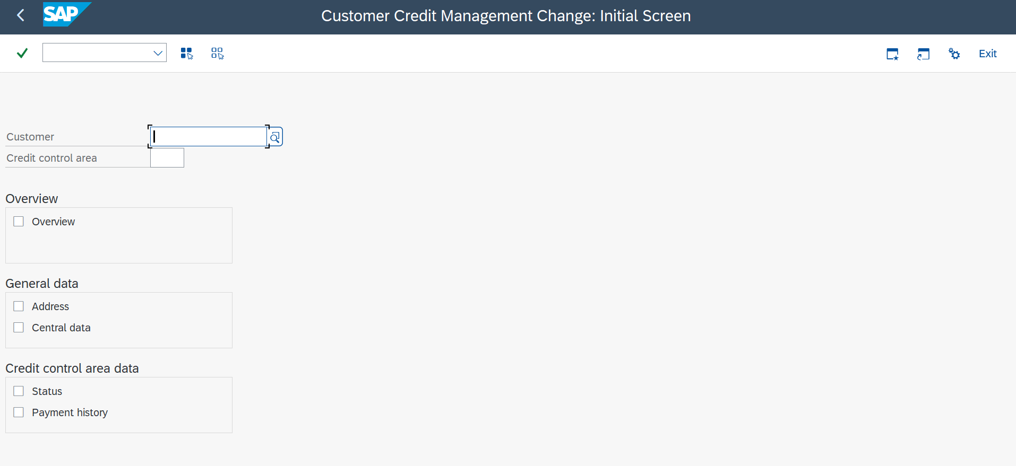

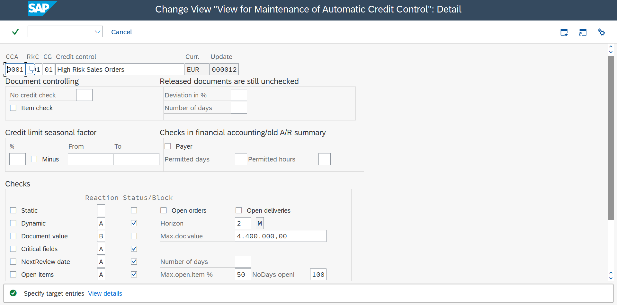

**Q. How automatic credit control area determined?**

Credit control area + risk control category + credit group.

**Q. What is Horizon?**

Specifies the credit horizon for a dynamic credit check.

ACCOUNT DETERMINATION

Customer Account assignment group: - XD01🡪sales area data🡪Billing documents

Material account assignment group: - MM01🡪Sales org 2  
  
Spro🡪sales and distribution🡪basic functions🡪account assignment/costing🡪revenue account determination🡪define and assign account determination procedure.

Only one procedure: - KOFI00  
Two condition types :- 1) KOFI (Accounting)

2) KOFK (Costing)

Spro🡪sales and distribution🡪basic functions🡪account assignment/costing🡪revenue account determination🡪Assign G/L Accounts  
  
What is chart of accounts (INT1)?  
The chart of accounts in SAP is a group of **GL Accounts** that controls the name of the General GL Master, the number of GL Master and some control information. In other words, the grouping of G/L accounts forms the framework for recording accounting transactions in a structured way.  
  
How to see accounting document: - VF02🡪accounting (on top)  
  
What is provisional account?  
Used for discounts.  
  
How to create new table?  
Spro🡪sales and distribution🡪basic functions🡪account assignment/costing🡪revenue account determination🡪Define dependencies of revenue account determination🡪create table  
  
How to find error in accounting?  
VF02🡪Environment (on top)🡪Account determination analysis🡪Revenue Accounts

**Tax Determination**

Path:- SPRO--> sales and distribution--> basic functions--> taxes--> define tax determination rules

* MWST is the most commonly used tax category used around the world.

How is Net value/price posted in Finance: - VKOA  
How is Tax posted: - OB40

TPO (Third Party Order)

Item Category - TAS

Material Type - BANS

Schedule line Categories- CS

In TPO after getting the order from customer. There is no manufacturing. Vendors supply the product.

**Types of TPO**

* With shipping notification (both MIGO and MIRO)
* Without shipping notification (only MIRO)
* TPO is also called Triangle sales
* In TPO there is STATISTICAL MIGO
* MIGO (Movement in Goods Out) is Goods Receipt
* MIRO (Movement in Receipt Out) is Invoice verification

**PROCESS OF CREATING TPO -**

1. Creation of TPO Material

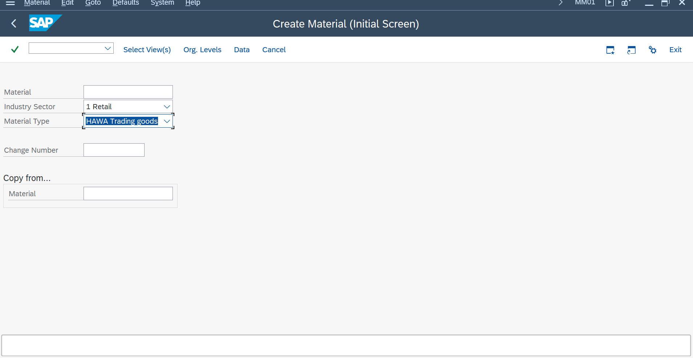

1. We have to put BANS in General Item category Group and item category group.

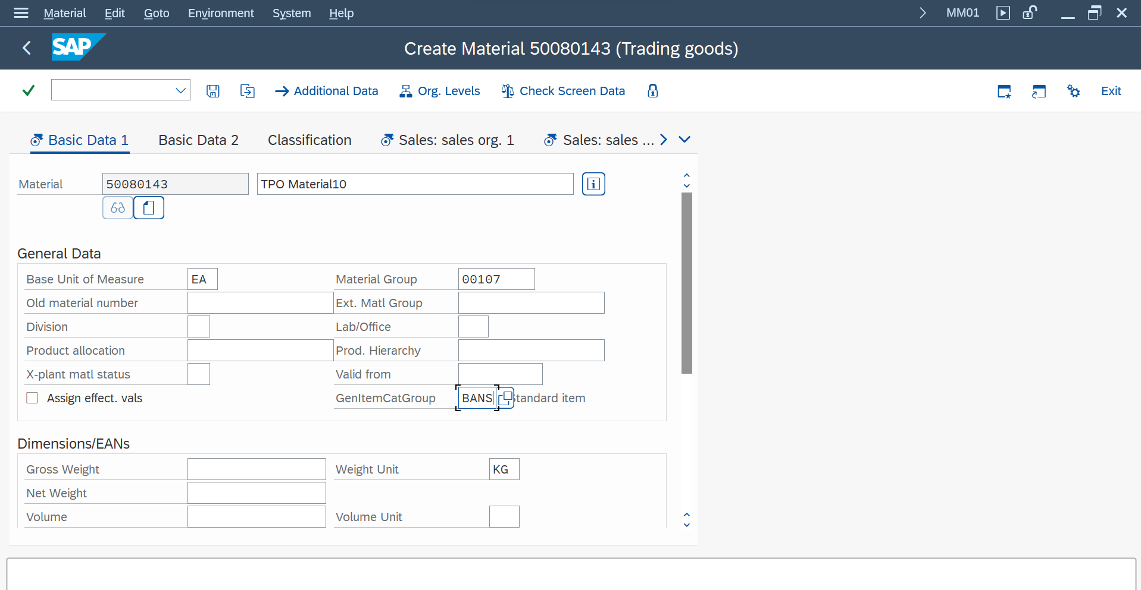



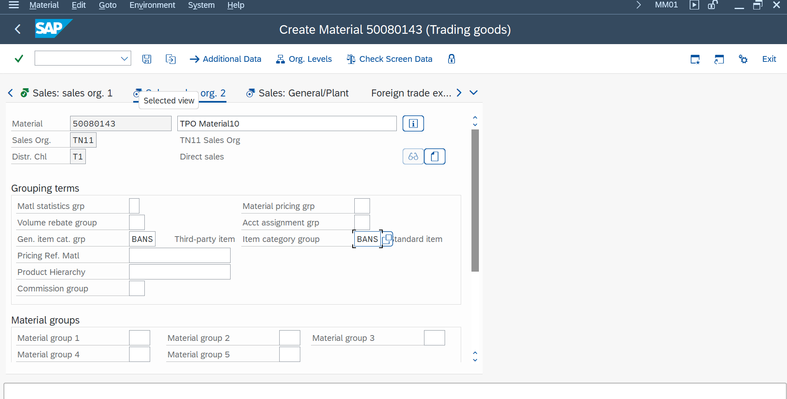



1. Then we need to create a sales order using that TPO Material.

The item category in Item level should be **TAS.** The Purchasing Group in Purchasing view should be 313.

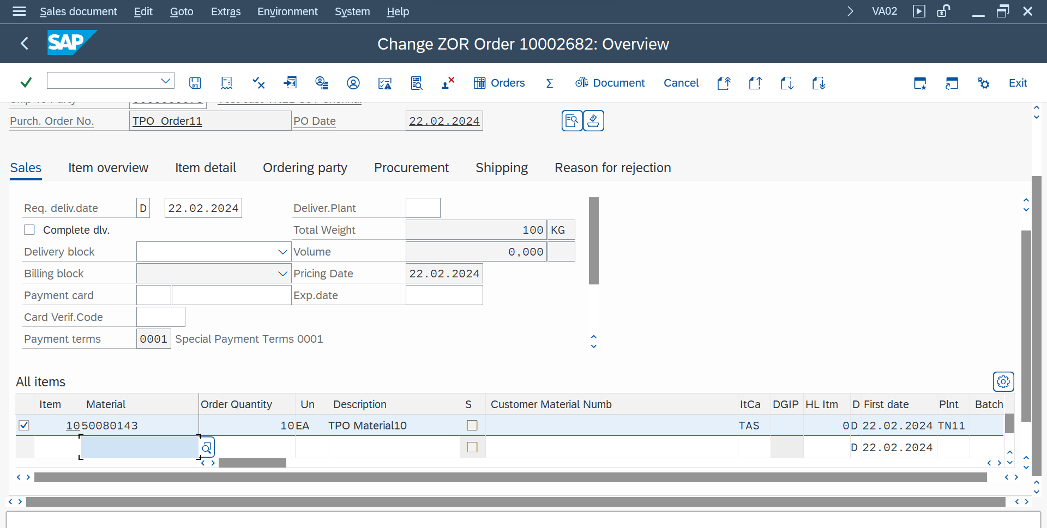



1. Then we need to copy the Purchase Requisition in schedule lines of the document.

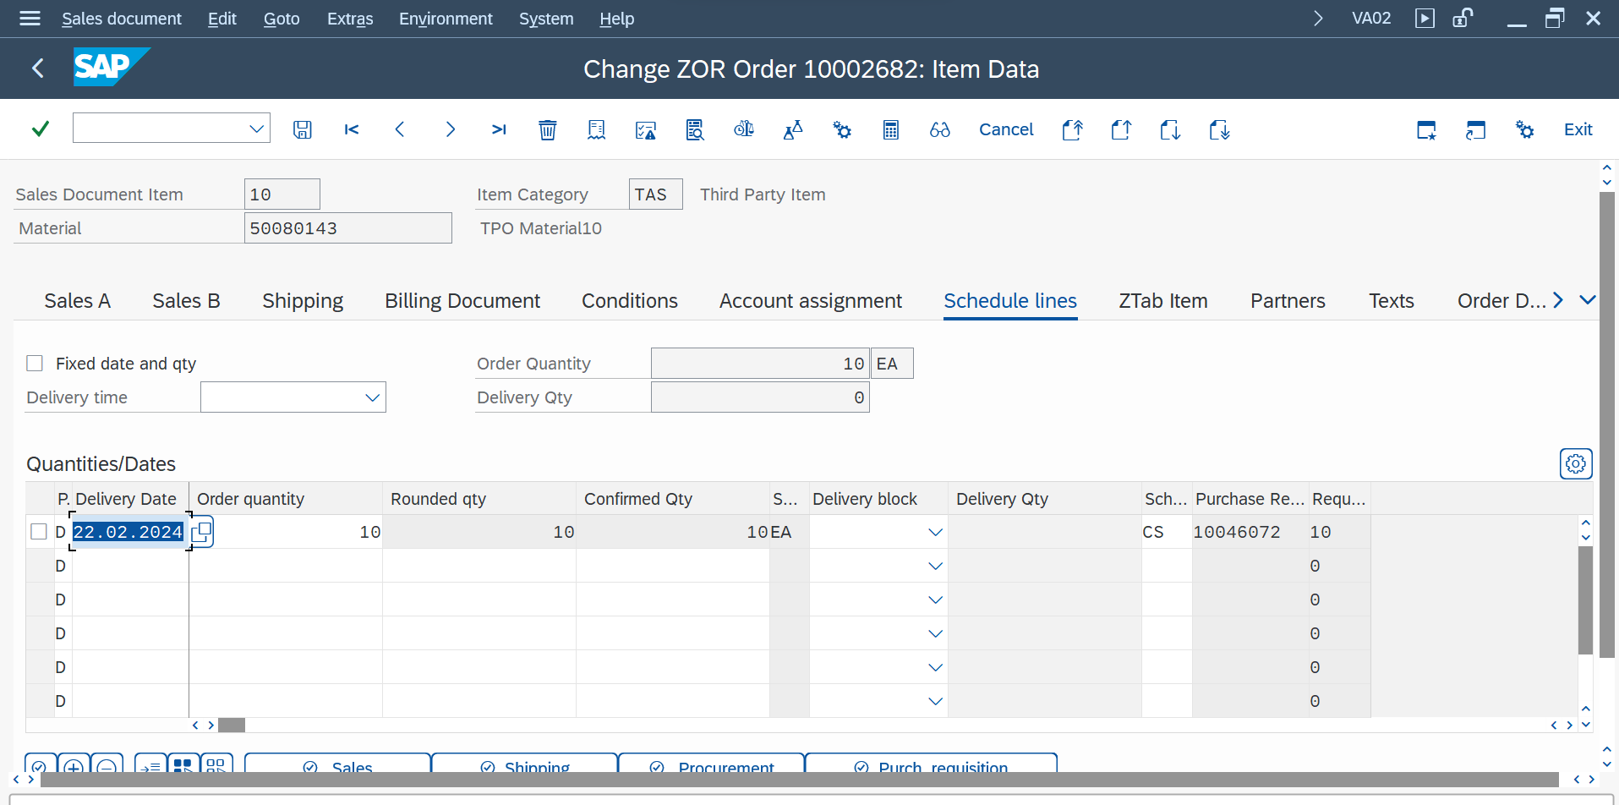



1. Then we need to put one vendor in the in “Create Purchase Order” and we need to paste the Purchase Requisition that we copied in the Sales Order.



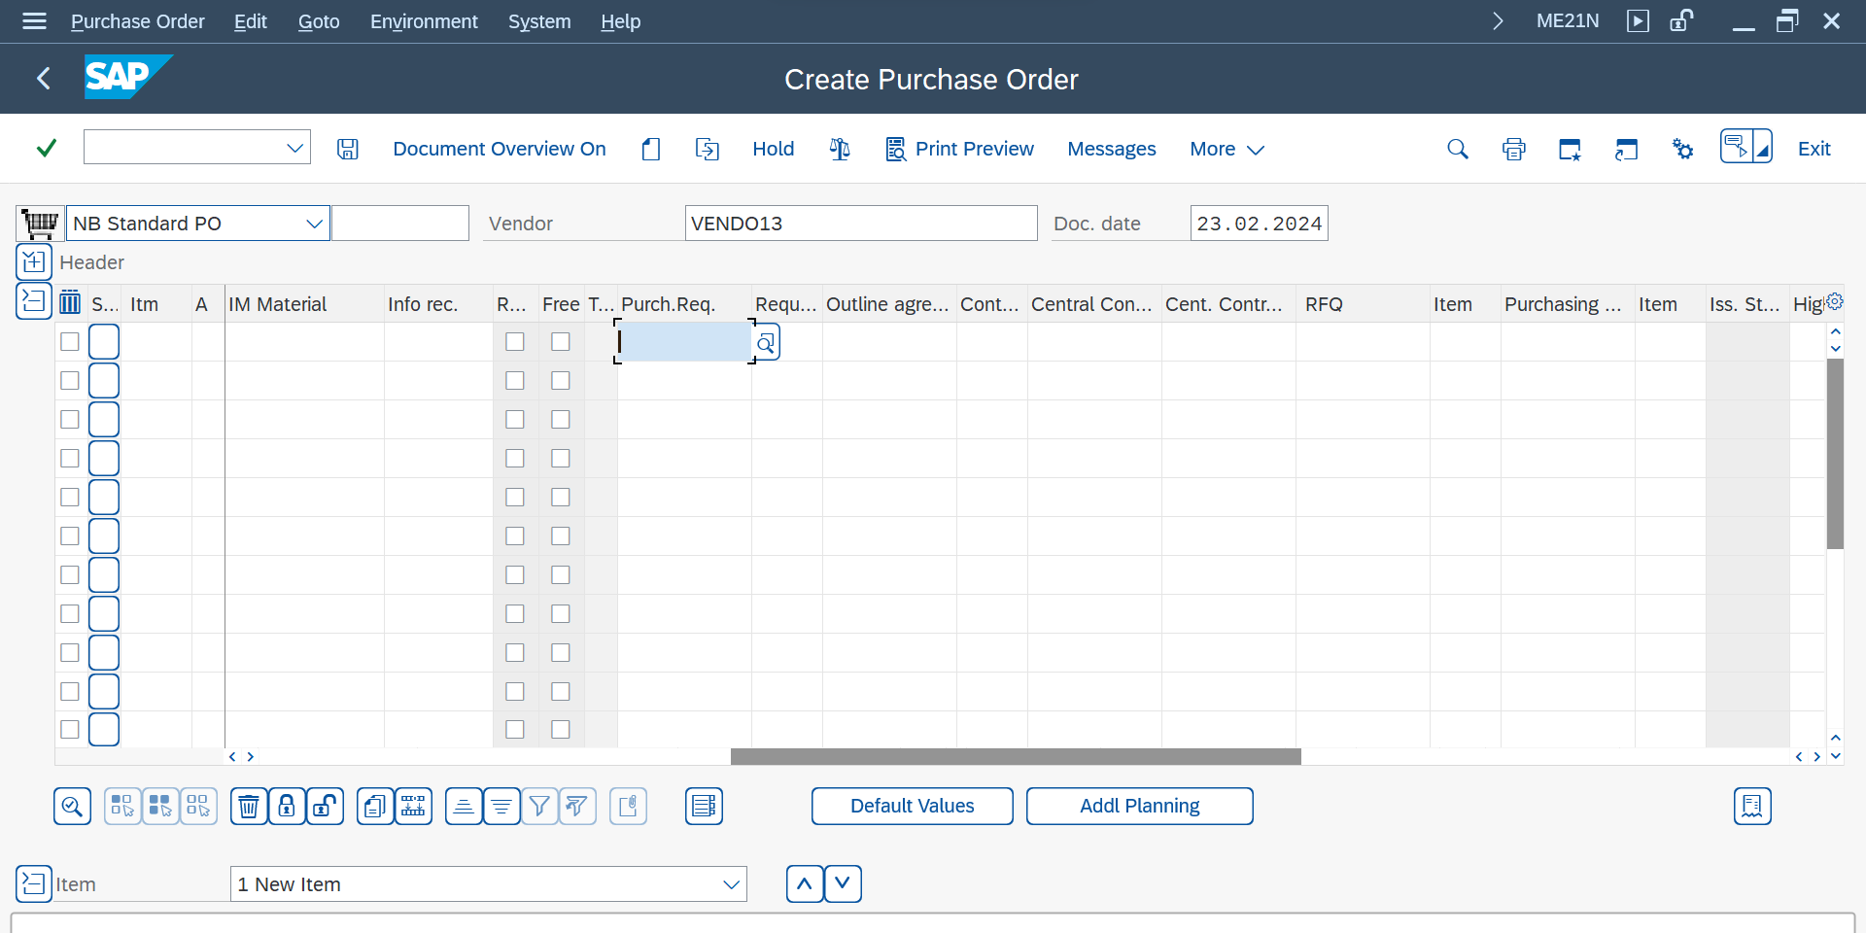



1. Then we should give the purchasing org, purchasing grp, company code in the Header. Then we have to check for any messages and if all okay then save it. Then we will get the standard PO Number.



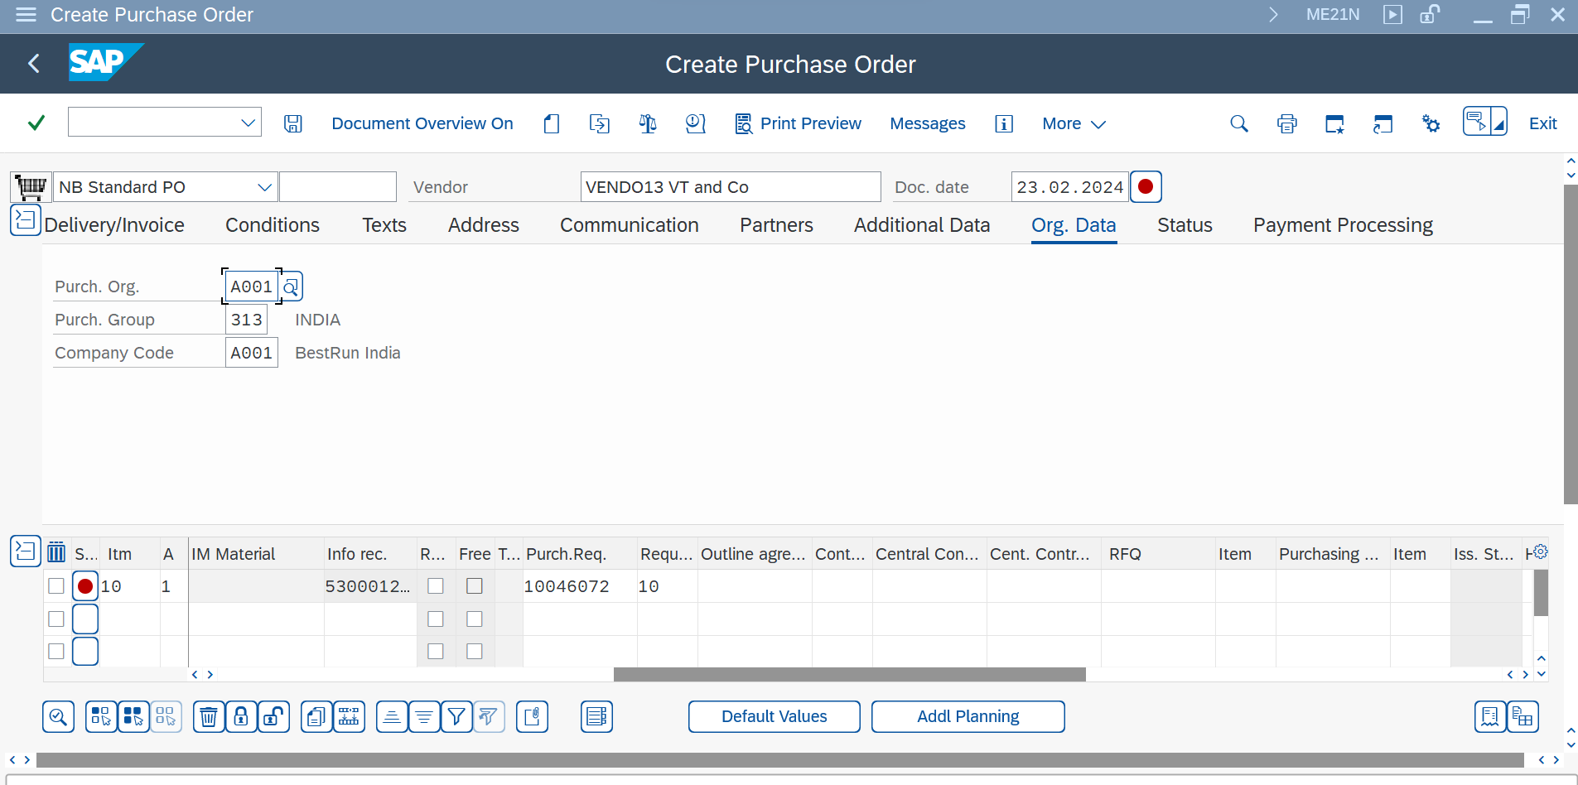



1. We go to the T Code- MIGO for the goods receipt

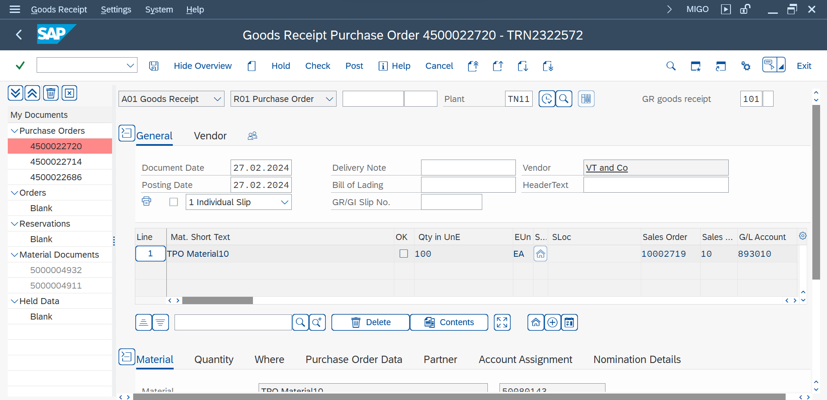



We have to put the standard PO number in the highlighted part and have to enter.

1. Then we have to tick the checkbox and have to check if the document is OK.

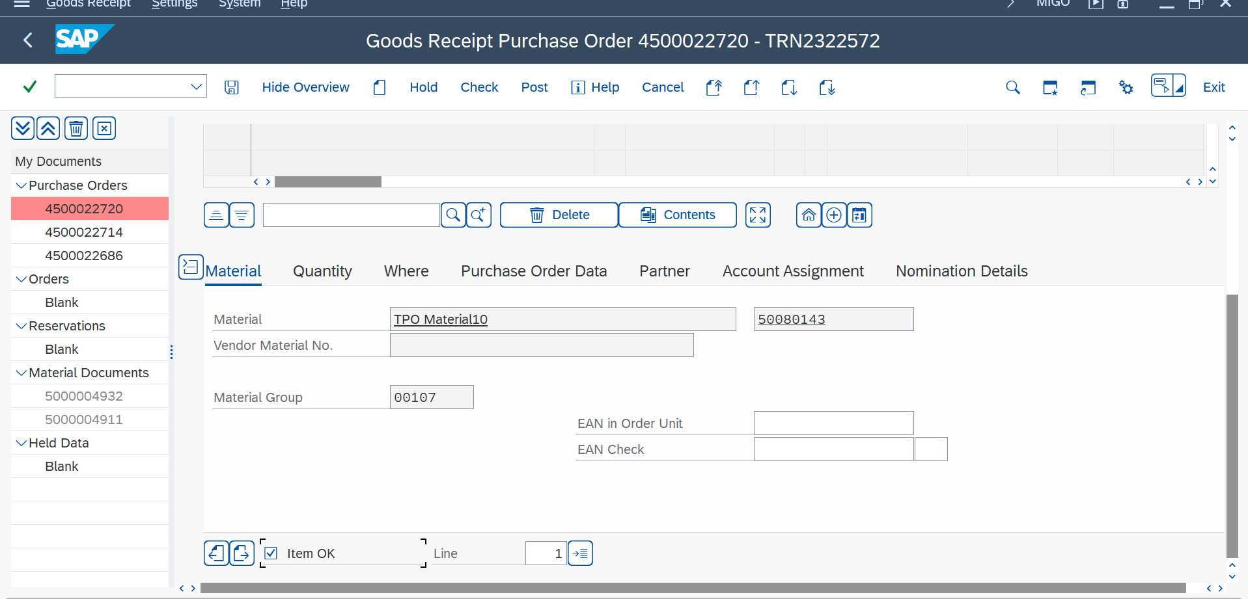



If the document is OK, then we have to save it and we will get the material document number.

1. Then we have to go the T code- MIRO and have to maintain all the highlighted fields.

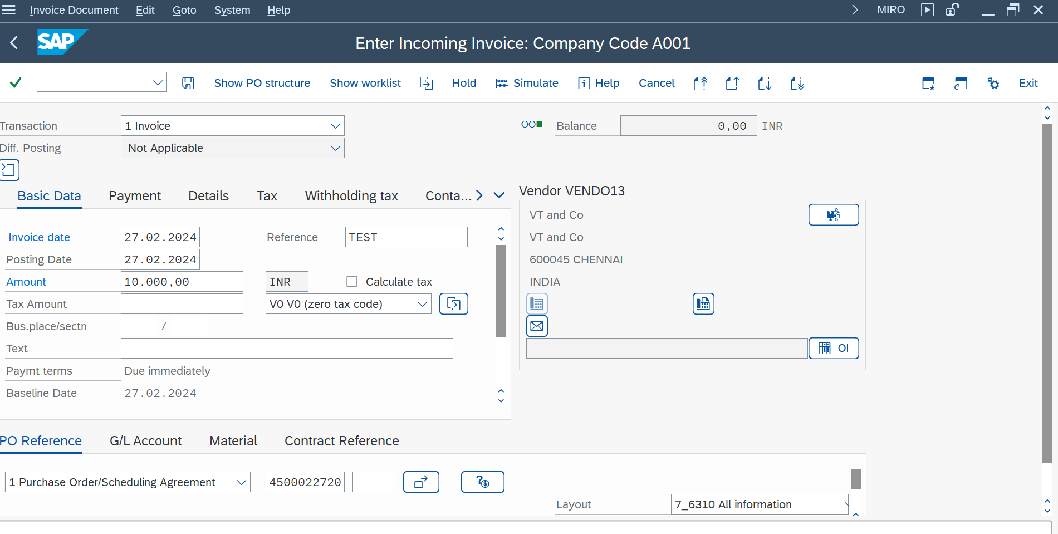



1. Then we have to Simulate it.

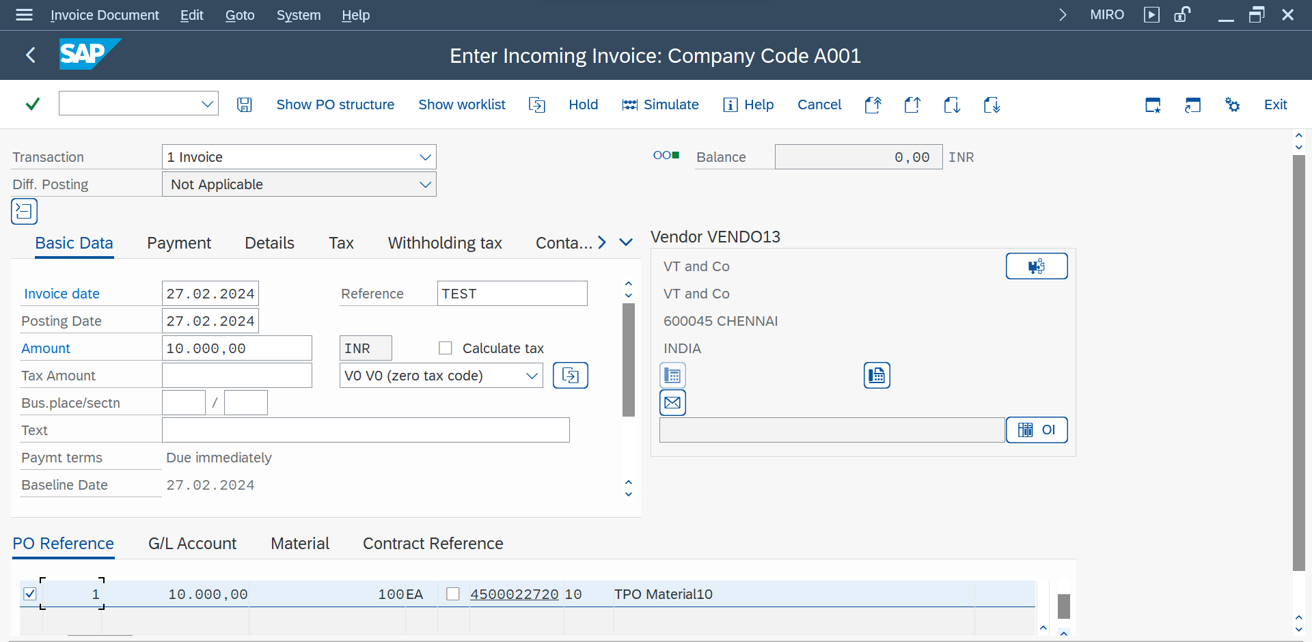



1. Then we have to post it.

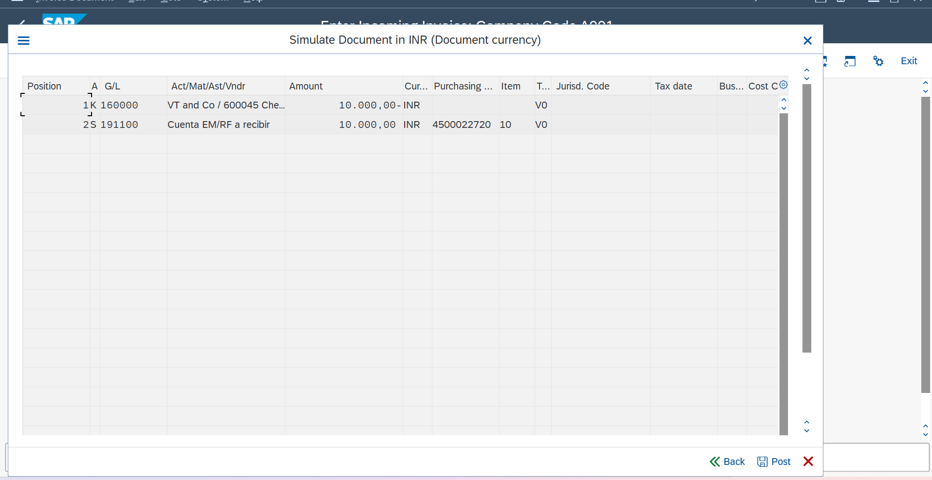



And the process is done we will get the document number.

Availability Check

**Availability check**

**->** Go to material -> Sales: general plant

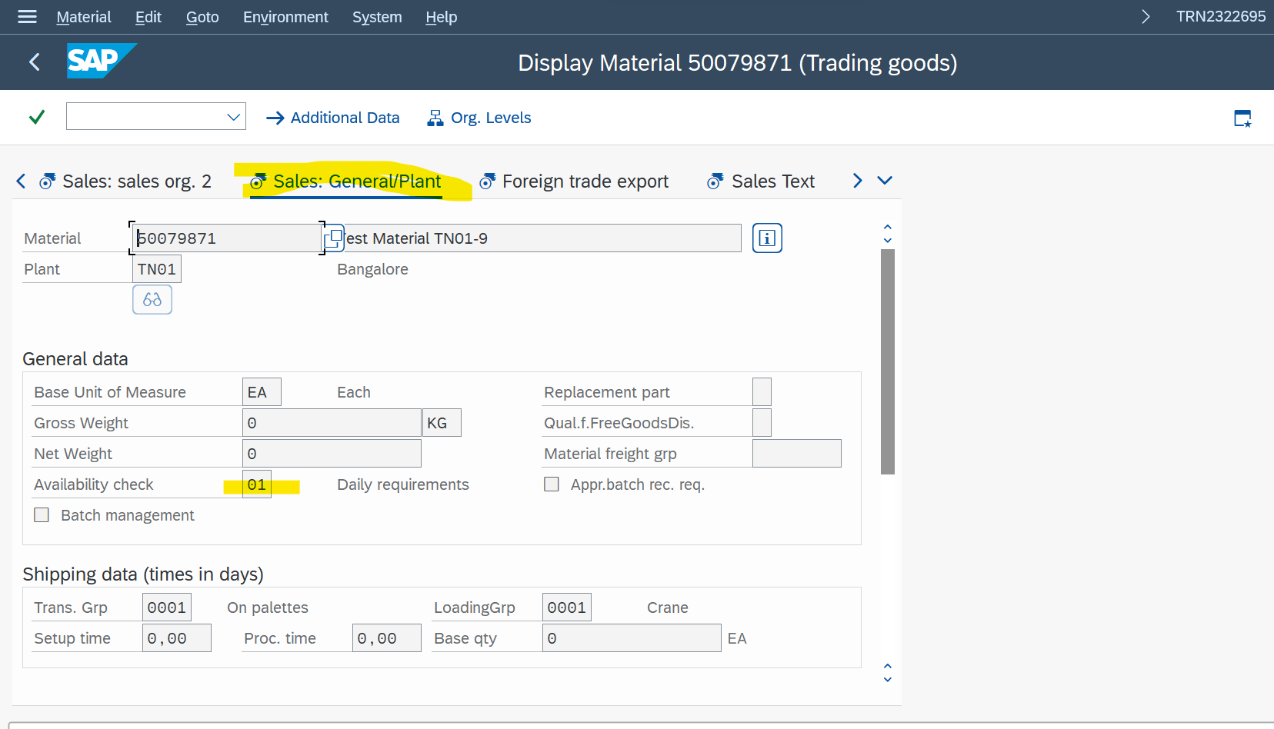

**CP and CN Determination For MTO Schedule line**

**->**Sales & Dis. -> Sales Document -> Sales -> schedule line -> define.

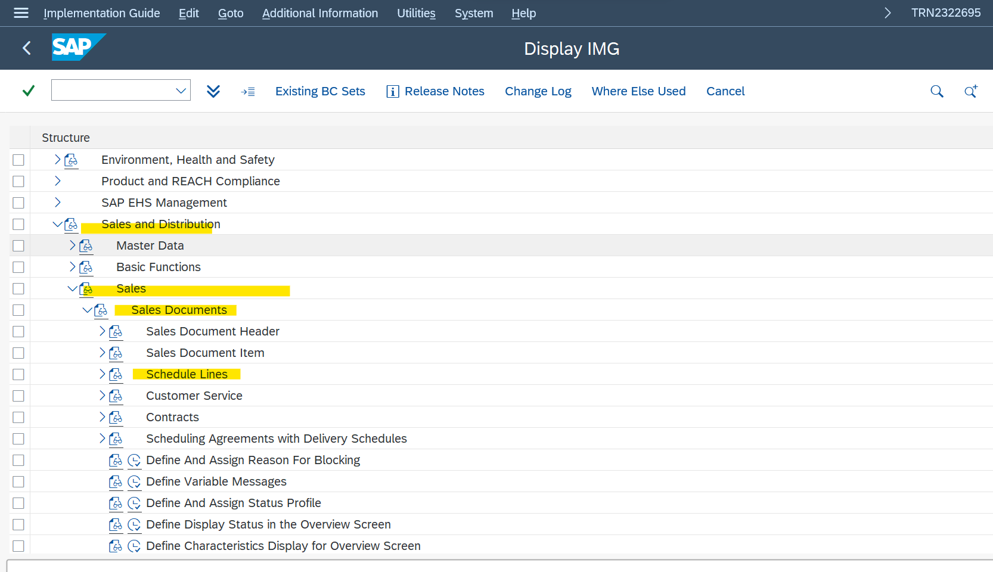

Whenever we create a sales order firstly system check the availability of stock if stock is available then then it directly go for the delivery, But If stock is not available then it is go for second line that is called second line scheduling.

**Q. What is Forward and Backward Scheduling?**

**->** Backward Scheduling – If Material (stock) is available for the delivery then we will be able to deliver the stock in customer requested delivery date that is called Backward Scheduling.

MTS (Make to stock)

Strategy Group – 10

Forward Scheduling – When stock is not available then the delivery date will extend to another date that is called forward scheduling.

MTO (Make to Order)

Strategy Group – 20

MTO & MTS

**MTO –** Make to Order

**MTS –** Make to Stock

**Create A MTO Material**

**TCODE- MM01**

Industry sector – P Pharmaceuticals

Material Type - FERT Finished Product

Select Views – Basic Data 1, sales: Sales org. Data1, Sales: Sales org. data 2, Sales: General/plant Data, MRP1, MRP2, MRP3, Accounting.s

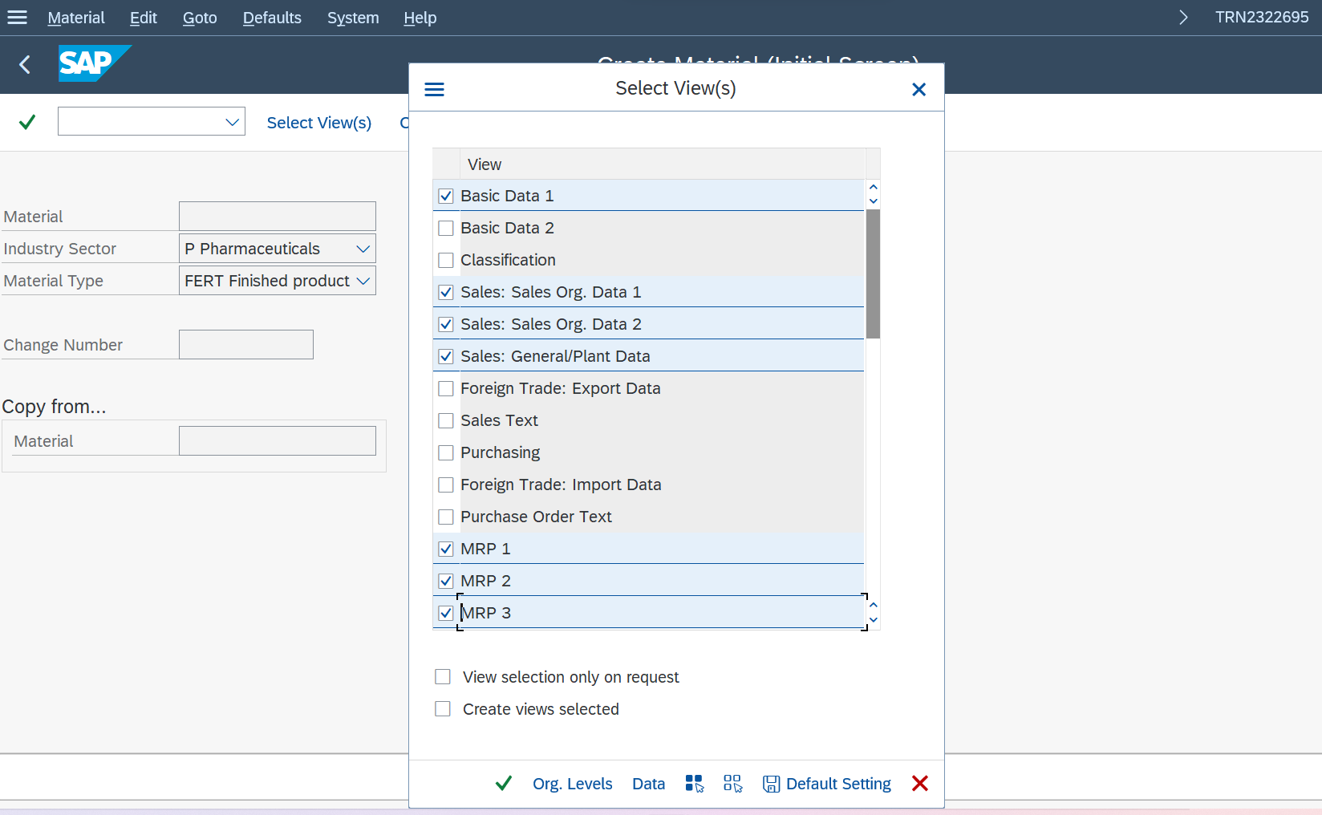

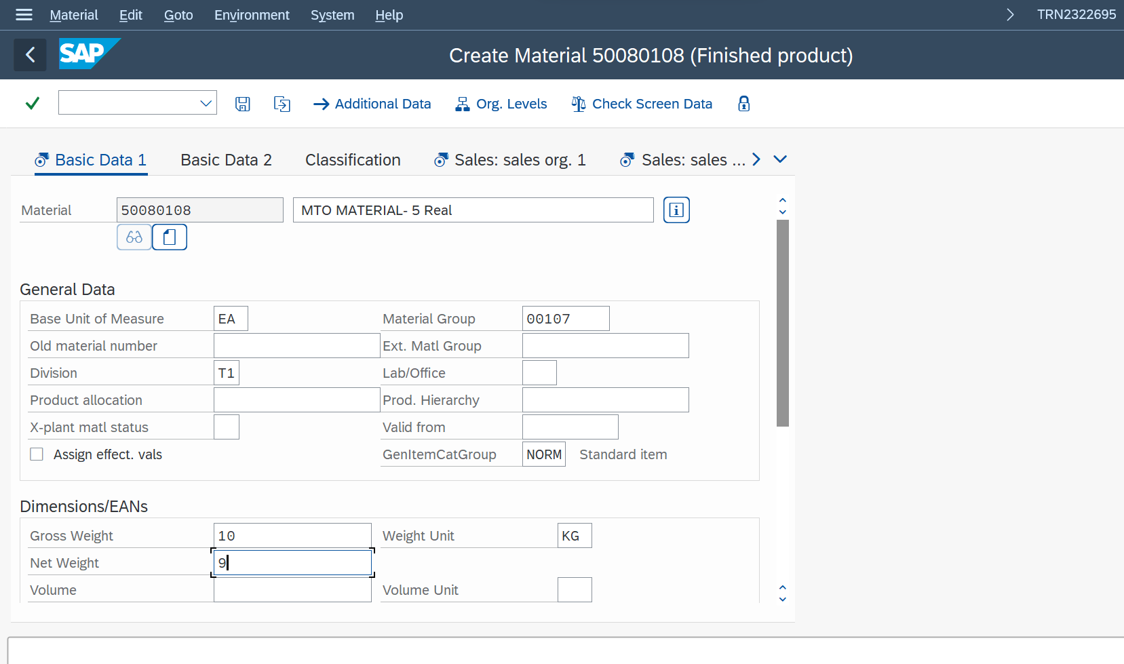

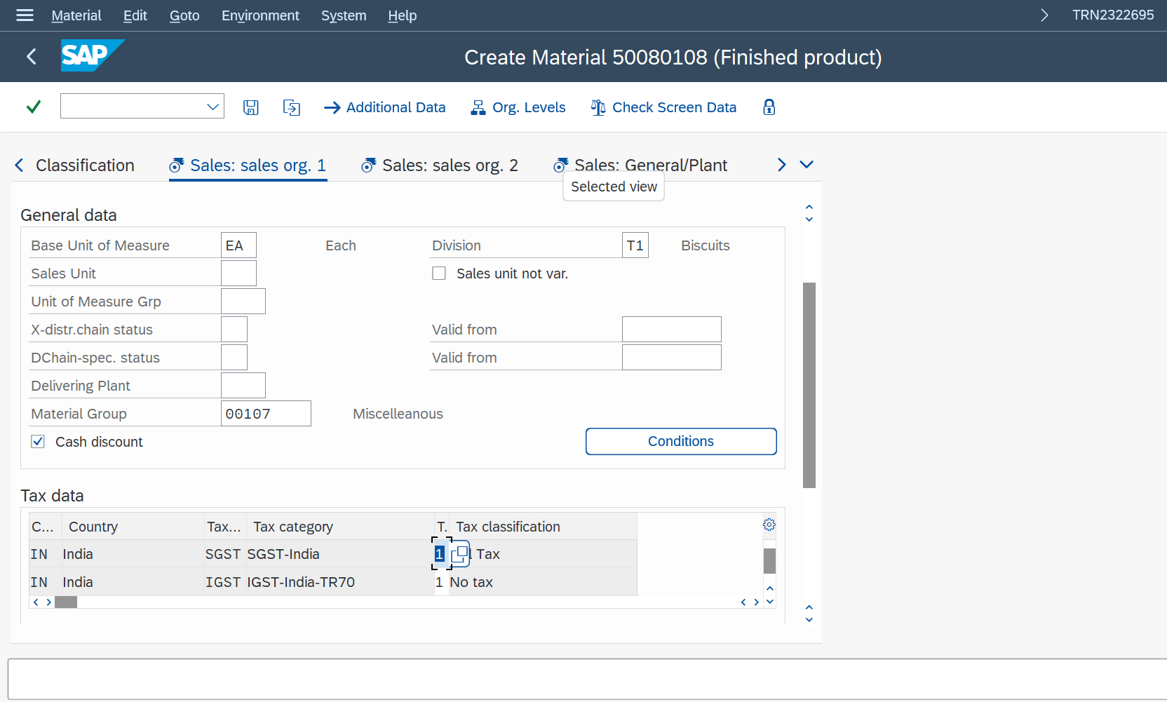

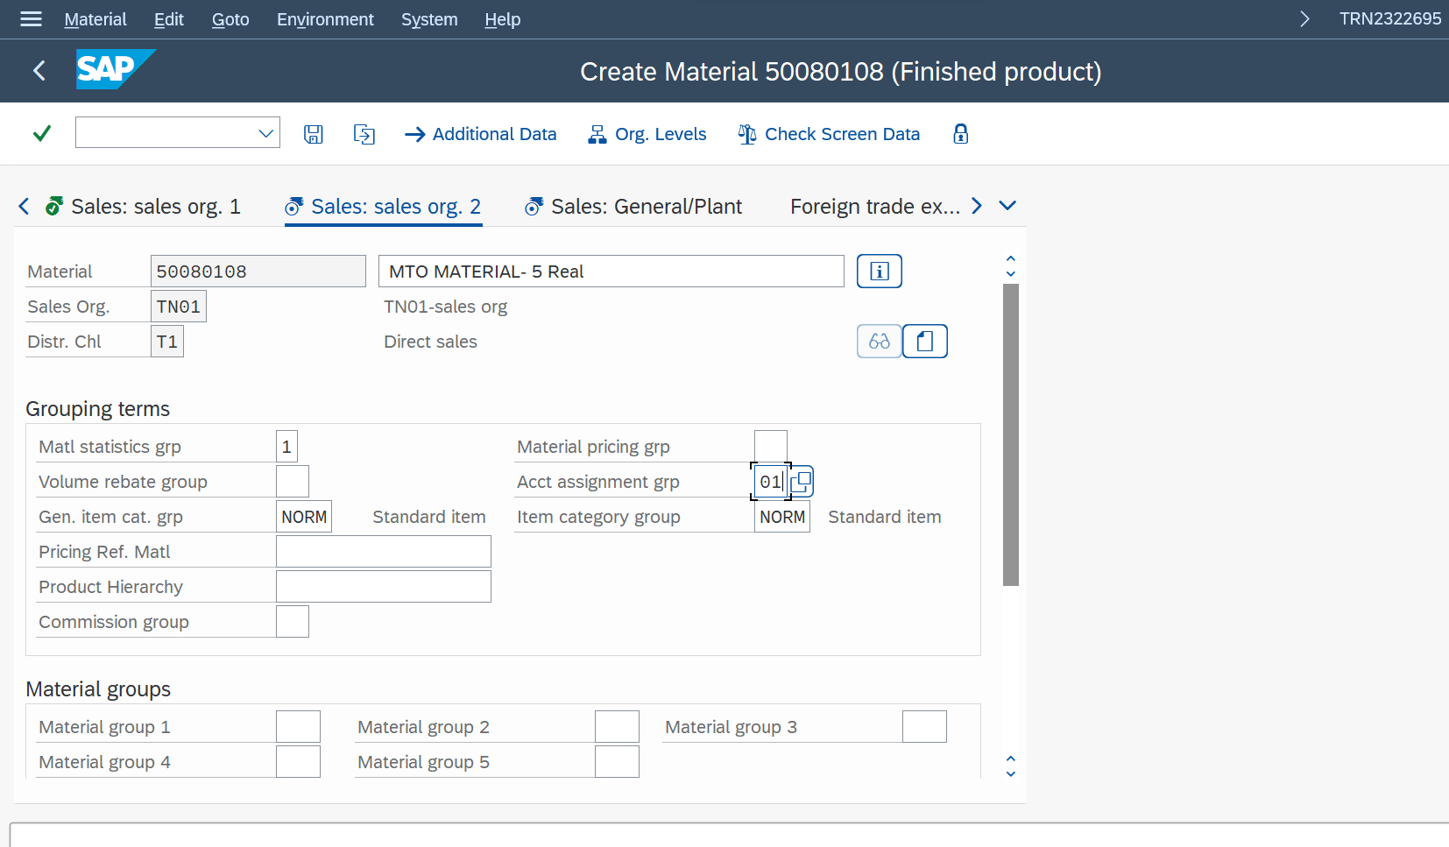

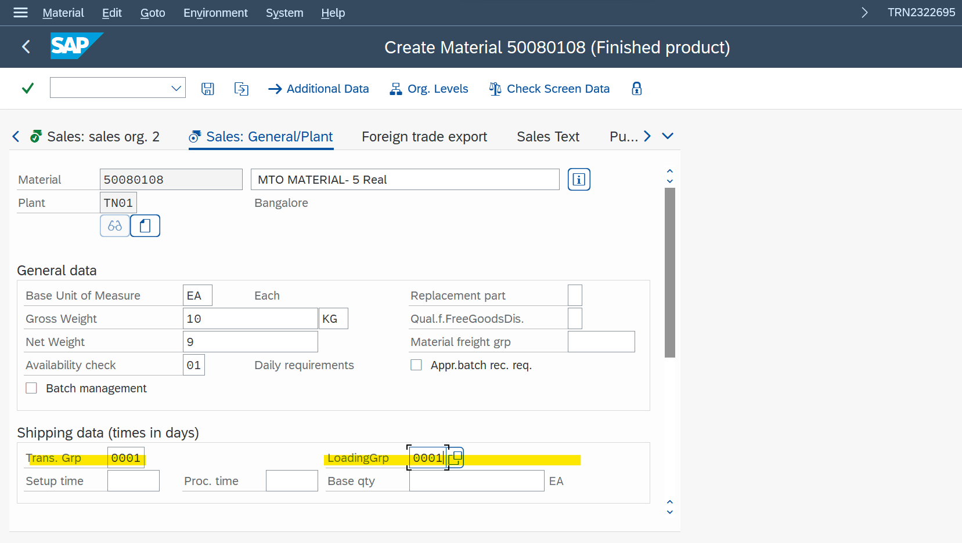

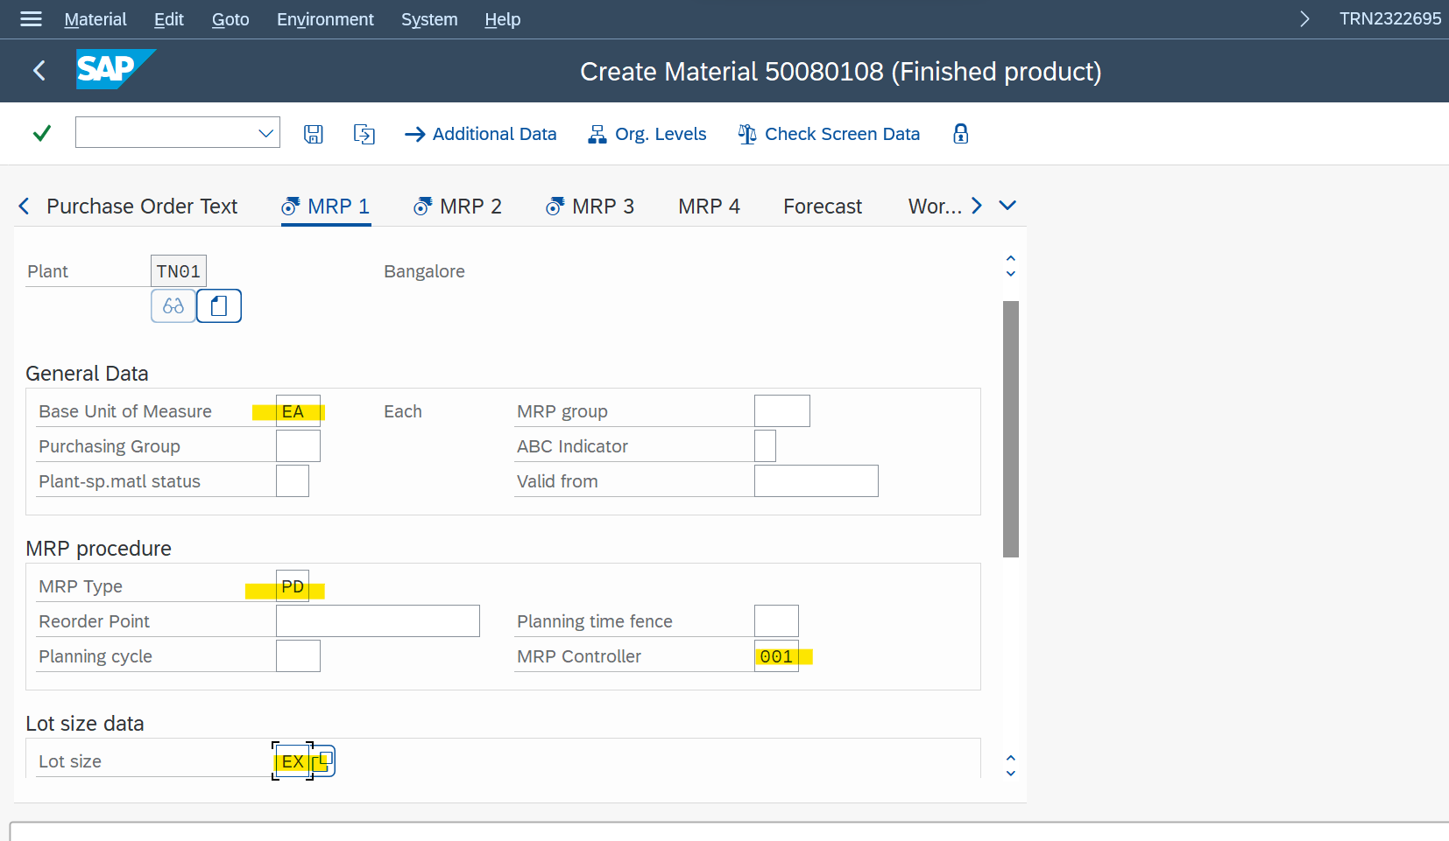

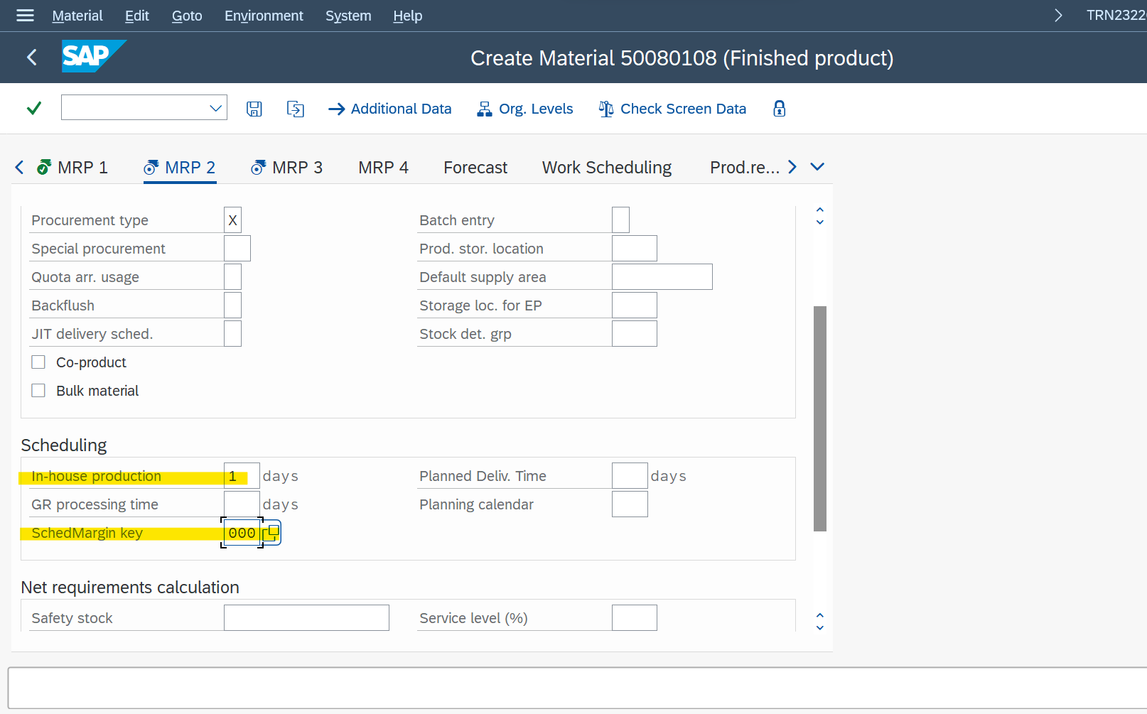

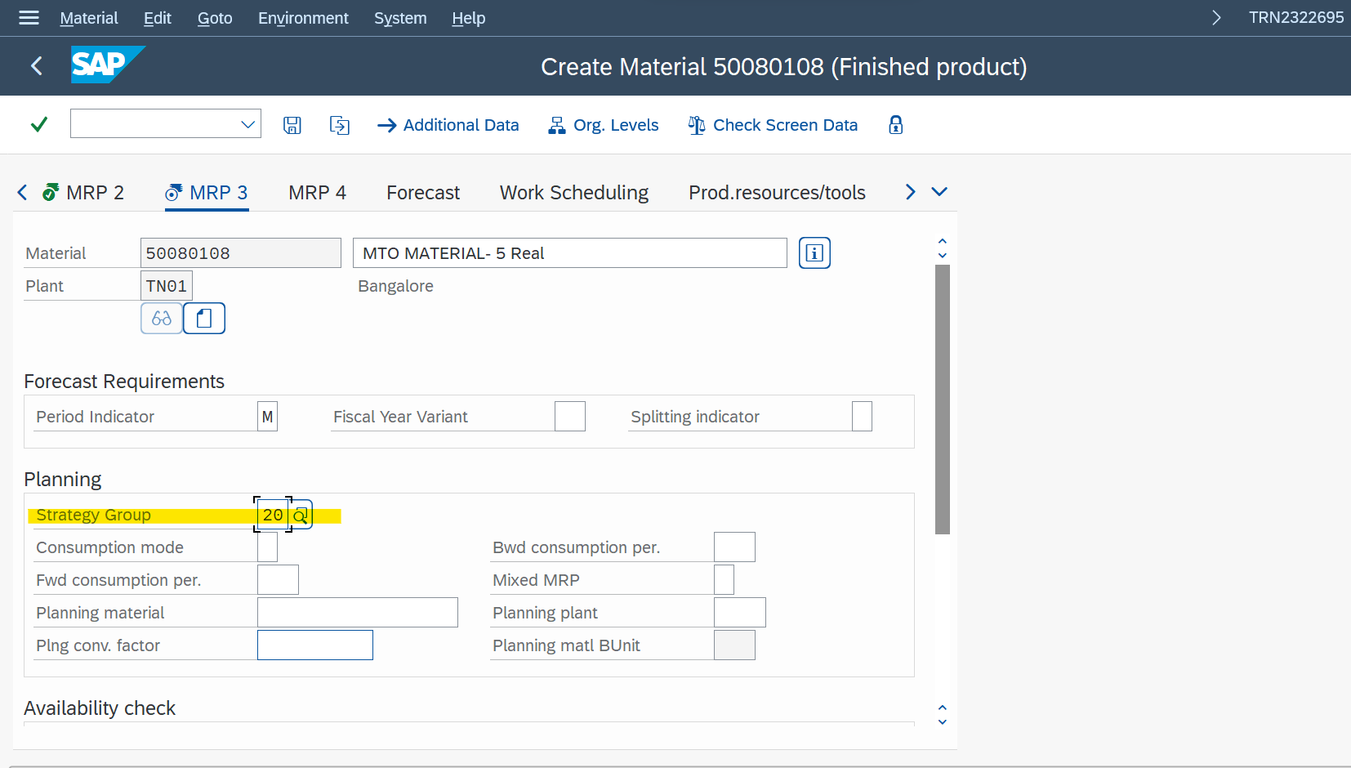

Strategy group Define the material is MTO or MTS

If Strategy Group is 20 It is MTO

If Strategy Group is 10 It is MTS.

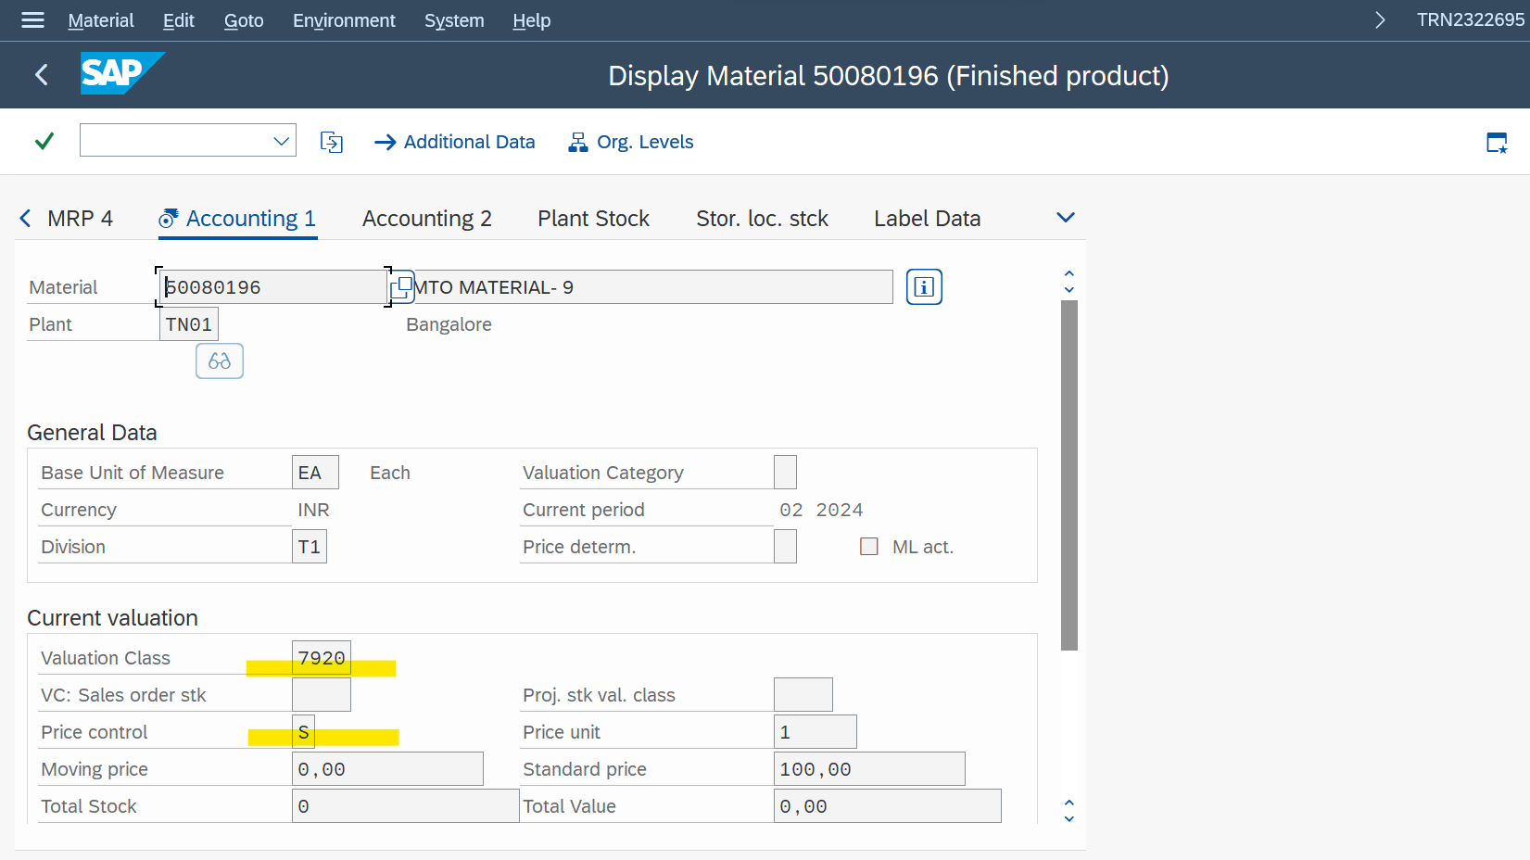

Valuation class – 7020

**TCODE** - VA01 – Create A ZOR

After creating the zor we need to give the stock

**TCODE - MB1C**

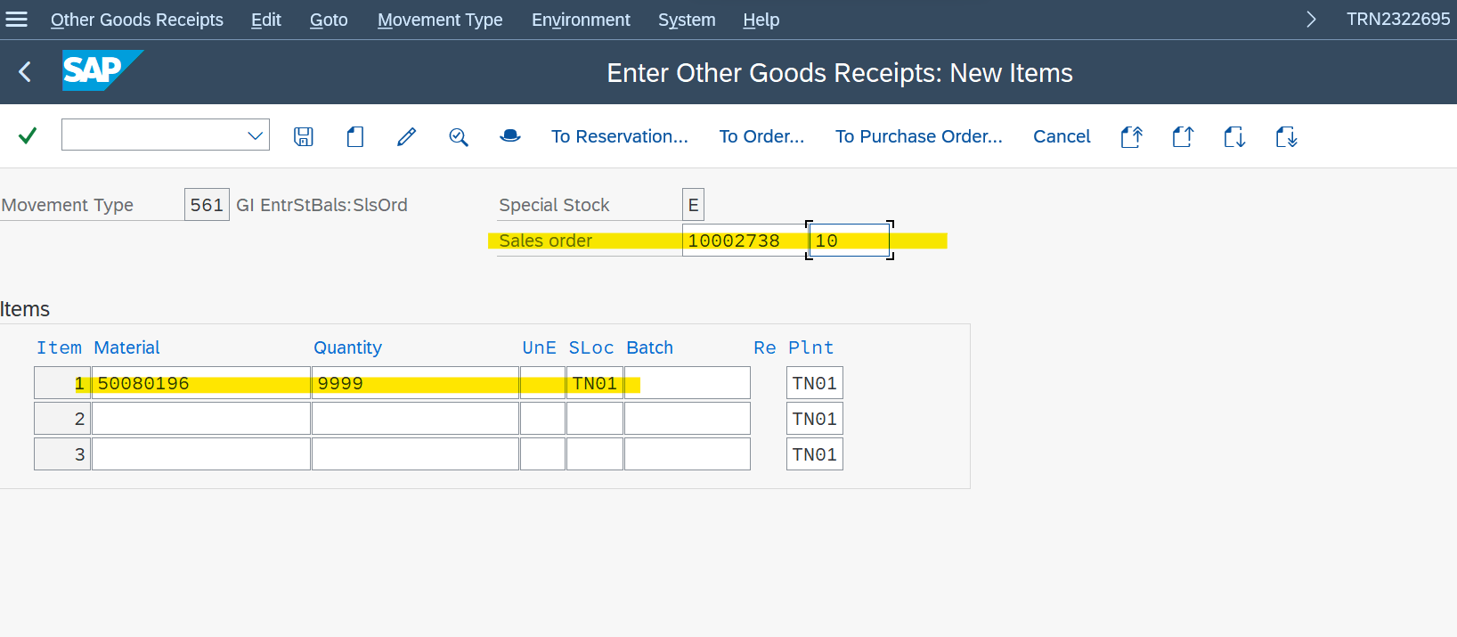

**THEN DELIVERY – VL01N**

**THEN BILLING – VF01**

OUTPUT CONTROL

It is nothing but

* printing the documents
* sending the documents by mail

SPRO 🡪 Sales and Distribution 🡪 Billing 🡪 Billing Documents 🡪Define Billing Types 🡪 position : F2

To know the combinations for which we can print the sales documents

SPRO 🡪 Sales and Distribution 🡪 Basic Functions 🡪 Output Control 🡪 Output Determination 🡪 Output Determination Using the Condition Technique 🡪 Maintain Output Determination for Sales Documents 🡪 Maintain Condition Tables 🡪 Maintain Output Condition Table for Sales Documents 🡪

To view different standard sales types available

SPRO 🡪 Sales and Distribution 🡪 Basic Functions 🡪 Output Control 🡪 Output Determination 🡪 Output Determination Using the Condition Technique 🡪 Maintain Output Determination for Sales Documents 🡪 Maintain Output Types

Standard Types Available

BA00 – Sales Order

AN00 – Quotation

AF00 – Inquiry

LD00 – Delivery

RD00 – Billing Document

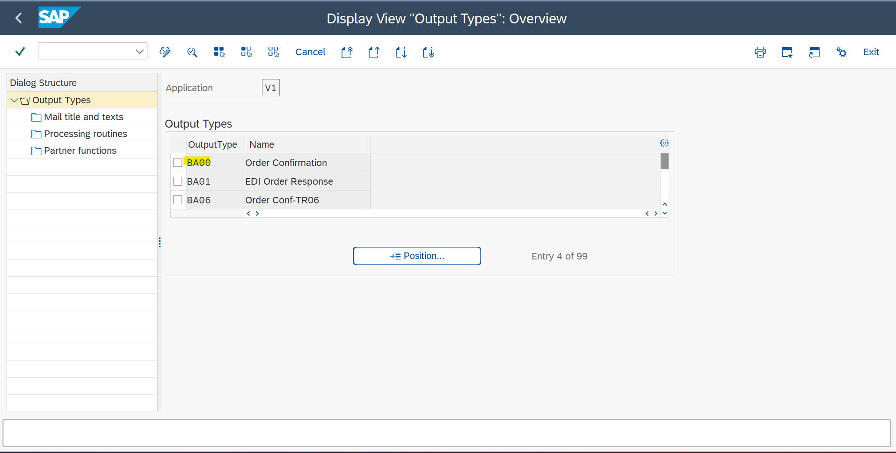

* To maintain output determination procedure

SPRO 🡪 Sales and Distribution 🡪 Basic Functions 🡪 Output Control 🡪 Output Determination 🡪 Output Determination Using the Condition Technique 🡪 Maintain Output Determination for Sales Documents 🡪 Maintain Output Determination Procedure

V10000 + control data

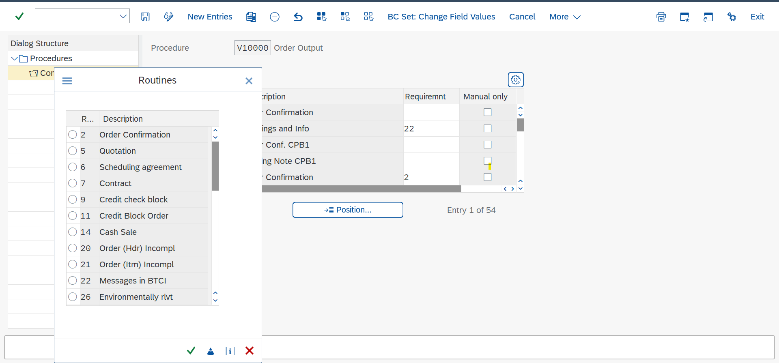

For sale order we usually choose the 9-credit check block in the requirement field

It will check whether the order is released for credit or not

* SPRO 🡪 Sales and Distribution 🡪 Basic Functions 🡪 Output Control 🡪 Output Determination 🡪 Output Determination Using the Condition Technique 🡪 Maintain Output Determination for Sales Documents 🡪 Assign Output Determination Procedure 🡪 Allocate Sales Document Header

ZOR

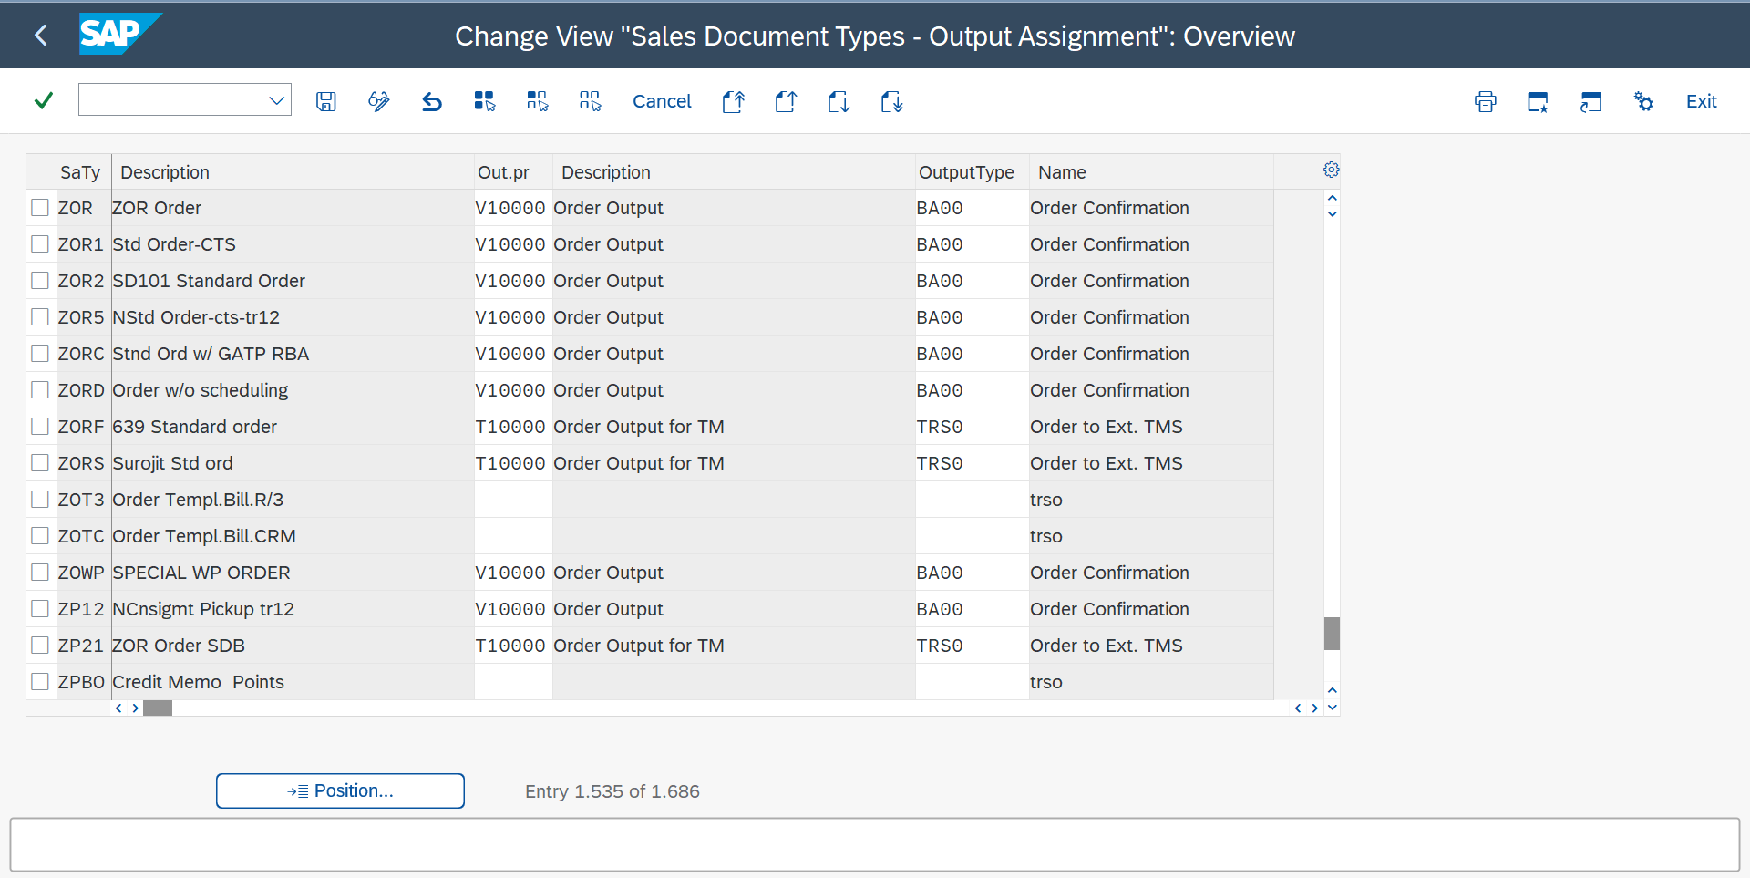

* **T - code**: NACE – Output Configuration

V1 – Sales

V2 – Shipping

V3 – Billing

1. V1 + Output types 🡪 BA00 + Processing Routines (Programmes used for printing the format of the form – driver program)

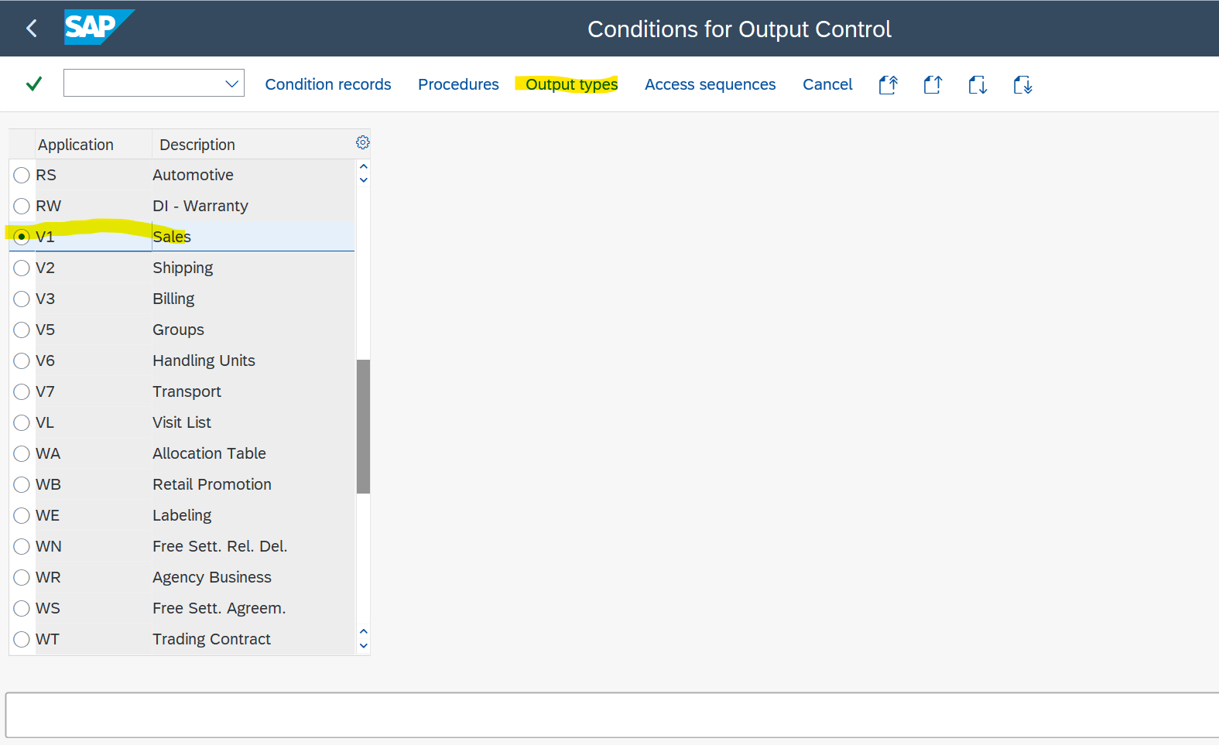

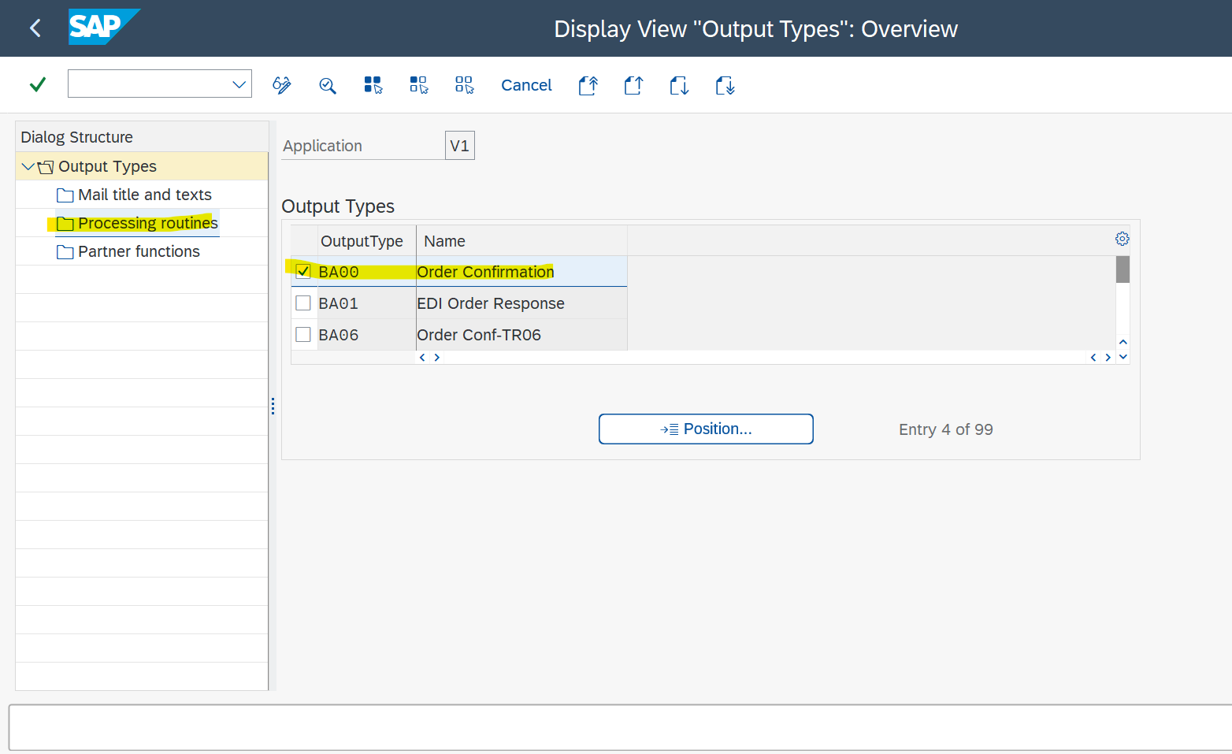

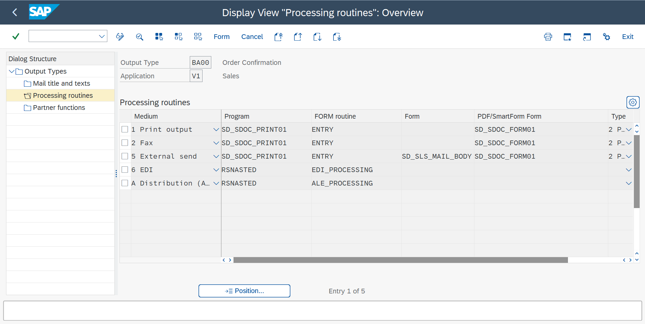

1. V1 + Output types 🡪 BA00 + Details ( When it is needed to be printed or what combinations are needed to be printed)

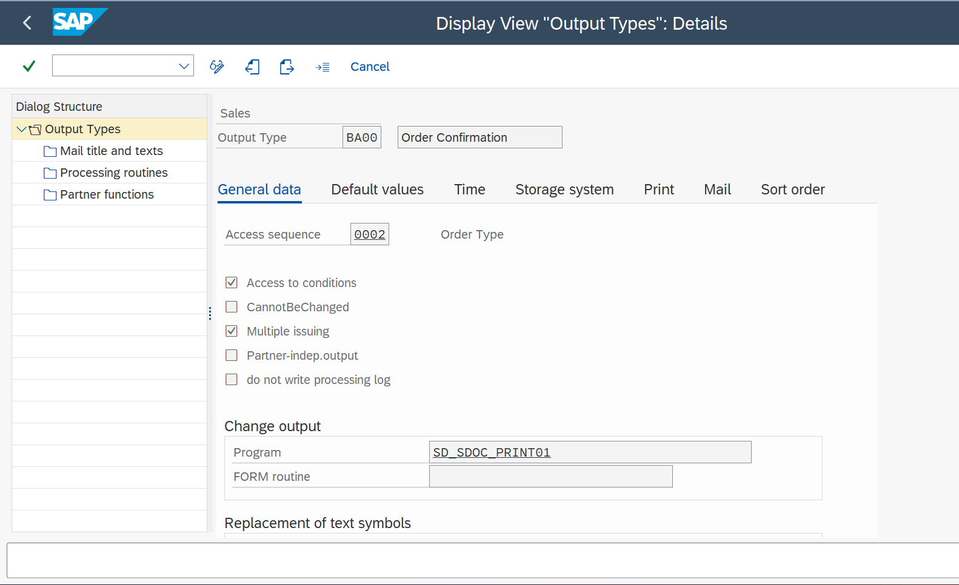

V1 + Procedures 🡪 V10000 + control (Checking BA00)

V1 + Condition records

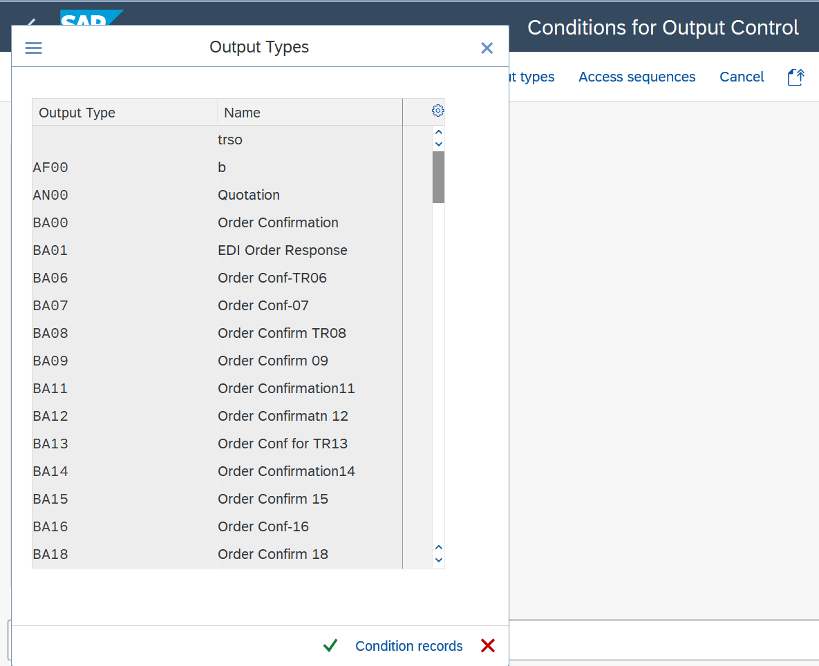

For maintaining output type for different document types

VV11,12,13 – Sales Order

VV21,22,23 – Delivery

VV31,32,33 – Billing Documents

VV11 + BA00 🡪 Sales org + Enter 🡪 Communication 🡪 Output Device: LP01 + print immediately

Open sales order 🡪 Extras 🡪 Output 🡪 Header 🡪 Output 🡪 Save

Go to sales order 🡪 Sales Document 🡪 Issue Output to 🡪 Print

Only in edit mode display mode we can see the output

/ose16n – General Table Display

**Functional Specification**

Se16n🡪Search in Table🡪

VBRK🡪(Without order reason)

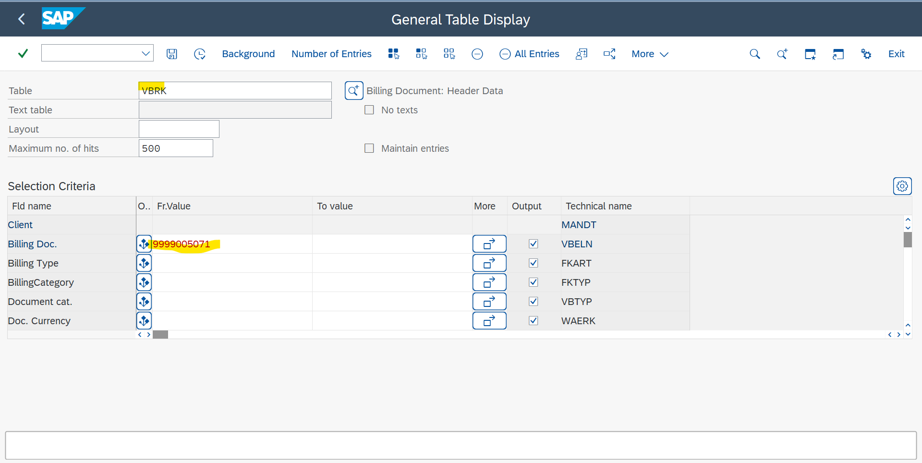

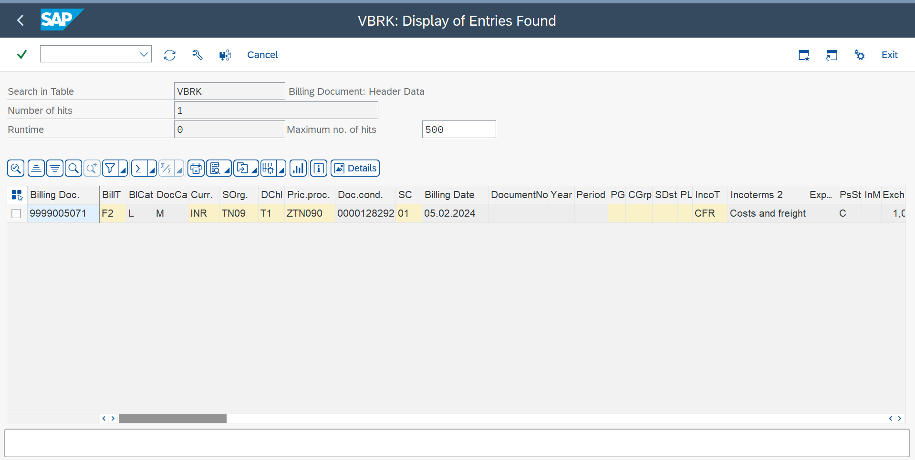

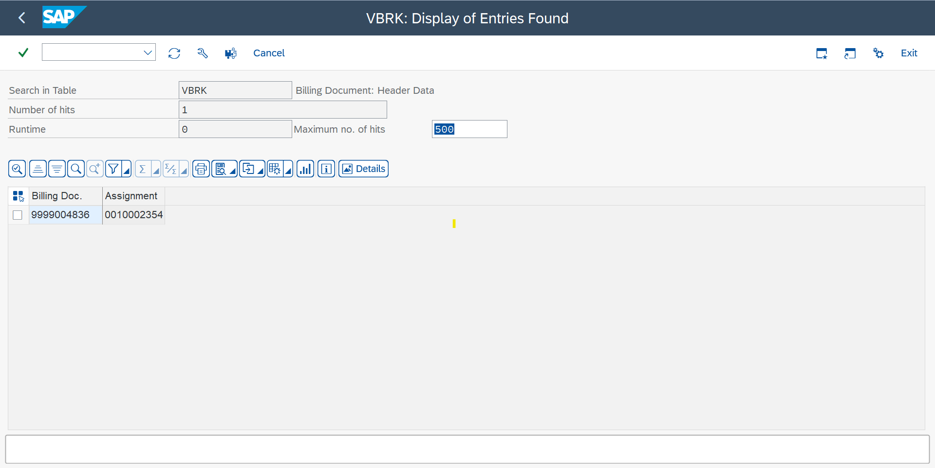

Search(Order Reason)

VBFA(With order Reason)

After filling follow up doc. And executing, we will get two line but we are needed to give one line request to the ABAP

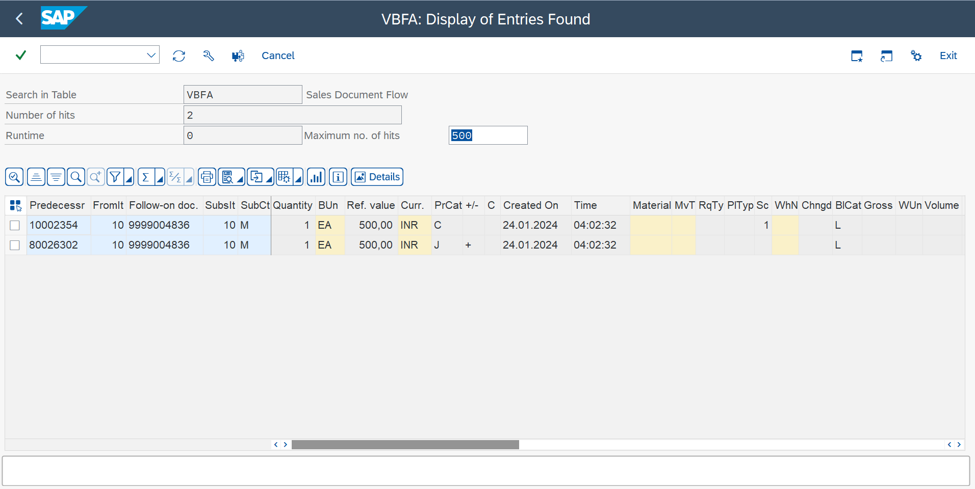

Preceding Document🡪

Subsequent Document🡪Follow on doc 🡪execute

Prec.cod.categ. 🡪C🡪execute(single line)

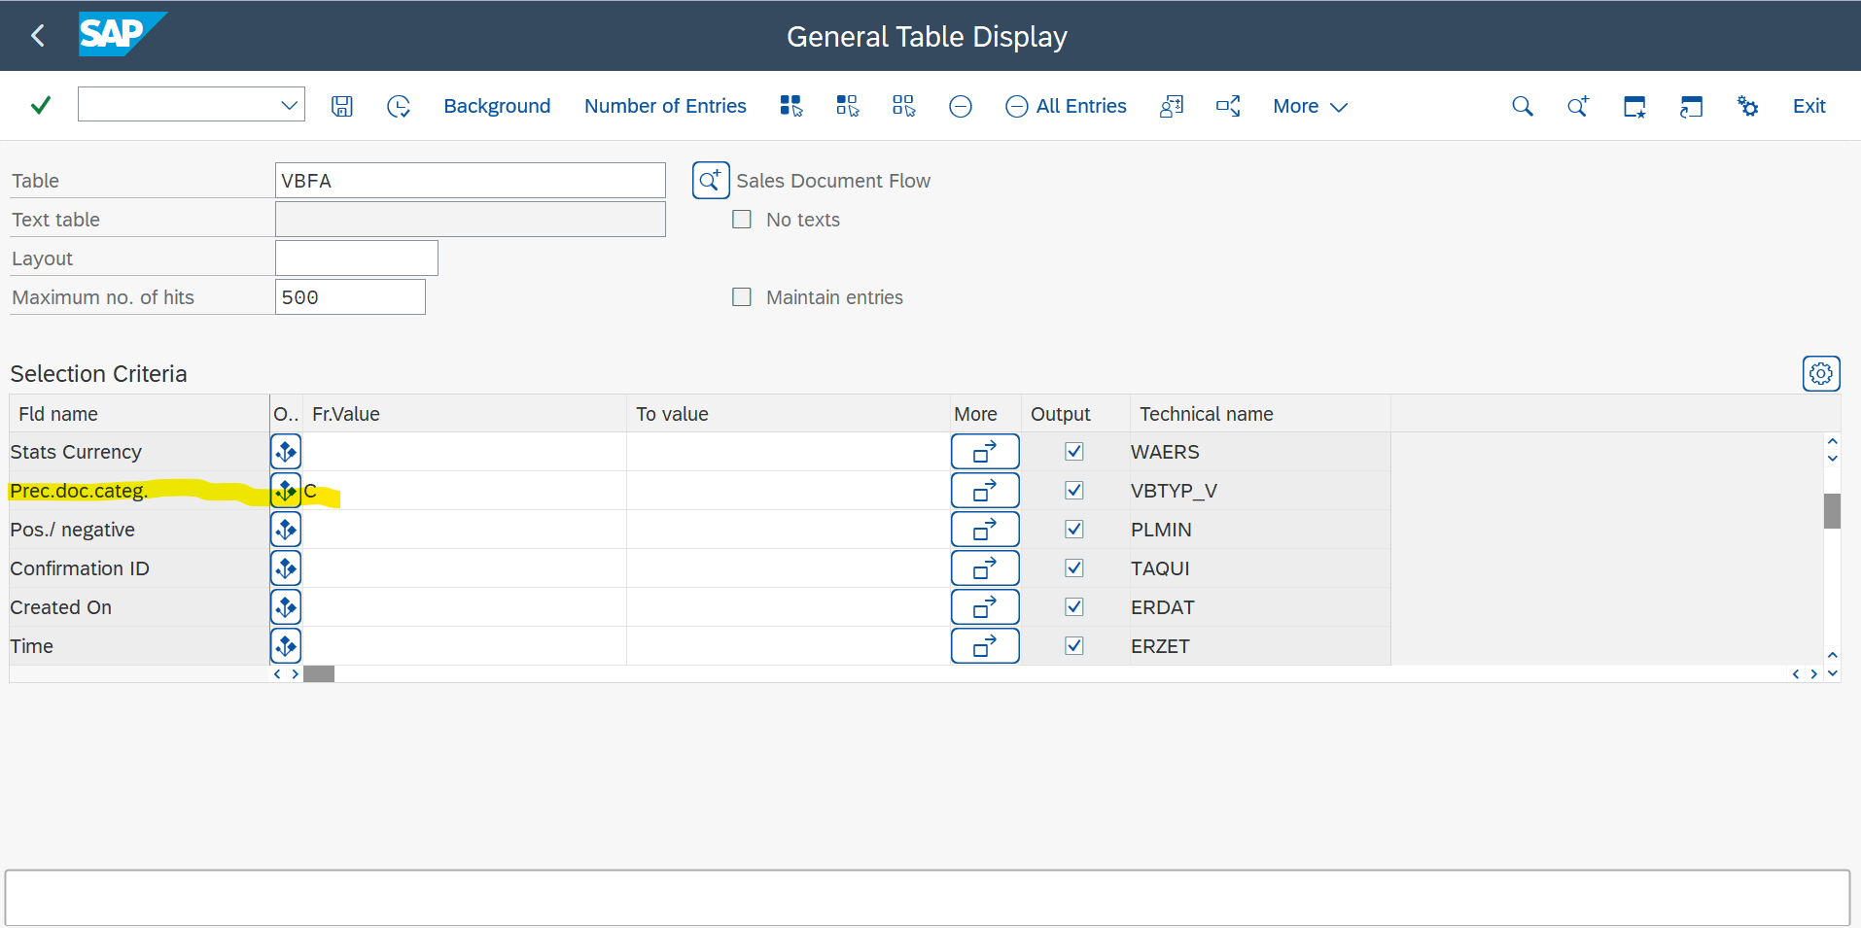

KNVP

🡪customer no. 🡪all details you will get

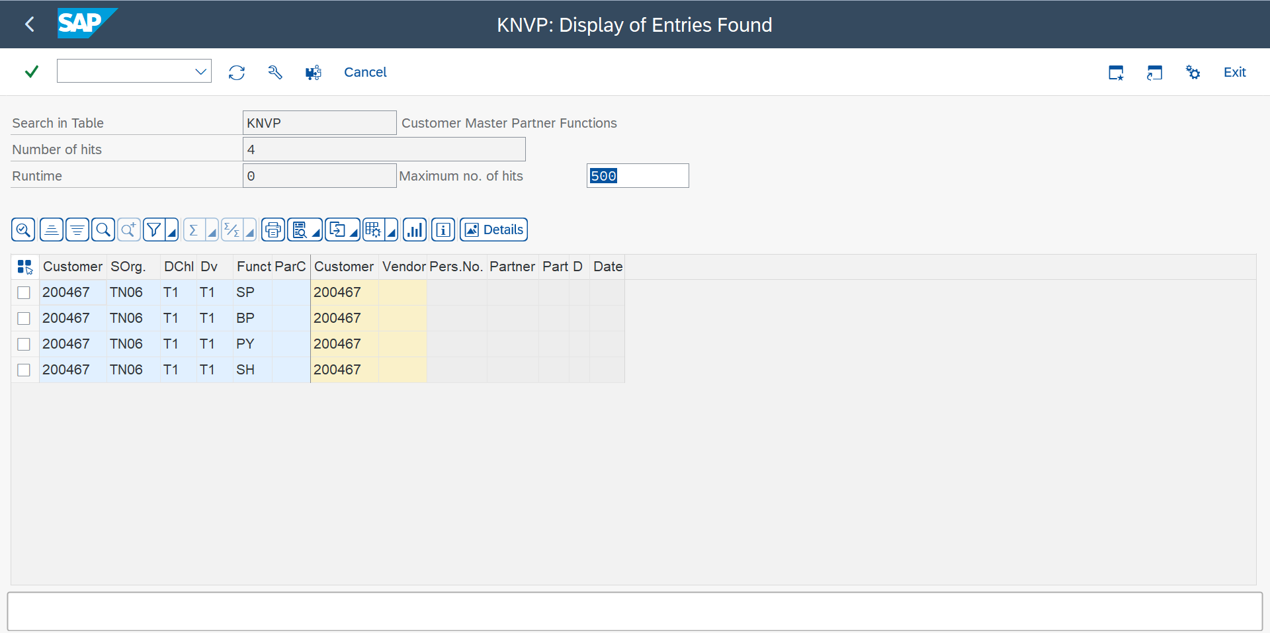

To fetch a single line🡪Parter function🡪execute

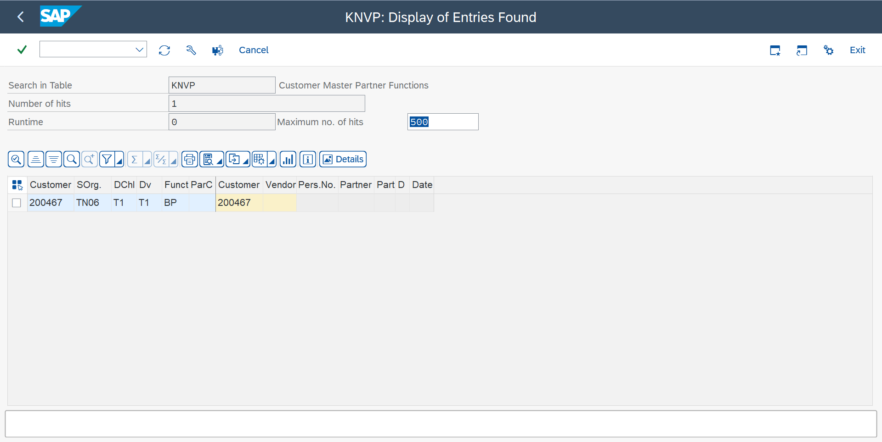

**TEXT CONTROL**

Customizing Text Determination

Creating a text and taking to different document

Spro🡪sales and distribution🡪basic function🡪text control🡪define text types🡪

Sales Document🡪Header + text types

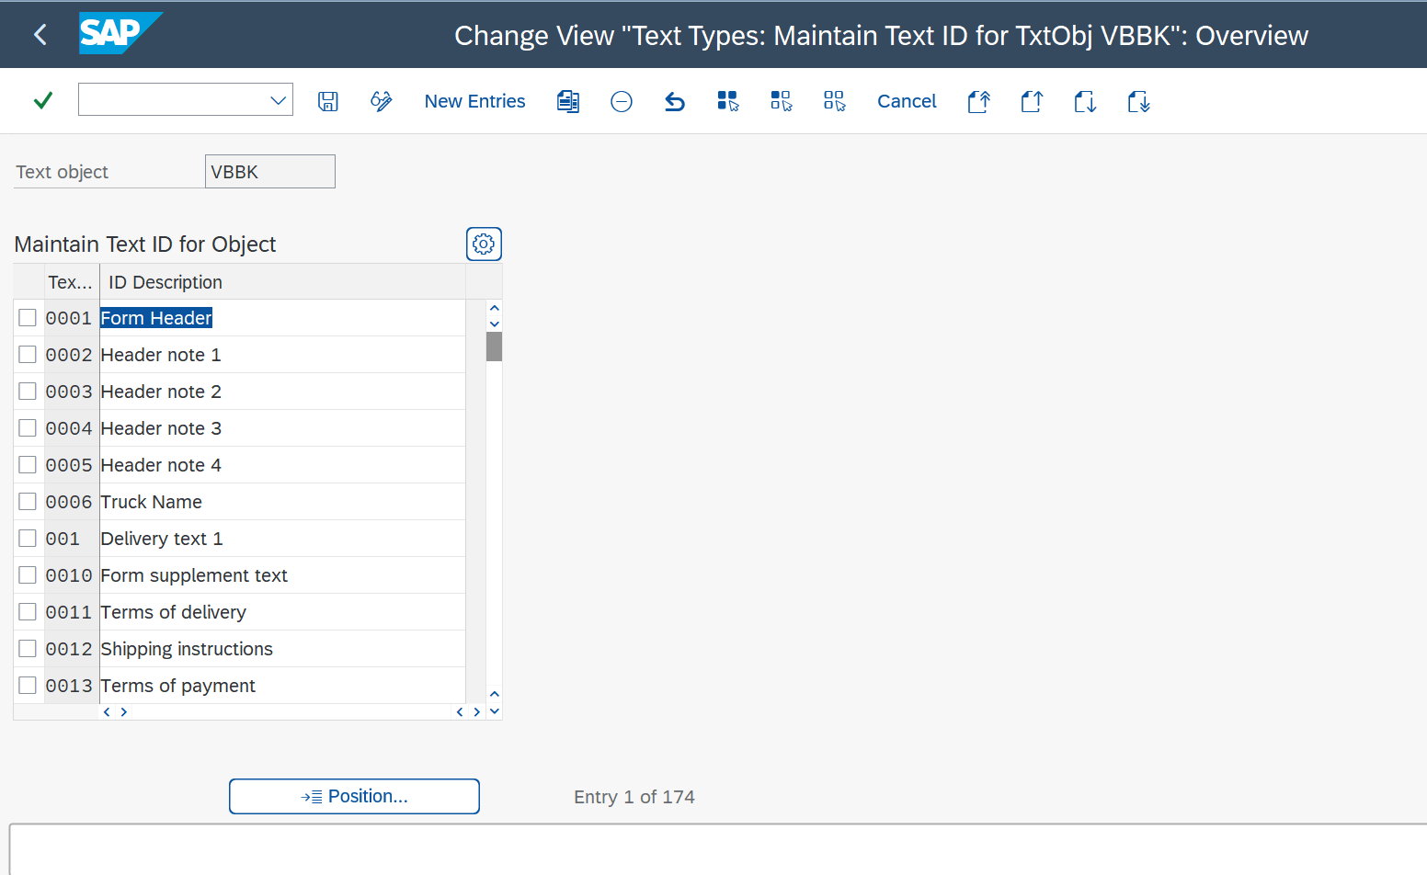

Position 🡪 form header (copy anyone) (ZT01)(Test Text –006)🡪save

Now assigning

Spro🡪sales and distribution🡪basic function🡪text control🡪define and assign text determination procedures🡪

Sales Document🡪Header + Change

Sales header + text ID’s in text procedure 🡪

Create new seq. no(created 290)🡪check the reference🡪Access Sequence🡪0976🡪save

Text procedure assignment🡪ZOR

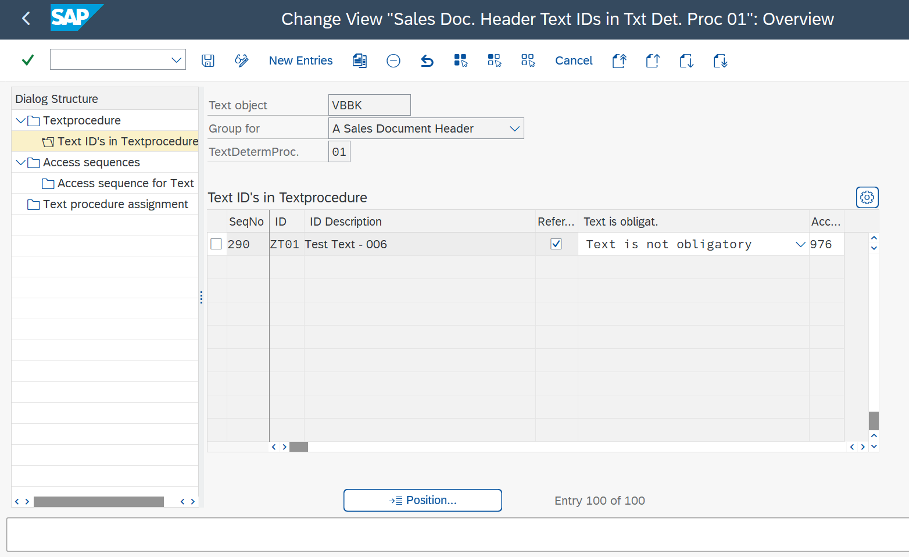

Spro🡪sales and distribution🡪basic function🡪text control🡪define access sequence

Sales header + access sequence

976+access sequence for text🡪edit id and id description🡪save

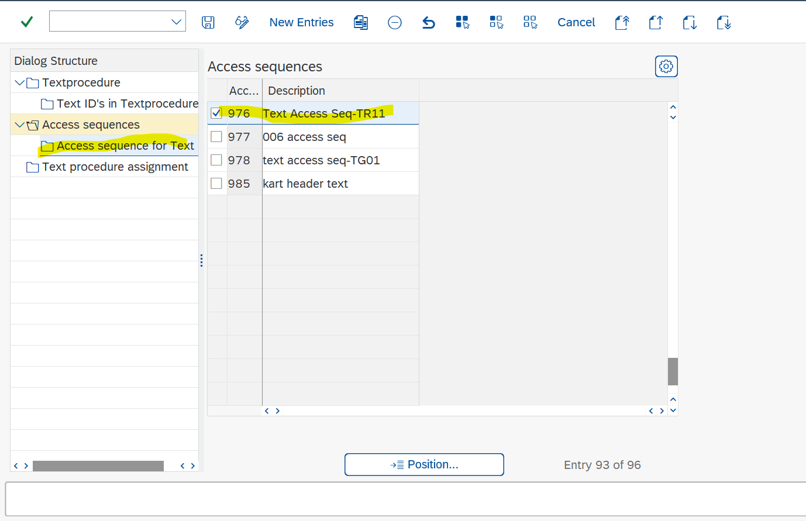

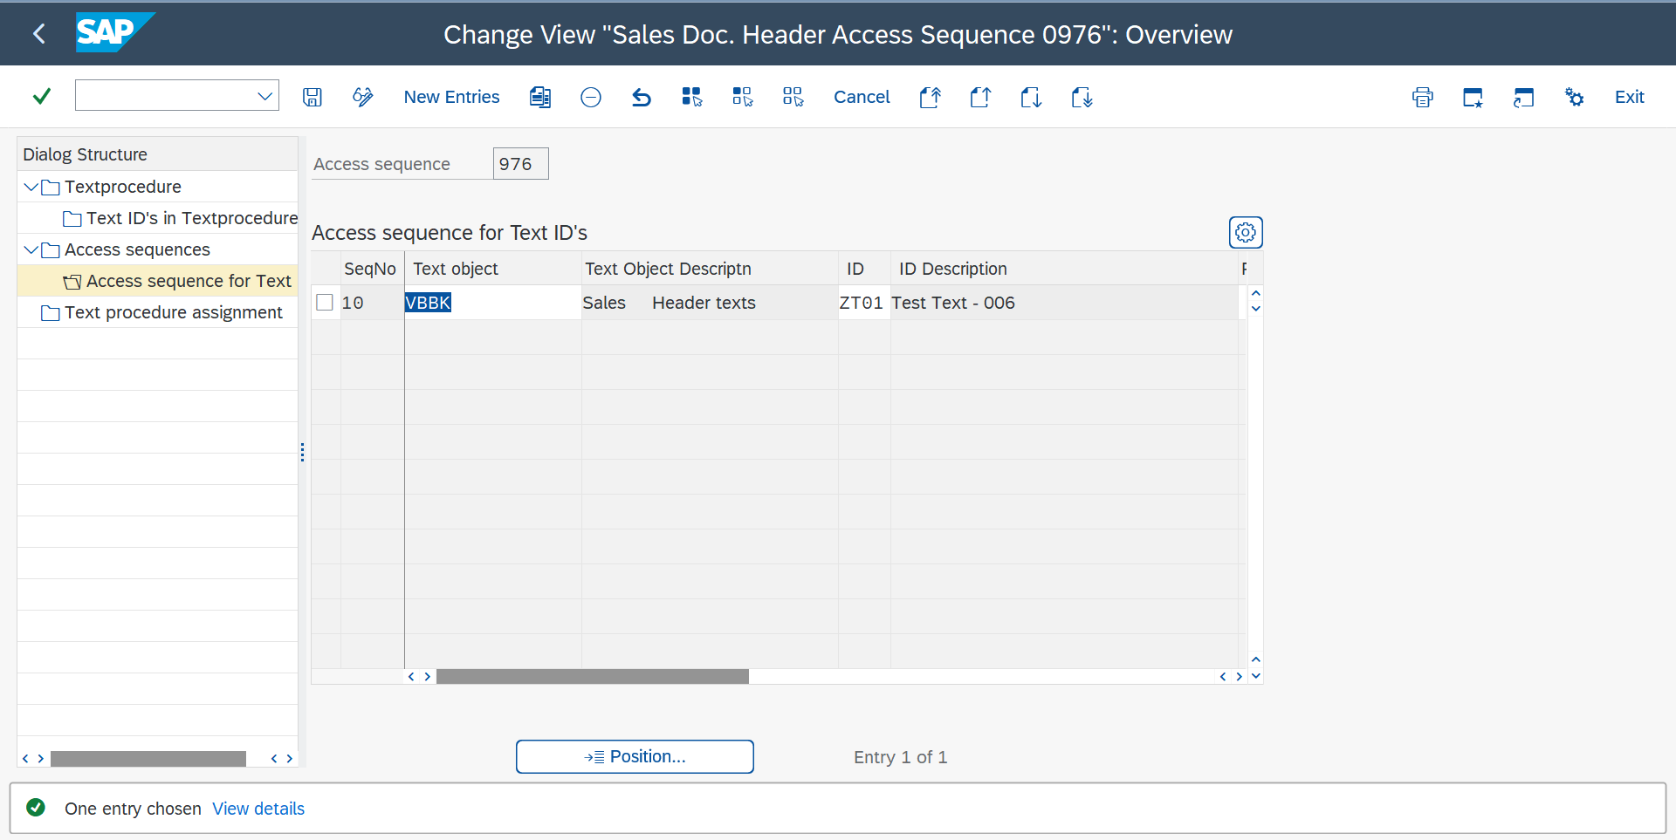

Delivery + Header + Change

Delivery header + text id’s in text procedure

Access sequence is the linking wire it will copy the text from one sales order to delivery to billing

Now create a sales order 🡪 Texts

Text id – TR70 + some more 🡪 edit assign some text 🡪save

🡪delivery🡪head 🡪text

Similarly check in billing document

Cross client: Workbench Request (se10) put user🡪display

Normal customization here